Task 2 • Card balance game teacher notes
(Y2)

(Y2)

Slide 9
What you need to play
Each group needs:
- 2-3 players
- 1 Pack of cards

Each player is given:
- four card piles of four cards, placed face down, in two sets of two.
- an equals sign card to place in the middle of the cards when the two sets balance.

Slide 10
The aim of the game
The aim of the game is to balance the sets of numbers.
If using picture cards, a King, Queen or Jack = 0

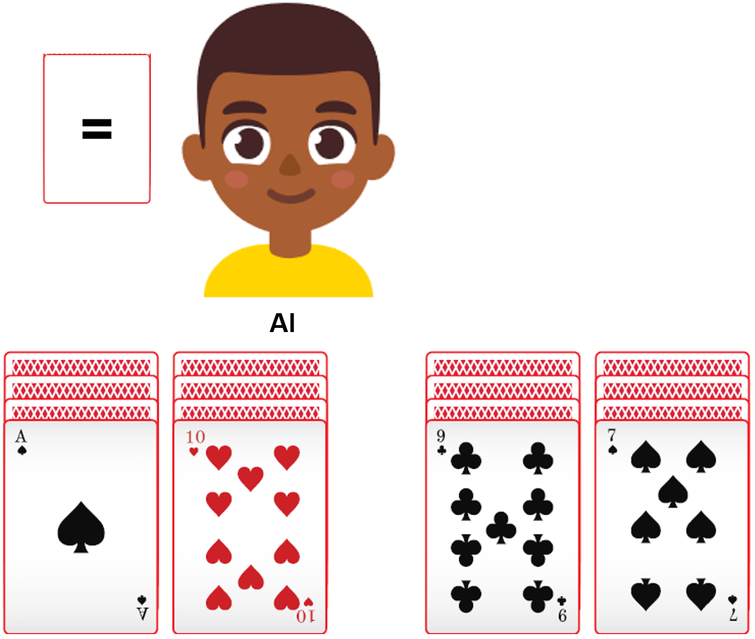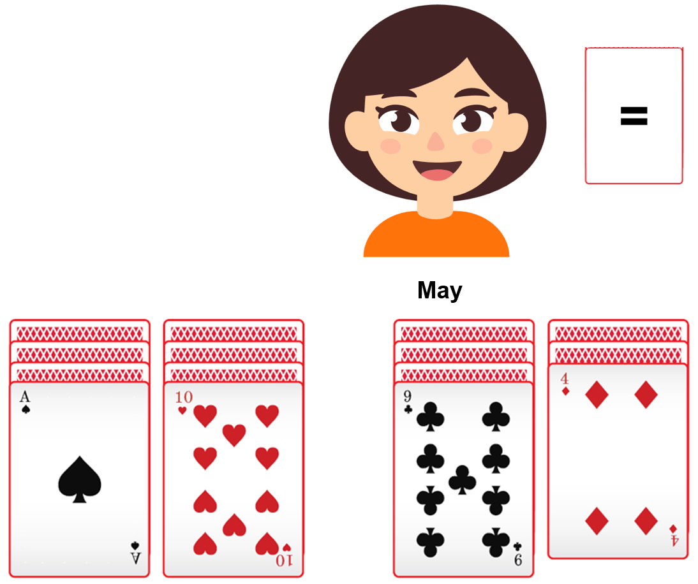

Slide 11
Let’s watch Al play
It is Al’s turn to make a move.
Which card do you think he might choose to discard to try to balance his cards?

Slide 12
Discard and flip, or balanced?
Al discards the 7 and flips over a 4 underneath.
He puts the 7 card to one side, and it is out of play.
His cards do not balance as 1 + 10 do not equal 9 + 4
On his next go he will try to balance the value of the cards on both sides.
He could stop now with a score of 2 points, which is the difference between 11 and 13, the total of each pair of cards.

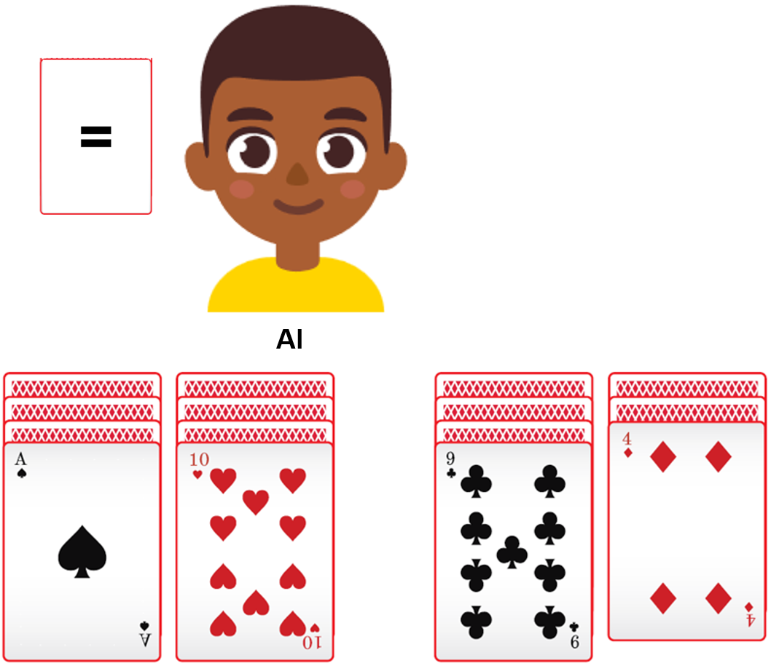

Slide 13
Discard and flip, or balanced?
Which card do you think he might choose to discard to try to balance his cards?
On his next go, Al decides to carry on playing and he discards the 9 card and flips over a 5.
He puts the 9 card to one side, and it is out of play.
His cards do not balance as 1 + 10 do not equal 5 + 4
Al could try to balance the value of the cards on both sides or stop with a score of 2 points, which is the difference between 11 and 9, the total of each pair of cards.

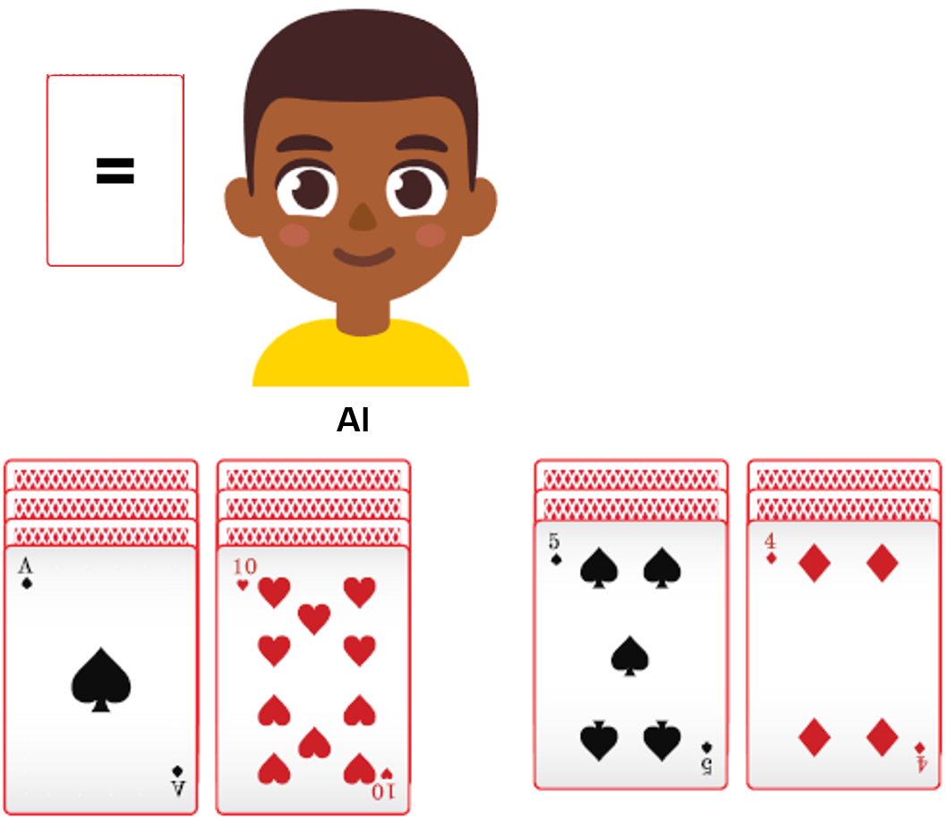

Slide 14
Discard and flip, or balanced?

Al chooses to continue and discards the 10 and flips over an 8.
This time his cards balance with-
1 + 8 = 5 + 4
9 = 9

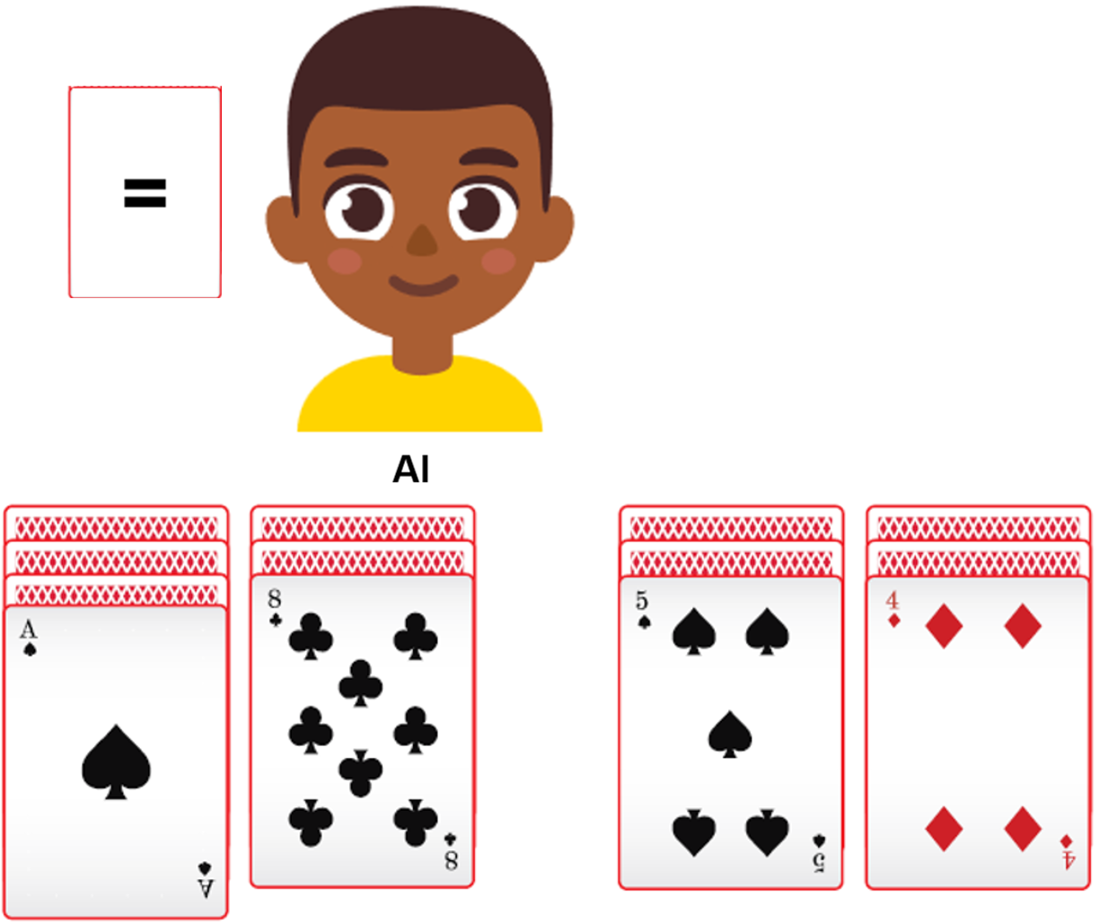

Slide 15
Al shows that his cards balance by putting down his equals sign card.
He wins this game because his cards balance.
His score is 0, because the difference between 9 and 9 is 0.

The players can deal out new cards to play again.
The player with the lowest score over three games is the winner.
Balanced cards

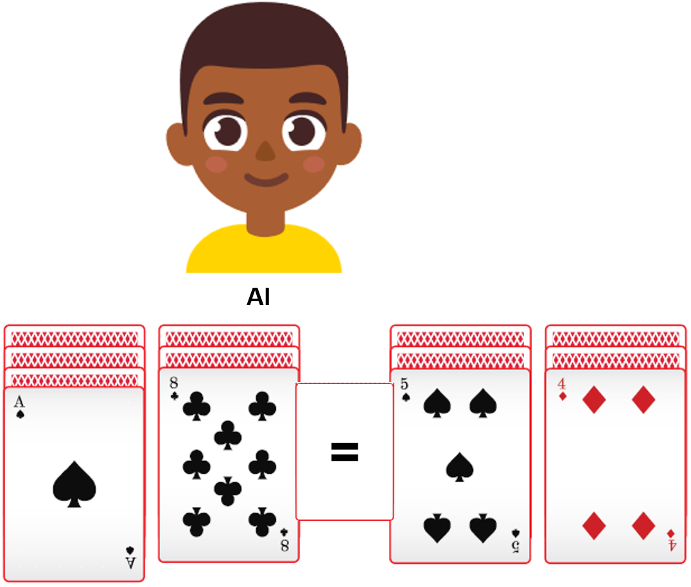

Slide 16
How to play

- All players flip over the top card on their four card piles.
- Players take turns to discard one of their top cards and flip over the card underneath. Each discarded card is out of play.
- If their number cards balance, they put the equals sign in between their cards and their score is zero.
  - The number cards = the number value
  - An ace = 1
  - A picture card (King, Queen or Jack) = 0
- The game ends when all players have balanced their cards or have no more cards left to flip over.
- At the end of the game, a player’s score is the difference between their two pairs of cards.
- The lowest score over three games wins.

As you model the game in the slides, invite students to work out the totals of the cards on each slide, to see if they are equivalent and balance.

The purpose of this game is to balance the sets of numbers.
The winner is the first player to show their cards balance by putting their equals sign card in the gap.

