Name:

Task 3 • Balancing blocks
(Y2)

- The blocks in these two pictures balance:
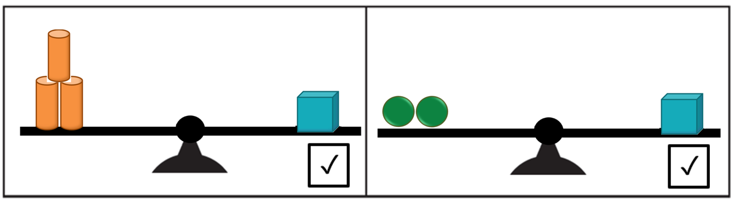

Which of these scales will balance? Put a ✓ in the box of the scales which balance.
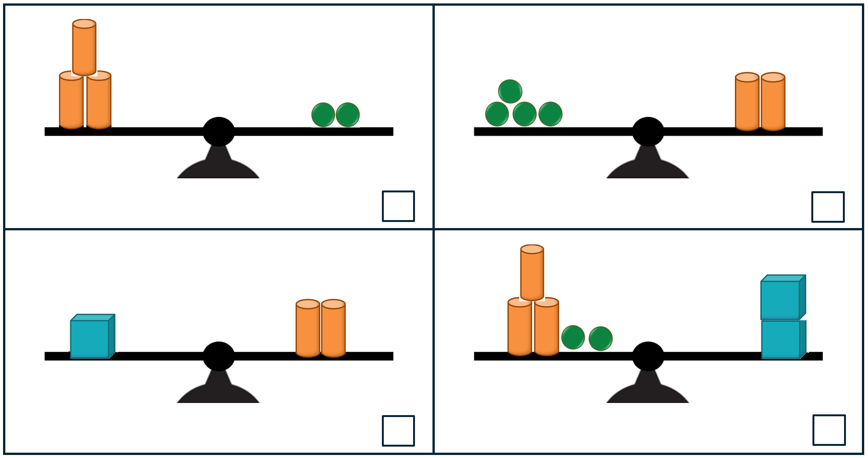

Which ones don’t balance? Draw in blocks so that they will balance.
- The blocks on these scales balance:
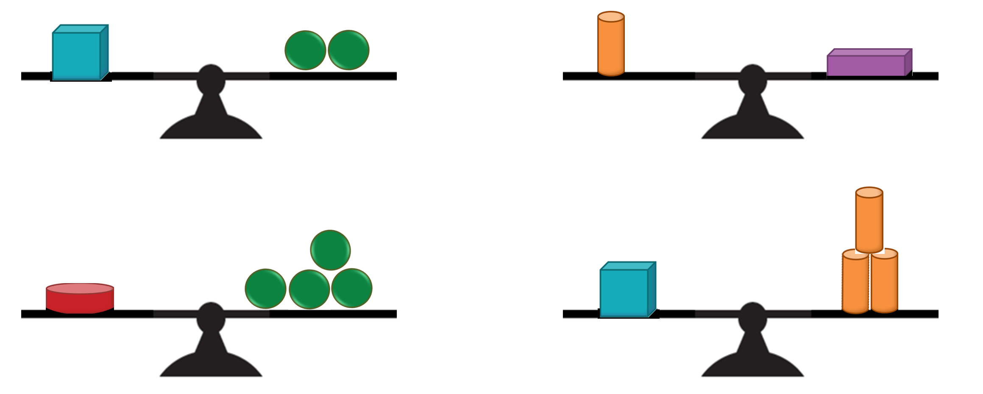

Draw other ways to balance the blocks.
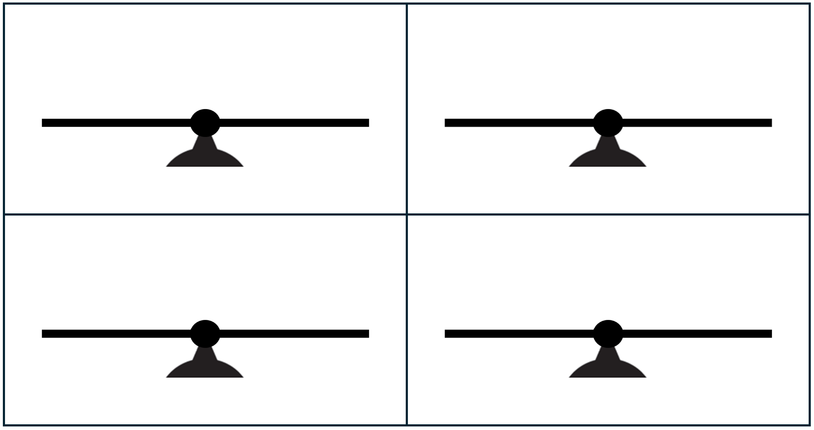

- The blocks on these scales balance:

Draw ways which do not balance the blocks.
