Name:

Task 4 • Finding equivalence
(Y2)

(Y2)

There is one weight on one side of the number balance and two weights on the other side.
The number balance is balanced. What might the numbers be?

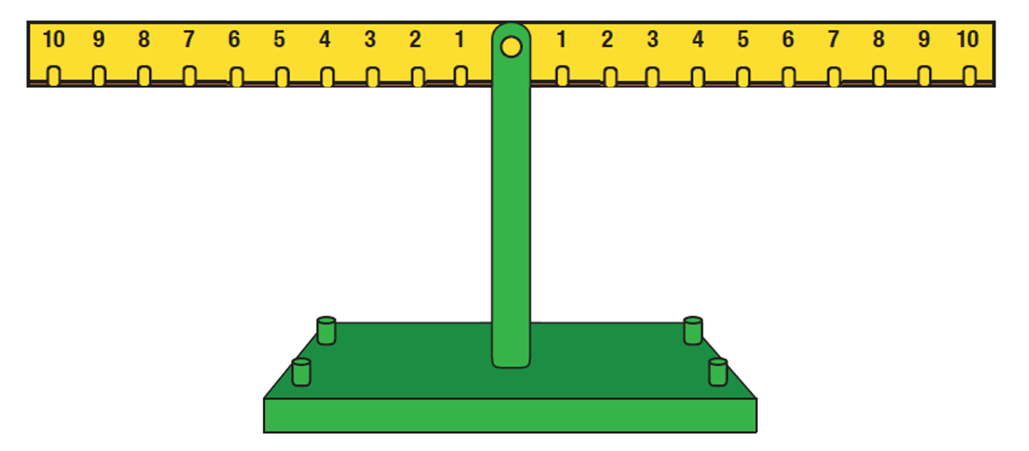

___ + ___ = ___

___ = ___ + ___

The number balance is balanced. What might the numbers be?

___ + ___ = ___ + ___ + ___

What could the missing numbers be?
20 + ___ = ___ + 10

20 + ___ = ___ + 10

20 + ___ = ___ + 10

20 + ___ = ___ + 10

20 + ___ = ___ + 10

The equals sign means these blocks are equivalent, so they balance.
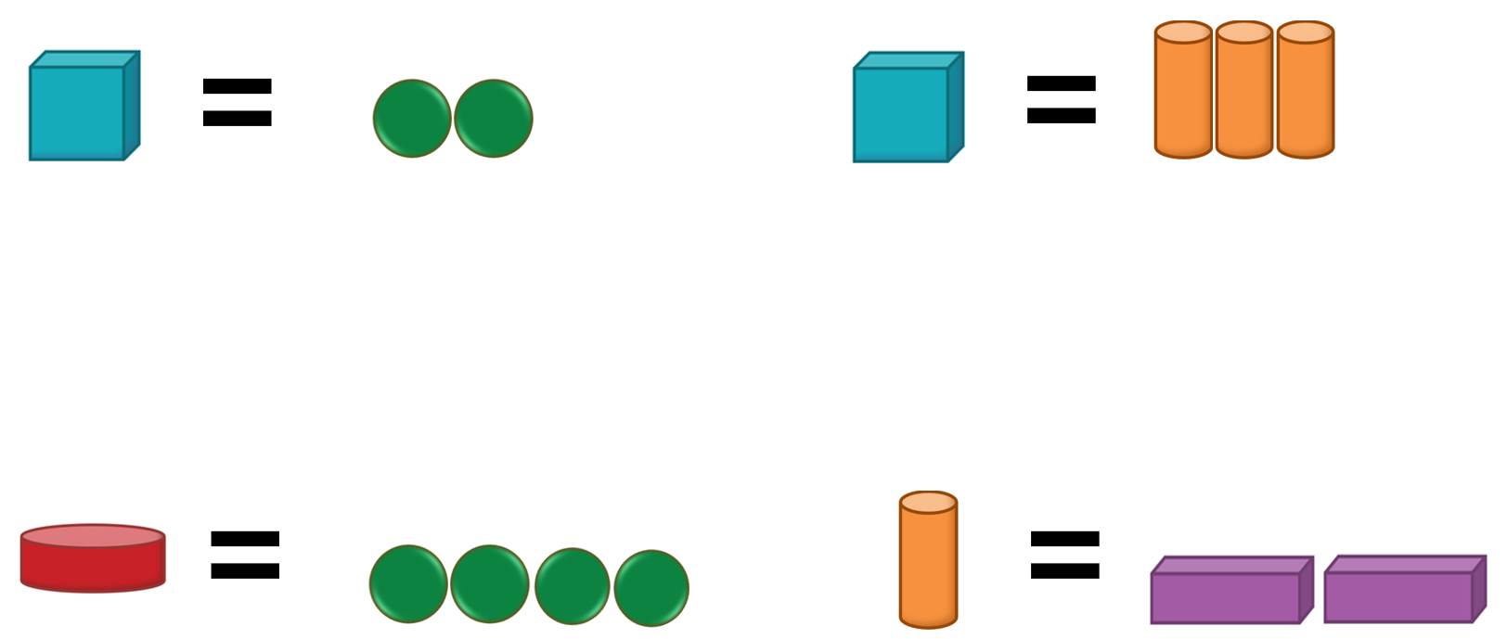

Draw some different ways to balance the blocks.
