Counting your odds
(Y4)

Always / Sometimes / Never

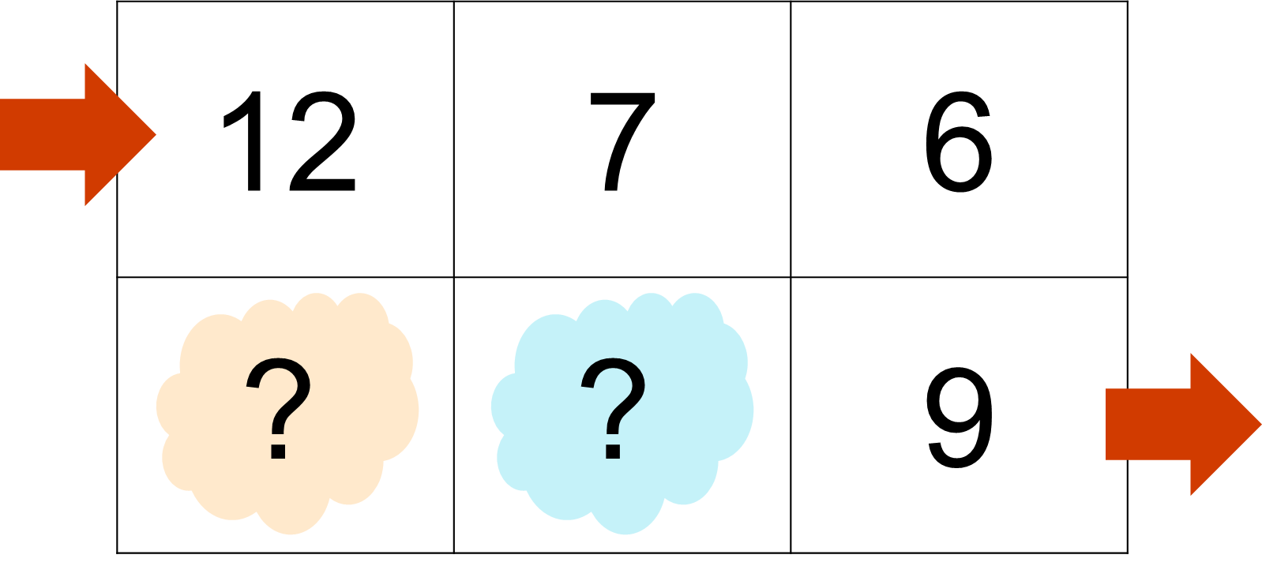
Circle your answer and explain your thinking.
1. Does changing the 12 to a different number change whether your total is odd or even? | Always | Sometimes | Never
Because…

2. Does the path you choose change whether your total is odd or even? | Always | Sometimes | Never
Because…

3. If both mystery numbers are odd, will the total always be odd? | Always | Sometimes | Never
Because…

4. If both mystery numbers are even, will the total always be odd? | Always | Sometimes | Never
Because…

