Counting your odds and evens
(Y4)

We are sure that… | We wonder… | 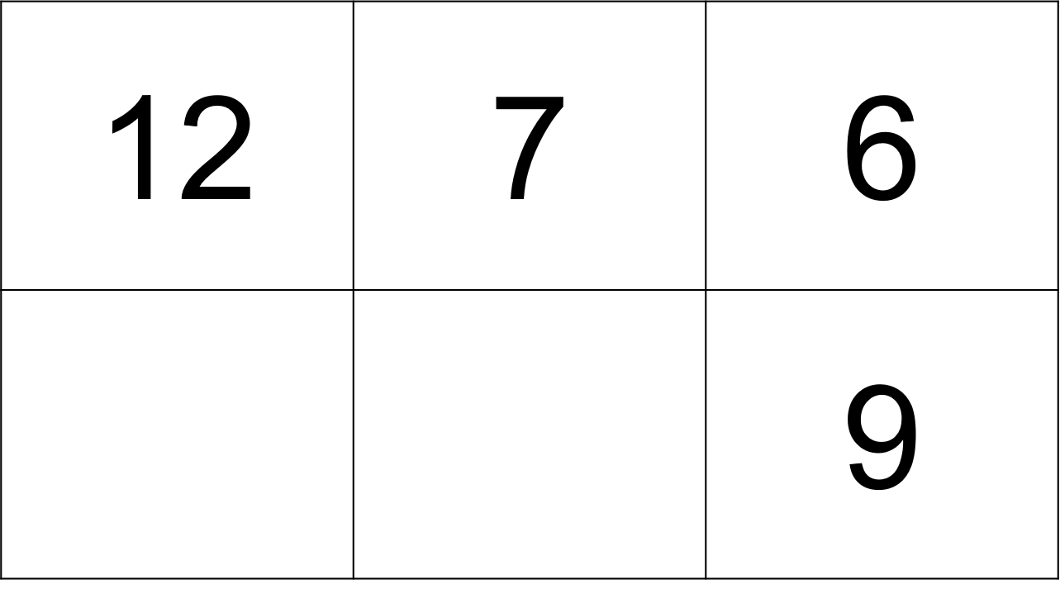  ?  ? | Argue like a mathematician
- We think... because...
- We know this is always true because...
- We tried... and found...
- We tested... and every time...
- This makes sense because…
- It doesn’t matter what... as long as...
Our claim is… |  | We know this because… | We can show this by…
Write what you think is true about each path. |  | What did you test? What did you find? | Draw it. Write it. Use numbers to explain.

