
LESSON 1

(Y7)

Lesson 1 • Deciphering ciphers
To read the most recent version of this lesson, download associated resources, and view embedded professional learning including classroom videos and work samples, visit: https://resolve.edu.au/teaching-sequences/year-7/mathematical-modelling-cracking-codes/lesson-1-deciphering-ciphers

Lesson overview
Students attempt to decipher codes encrypted with a substitution cipher and reflect on the strategies they found particularly helpful.

Learning goals
Investigating a problem in context allows us to consider how mathematics might be used as a tool to help solve the problem.
By finding and identifying patterns in language, we begin to recognise how mathematics can be used as a tool to decipher codes.

Resources
Each group
- Access to a computer or tablet
- Access to ASD Code Breaker

Lesson phase | Estimated time | Lesson type
Problem in context | Exploring ciphers | 35 minutes | Small group
Problem in context | Deciphering strategies | 10 minutes | Individual

Teach this lesson

Problem in context | Exploring ciphers
Introduce substitution ciphers to the students. Explain that in substitution ciphers each letter of the alphabet is replaced with another letter, character, or symbol. Every occurrence of a letter is replaced with the same symbol. For example, every occurrence of the letter ‘a’ in a passage could be replaced by the symbol ‘£’.
Provide pairs or small groups of students access to computers or tablets. Ask them to decipher the substitution codes in the ASD Code Breaker challenge on the Australian Signal Directorate’s (ASD) website.
ASD Code Breaker challenge
In the ASD Code Breaker challenge, a substitution cipher has been used to code passages of text which relate to the themes and stories of the ASD’s history in cryptography. The challenge starts off with easier codes and gets progressively harder. The TACTICS button at the side of the page suggests some strategies that students might use. Encourage students to have a go at deciphering the codes before clicking on the TACTICS button.

Problem in context | Deciphering strategies
Conduct a class discussion: What strategies did you use to help decipher the messages? How helpful were your different strategies?
Create a class list of the different strategies that students used, such as letter frequencies, common words, and common letter patterns. The professional learning Code breaking strategies embedded in the online version of this lesson describes common word and letter patterns that can be used to help decipher codes.

LESSON 2

(Y7)

Lesson 2 • Exploring frequency
To read the most recent version of this lesson, download associated resources, and view embedded professional learning including classroom videos and work samples, visit: https://resolve.edu.au/teaching-sequences/year-7/mathematical-modelling-cracking-codes/lesson-2-exploring-frequency

Lesson overview
Students predict the frequency of letters in the English alphabet, then analyse a piece of text to compare and refine their predictions.

Learning goals
Data is used as evidence to inform predictions and decisions.
By analysing letter usage in text, we can determine the expected frequency of each letter.

Resources
Whole class
- Cracking Codes PowerPoint
Each group
- Exploring frequency Student sheet
- Access to computers or tablets
- Access to spreadsheet software
- A passage of text. The passage should be different for each group and can be accessed by students online (if students will be analysing the passage digitally), or printed by the teacher prior to the lesson (if students will be analysing the passage manually).
  - If using computers, students might use Wikipedia pages on a subject of interest to them.
  - If using printed pages, provide each group with different pages from a novel (for example).

Lesson phase | Estimated time | Lesson type
Mathematical problem | How can we use maths? | 5 minutes | Whole class
Mathematical result | Creating frequency graphs | 30 minutes | Small groups
Mathematical result | Comparing graphs | 10 minutes | Whole class

Teach this lesson

Mathematical problem | How can we use maths?
Show the students slide 3 of Cracking codes PowerPoint. Explain that students will use the process of mathematical modelling to determine methods that can be used to decipher substitution ciphers. Now that they have explored the problem in context, they need to formulate a mathematical problem.
Review the strategies students used to decipher the coded messages in Lesson 1.
Discuss: How might we use mathematics to help us decipher substitution ciphers like this more efficiently?
- In English text, letters appear with different frequencies. Comparing letter frequencies in a coded message to known letter frequencies in English text can help us to decipher substitution ciphers.
  - For example, the letters e, t, and a are among the most common in English, so it is likely that they are mapped to the more frequently occurring symbols in a cipher.

Mathematical result | Creating frequency graphs
Divide students into small groups and provide each group with a copy of Exploring frequency Student sheet. Ask the students to sort the letters of the English alphabet into four categories, based on how frequently they appear in English texts: most common, common, less common, least common. They can do this by cutting out the letters on the sheet and then sorting, or by writing letters into the appropriate space on the sheet.
Invite groups to share their strategies for sorting their letters and to justify their reasoning. Discuss the differences and similarities between the ways each group sorted their letters.
Discuss the different strategies students used to sort their letters. For example, the students may have used some text to inform their sort, or they may have used their instincts. Establish the need to collect data as evidence to inform their sorting.
Explain to students that each group will analyse a different passage of text to determine letter frequency. They will then use this data to create a column graph and compare their graph to their letter sort.
Provide each group with a passage of text. Ask students to determine how often each letter of the alphabet is used in the passage.
- For online text, the frequency of letters can be quickly calculated using the “Find” feature (Ctrl+F in Windows or Command+F on a Mac). Typing in a single letter into the search bar will count the number of times that letter appears.
- For printed text, students will need to manually count the number of occurrences of each letter.
Ask students to use spreadsheet software to create a column graph showing the frequency of letters obtained from their text analysis.
Have groups compare the results of their frequency analysis to their four categories of lessons. Allow groups time to recategorise any letters. They should keep track of any changes that they make and record reasons for why they choose to make these changes.

Mathematical result | Comparing graphs
Select students to present their frequency graph and letter sort to the class. Ask them to share why they chose to recategorise some letters in their sort after completing their text analysis.
Discuss:
- What did you notice about the frequency of letters in your passage compared to your letter sort? Does the frequency of any letters surprise you? Why?
  - It is likely that the students will be surprised by the data. It is also important to note that this is just a small sample of text at this point and so unusual letter frequencies may be present.
- How are the results of each group similar?
  - It is likely that there will be similarity between the letters that appear more frequently across the frequency graphs.
- How are the results from each group different?
  - The relative frequency of letters will differ across the frequency graphs.
- Why might these similarities and differences exist?
  - There will be differences evident because each group has used different passages of text. Each group has also used only a small sample of text.
- At this stage, we can observe differences in each group’s data. How could we adjust our approach to achieve greater consistency across groups? What strategies could help us collect more reliable and representative results?
  - A larger amount of data is required. This can be achieved by analysing further text and combining the data from each small group to create a class dataset.

LESSON 3

(Y7)

Lesson 3 • Frequency analysis
To read the most recent version of this lesson, download associated resources, and view embedded professional learning including classroom videos and work samples, visit: https://resolve.edu.au/teaching-sequences/year-7/mathematical-modelling-cracking-codes/lesson-3-frequency-analysis

Lesson overview
Students use a spreadsheet to analyse letter frequency in a text and compare it to the typical distribution in the English language.

Learning goals
Data is used as evidence to inform predictions and decisions.
By analysing letter usage in text, we can determine the expected frequency of each letter.
The more high-quality data we include in our dataset, the more representative of the population our results become.

Resources
Whole class
- Cracking codes PowerPoint
- Frequency analysis Spreadsheet
Each group
- Access to computers or tablets
- Frequency analysis Spreadsheet

Lesson phase | Estimated time | Lesson type
Mathematical problem | What is typical? | 10 minutes | Whole class
Mathematical result | More typical frequencies | 20 minutes | Small group
Mathematical result | Even more typical | 15 minutes | Whole class

Teach this lesson

Mathematical problem | What is typical?
Review the previous lesson, focusing on the similarities and differences between the frequency graphs created by each group, and the need for a larger dataset to get a more accurate indication of letter frequency.
Show students slide 5 of Cracking codes PowerPoint. Explain to the students that this slide shows the results of a 1982 manual analysis of letter usage in newspapers and novels, with a total sample of 100 362 alphabetic characters. Invite students to share some of their noticings.
(Slide 6) Explain that this slide shows the results of a second analysis conducted in 2012. In this analysis, computers were used to analyse Google books, with a total sample of 3 563 505 777 820 alphabetic characters. Invite students to share some of their noticings.
(Slide 7) Make comparisons between the two sets of data.
Discuss:
- How are the two graphs similar?
  - The shape of the two graphs is quite similar, indicating that the order and frequency of many letters are quite similar across both studies.
- How are the two graphs different?
  - The are some interesting differences. Letters r, c and p appear more frequently in the second study with letters like h, w, and d appear less frequently.
- Why might account for the differences between the two analyses?
  - The two studies analysed different genres of text at different points in time.
- Which study do you think shows the more 'typical' results? Why?
  - The second study is more recent and analysed significantly more data. Interestingly it is the data from the first study that is seen much more frequently as the 'typical distribution'.

Mathematical result | More typical frequencies
Provide students with access to the Frequency analysis Spreadsheet, which contains two sheets: Analysing text and Comparing frequencies. In this section of the lesson, the students will use the Analysing text sheet. This page includes a section that counts how often each letter appears in a passage and then automatically calculates the percentage frequency of each letter. The sheet also displays the results of the typical letter distribution in English from the previously mentioned studies for easy comparison. It is possible for students to code their own spreadsheets using the Frequency analysis Spreadsheet as a guide.
Have each group select some online text (e.g. a Wikipedia page on a topic of interest) and then use the Analysing text sheet to determine the frequency of letters in the selected passage of text. Ask students to calculate the relative frequency in the final column of the table.
Ask: Compare your analysis to the results of typical distribution of letters in the English language from the two studies we looked at earlier? What similarities and difference do you notice?
Ask students to add additional text to their spreadsheet by pasting passages of text, one after the other, into the relevant section of the spreadsheet. After each addition of new text, ask students to consider again the similarities and differences between the distribution of letters in their data, and the typical distribution of letters.
Discuss: What do you notice about the distribution of your data and the distribution of letters in the English language from the two studies we looked at earlier?
- Students should notice that as they added more text to their sample, the distribution of their data becomes increasingly similar to the typical distribution graphs. It is also likely that they will notice differences between their distribution and the typical distribution.

Mathematical result | Even more typical
Combine all the class data together in the Comparing frequencies sheet by typing the total count of each letter from each group. The final column of the spreadsheet combines all counts for each letter to create an even larger dataset. It is possible to add columns to this chart if needed.
(Slide 5) Ask: What do you notice about the distribution of our class data compared to the distribution of letters in the two large studies that we have looked at? Discuss the similarities and differences. Again, the greater volume of data should result in distribution more closely aligned to the typical distribution graph.

LESSON 4

(Y7)

Lesson 4 • Code Crackers
To read the most recent version of this lesson, download associated resources, and view embedded professional learning including classroom videos and work samples, visit: https://resolve.edu.au/teaching-sequences/year-7/mathematical-modelling-cracking-codes/lesson-4-code-crackers

Lesson overview
Students apply letter frequency and language patterns to decipher codes encrypted with a substitution cipher.

Learning goals
We need to interpret our mathematical results in context to determine what these results mean in practice. We also need to evaluate our mathematical results in context to determine whether the solution provides an adequate and sensible answer to the real-world context.

Resources
Whole class
- Cracking codes PowerPoint
Each group
- Frequency analysis Spreadsheet
Each student
- Digital copy of Encrypted text Student sheet
- Cracking codes Student sheet

Lesson phase | Estimated time | Lesson type
Results in context | Encrypted text | 30 minutes | Small group
Results in context | Evaluating strategies | 30 minutes | Whole class/Individual

Teach this lesson

Results in context | Encrypted text
Show slide 9 of Cracking codes PowerPoint. Explain that students have investigated the problem in context, formulated a mathematical problem, and solved the problem to give a mathematical result. Now they need to interpret their mathematical results in context to determine what these results mean in practice.
Revise the different strategies that students have used up to this point in the sequence, including letter frequencies, common words, and common letter patterns.
Divide students into small groups and provide each group with access to the Frequency Analysis spreadsheet. Also provide students with Encrypted text Student sheet, which includes encrypted pieces of text to decipher and instructions on how to use the Find and Replace function in Microsoft Word as a tool to efficiently substitute letters.
Explain to students that a substitution cipher has been used to encrypt the different passages of text, and they will need to use their deciphering strategies to decode the texts. Encourage students to use the Analysing frequency spreadsheet. To decipher the codes, students will need to use letter frequency in conjunction with other deciphering strategies they have used throughout the sequence.
Using Microsoft Word to decipher the codes
The Find and Replace function in Microsoft Word will search a document, find all instances of specified text, and replace it with alternate text.
Depending on your process for deciphering text, you may need a way to distinguish between the parts of the ciphertext that you have already decoded and the remaining encrypted text.
One way to do this is to format your decoded text differently to the original ciphertext.
Paste encrypted text into a new Word document.  Open Find and Replace which can be found in the editing tools on the Home ribbon (or by using the Ctrl-H shortcut). | 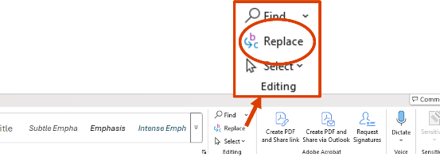
Setting the font format of the ciphertext  Ensure your curser is in the Find what box, then click on More > > > Format > Font.... This allows you to set the format of the font of the original ciphertext that you paste into Word. Only text formatted in this way will be searched. | 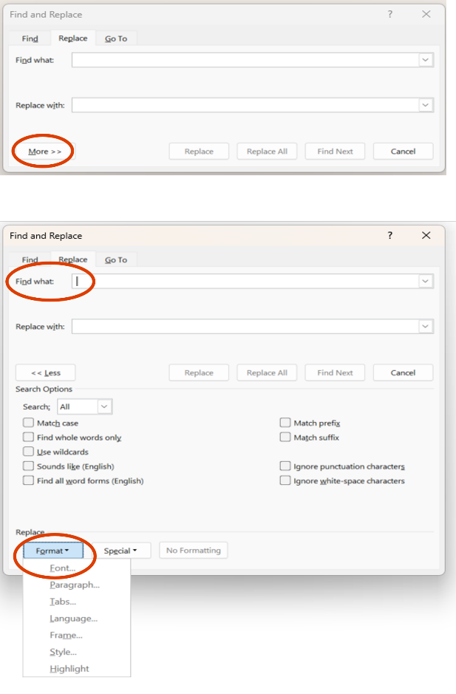
Set the font style and colour to match the format of the ciphertext. In most cases the font style will be Regular and the colour will be Automatic. Then click OK. | 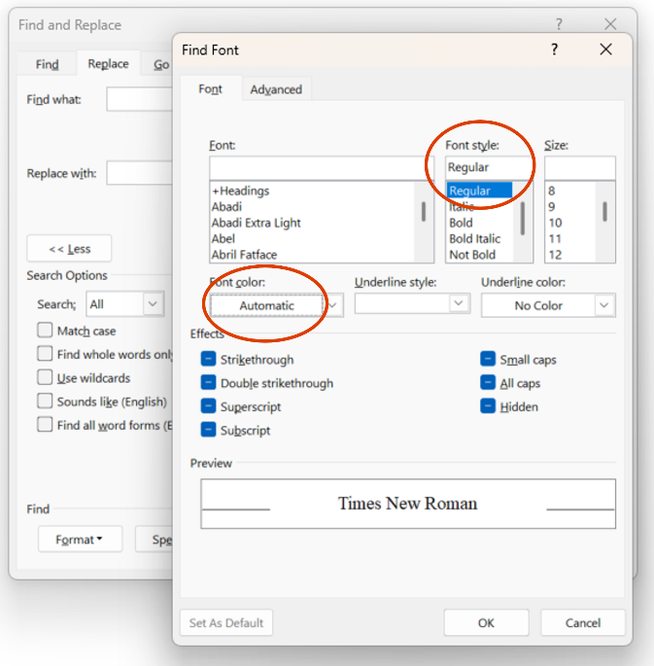
Setting the font format of the deciphered plaintext  Next, ensure your cursor is in the Replace with box and click Format > Font. Set the font formatting for the replacement plaintext. Make sure it stands out! For example, bolding the text and changing the colour will help distinguish this text. Click OK. | 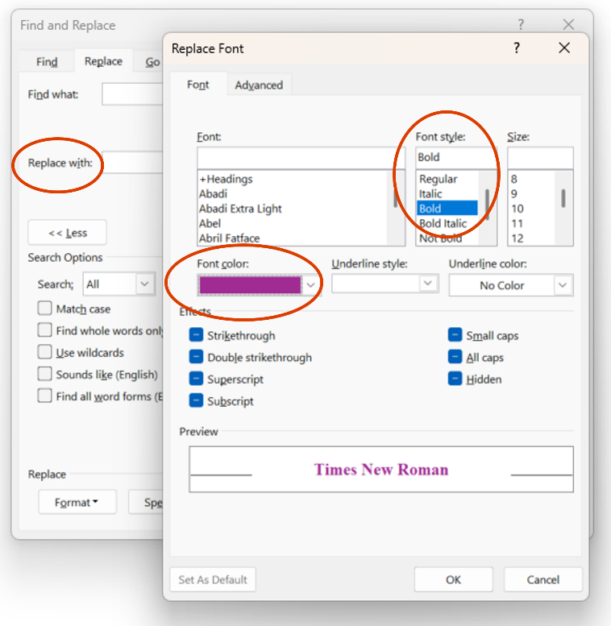
You will see the format of the font now for the text that will be searched and the replacement text. | 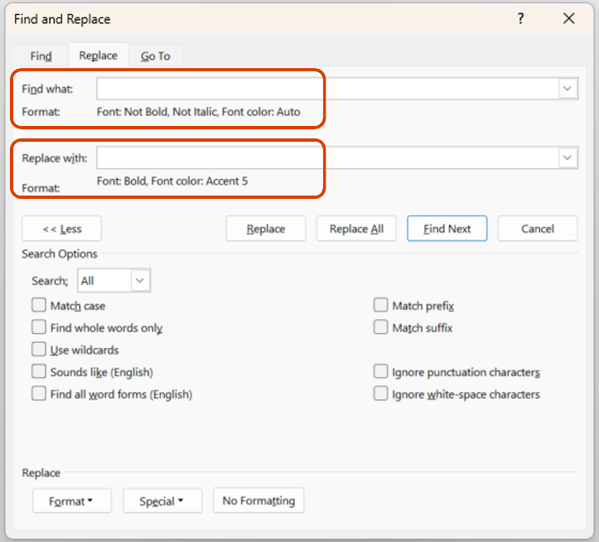
Use your deciphering strategies such as letter frequency, common words, and letter patterns to change letters in a coded piece of text. Your decoded text will stand out from the ciphertext to help you decide on which letters you would like to substitute. | 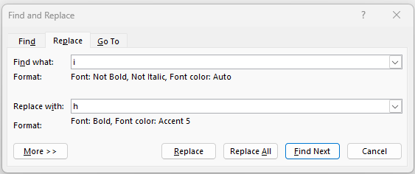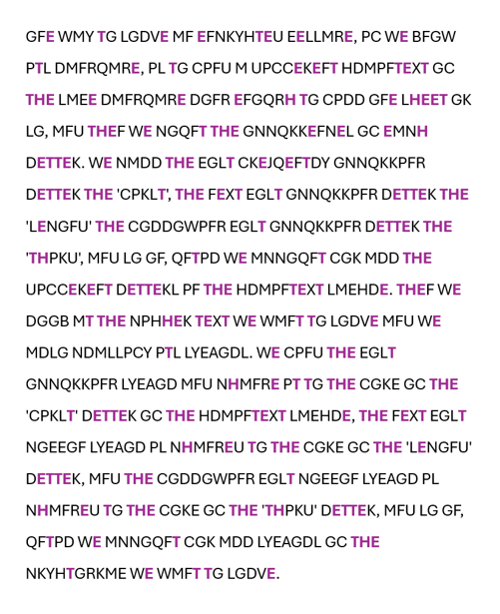

Codes to be deciphered
The students need to decipher four different codes. The codes range in length and the genres of each text is different. Each ciphertext uses a different substitution cipher.
Ciphertext 1 – From Harry Potter and the Philosopher’s Stone
Plain-text | A | B | C | D | E | F | G | H | I | J | K | L | M | N | O | P | Q | R | S | T | U | V | W | X | Y | Z
Cipher-text | E | J | A | L | Q | R | C | P | D | W | I | O | X | K | V | U | B | T | N | M | F | S | H | Y | Z | G
Harry tried. And tried. He had no idea what Mr Ollivander was waiting for. The pile of tried wands was mounting higher and higher on the spindly chair, but the more wands Mr Ollivander pulled from the shelves, the happier he seemed to become.
“Tricky customer, eh? Not to worry, we’ll find the perfect match here somewhere – I wonder now – yes, why not – unusual combination – holly and phoenix feather, eleven inches, nice and supple.”
Harry took the wand. He felt a sudden warmth in his fingers. He raised the wand above his head, brought it swishing down through the dusty air and a stream of red and gold sparks shot from the end like a firework, throwing dancing spots of light on to the walls. Hagrid whooped and clapped and Mr Ollivander cried, “Oh, bravo! Yes, indeed, oh, very good. Well, well, well… how curious… how very curious…”
He put Harry’s wand back into its box and wrapped it in brown paper, still muttering, “Curious… curious…”
“Sorry,” said Harry, “but what’s curious?”
Mr Ollivander fixed Harry with his pale stare.
“I remember every wand I’ve ever sold, Mr Potter. Every single wand. It so happens that the phoenix whose tail feather is in your wand, gave another feather – just one other. It is very curious indeed that you should be destined for this wand when its brother – why, its brother gave you that scar.”

Ciphertext 2 – Short text
Plain-text | A | B | C | D | E | F | G | H | I | J | K | L | M | N | O | P | Q | R | S | T | U | V | W | X | Y | Z
Cipher-text | I | S | D | T | E | K | M | C | L | U | H | P | R | Q | J | A | Z | F | Y | X | N | B | O | W | V | G
The quick brown fox jumps over the lazy dog.

Ciphertext 3 – Passage on how Mary, Queen of Scots used cipher
Plain-text | A | B | C | D | E | F | G | H | I | J | K | L | M | N | O | P | Q | R | S | T | U | V | W | X | Y | Z
Cipher-text | X | Y | Z | A | B | C | D | E | F | G | H | I | J | K | L | M | N | O | P | Q | R | S | T | U | V | W
While imprisoned by her cousin, Queen Elizabeth the First, Mary, Queen of Scots used substitution ciphers to secretly communicate with her supporters about plans to escape and overthrow Elizabeth. In her ciphers, Mary replaced each letter of the alphabet with a different letter or symbol. The key to decoding the message was knowing the exact substitutions, which Mary shared with her supporters.
However, Sir Francis Walsingham, Elizabeth's spymaster, had a team of codebreakers who successfully deciphered Mary’s messages using techniques like frequency analysis. Through these decoded letters, they uncovered Mary's involvement in the Babington Plot to assassinate Elizabeth. This led to Mary's trial and execution.

Ciphertext 4 – Passage on distribution in statistics
Plain-text | A | B | C | D | E | F | G | H | I | J | K | L | M | N | O | P | Q | R | S | T | U | V | W | X | Y | Z
Cipher-text | H | U | M | T | G | A | N | F | B | V | O | C | S | L | R | Y | I | Z | Q | J | X | K | E | W | P | D
We analyse data to understand its variability. Reasoning about distribution is key to accounting for and describing variability. Distribution refers to the patterns of similarity and difference in data. Graphical displays and numerical summaries are used to explore, describe, and compare variability in distributions. Observations that relate to distribution could relate to spread (including range), shape, clumps, gaps, centre and atypical values.

Results in context | Evaluating strategies
Conduct a class discussion. Allow the students to share the different strategies that they use to decipher each piece of text.
Discuss: Which of the ciphertexts were easier to decode? Why?
- It is typically easier to apply letter frequency and word patterns to longer passages. Short passages are much harder to decipher.
- Context is also important. It is much easier to decipher code when you know the context of the original passage.
Provide students with Cracking codes Student sheet and allow time for students to individually complete this sheet.
This reflection can be used as a post-assessment of students’ learning throughout this sequence. This final question on this sheet asks students to create their own coded message. Allow students to share their code with others to decipher.

