Cracking codes
(Y7)

Encrypted text
These messages have been encrypted using different substitution ciphers. Use your deciphering skills to decrypt each message.

Ciphertext 1
PETTZ MTDQL. EKL MTDQL. PQ PEL KV DLQE HPEM XT VOODSEKLQT HEN HEDMDKC RVT. MPQ UDOQ VR MTDQL HEKLN HEN XVFKMDKC PDCPQT EKL PDCPQT VK MPQ NUDKLOZ APEDT, JFM MPQ XVTQ HEKLN XT VOODSEKLQT UFOOQL RTVX MPQ NPQOSQN, MPQ PEUUDQT PQ NQQXQL MV JQAVXQ.
“MTDAIZ AFNMVXQT, QP? KVM MV HVTTZ, HQ’OO RDKL MPQ UQTRQAM XEMAP PQTQ NVXQHPQTQ – D HVKLQT KVH – ZQN, HPZ KVM – FKFNFEO AVXJDKEMDVK – PVOOZ EKL UPVQKDY RQEMPQT, QOQSQK DKAPQN, KDAQ EKL NFUUOQ.”
PETTZ MVVI MPQ HEKL. PQ RQOM E NFLLQK HETXMP DK PDN RDKCQTN. PQ TEDNQL MPQ HEKL EJVSQ PDN PQEL, JTVFCPM DM NHDNPDKC LVHK MPTVFCP MPQ LFNMZ EDT EKL E NMTQEX VR TQL EKL CVOL NUETIN NPVM RTVX MPQ QKL ODIQ E RDTQHVTI, MPTVHDKC LEKADKC NUVMN VR ODCPM VK MV MPQ HEOON. PECTDL HPVVUQL EKL AOEUUQL EKL XT VOODSEKLQT ATDQL, “VP, JTESV! ZQN, DKLQQL, VP, SQTZ CVVL. HQOO, HQOO, HQOO… PVH AFTDVFN… PVH SQTZ AFTDVFN…”
PQ UFM PETTZ’N HEKL JEAI DKMV DMN JVY EKL HTEUUQL DM DK JTVHK UEUQT, NMDOO XFMMQTDKC, “AFTDVFN… AFTDVFN…”
“NVTTZ,” NEDL PETTZ, “JFM HPEM’N AFTDVFN?”
XT VOODSEKLQT RDYQL PETTZ HDMP PDN UEOQ NMETQ.
“D TQXQXJQT QSQTZ HEKL D’SQ QSQT NVOL, XT UVMMQT. QSQTZ NDKCOQ HEKL. DM NV PEUUQKN MPEM MPQ UPVQKDY HPVNQ MEDO RQEMPQT DN DK ZVFT HEKL, CESQ EKVMPQT RQEMPQT – WFNM VKQ VMPQT. DM DN SQTZ AFTDVFN DKLQQL MPEM ZVF NPVFOL JQ LQNMDKQL RVT MPDN HEKL HPQK DMN JTVMPQT – HPZ, DMN JTVMPQT CESQ ZVF MPEM NAET.”

Plaintext | A | B | C | D | E | F | G | H | I | J | K | L
Cipher text

M | N | O | P | Q | R | S | T | U | V | W | X | Y | Z

Ciphertext 2
XCE ZNLDH SFJOQ KJW UNRAY JBEF XCE PIGV TJM

Plaintext | A | B | C | D | E | F | G | H | I | J | K | L
Cipher text

M | N | O | P | Q | R | S | T | U | V | W | X | Y | Z

Ciphertext 3
TEFIB FJMOFPLKBA YV EBO ZLRPFK, NRBBK BIFWXYBQE QEB CFOPQ, JXOV, NRBBK LC PZLQP RPBA PRYPQFQRQFLK ZFMEBOP QL PBZOBQIV ZLJJRKFZXQB TFQE EBO PRMMLOQBOP XYLRQ MIXKP QL BPZXMB XKA LSBOQEOLT BIFWXYBQE. FK EBO ZFMEBOP, JXOV OBMIXZBA BXZE IBQQBO LC QEB XIMEXYBQ TFQE X AFCCBOBKQ IBQQBO LO PVJYLI. QEB HBV QL ABZLAFKD QEB JBPPXDB TXP HKLTFKD QEB BUXZQ PRYPQFQRQFLKP, TEFZE JXOV PEXOBA TFQE EBO PRMMLOQBOP.
ELTBSBO, PFO COXKZFP TXIPFKDEXJ, BIFWXYBQE'P PMVJXPQBO, EXA X QBXJ LC ZLABYOBXHBOP TEL PRZZBPPCRIIV ABZFMEBOBA JXOV’P JBPPXDBP RPFKD QBZEKFNRBP IFHB COBNRBKZV XKXIVPFP. QEOLRDE QEBPB ABZLABA IBQQBOP, QEBV RKZLSBOBA JXOV'P FKSLISBJBKQ FK QEB YXYFKDQLK MILQ QL XPPXPPFKXQB BIFWXYBQE. QEFP IBA QL JXOV'P QOFXI XKA BUBZRQFLK.

Plaintext | A | B | C | D | E | F | G | H | I | J | K | L
Cipher text

M | N | O | P | Q | R | S | T | U | V | W | X | Y | Z

Ciphertext 3
EG HLHCPQG THJH JR XLTGZQJHLT BJQ KHZBHUBCBJP. ZGHQRLBLN HURXJ TBQJZBUXJBRL BQ OGP JR HMMRXLJBLN ARZ HLT TGQMZBUBLN KHZBHUBCBJP. TBQJZBUXJBRL ZGAGZQ JR JFG YHJJGZLQ RA QBSBCHZBJP HLT TBAAGZGLMG BL THJH. NZHYFBMHC TBQYCHPQ HLT LXSGZBMHC QXSSHZBGQ HZG XQGT JR GWYCRZG, TGQMZBUG, HLT MRSYHZG KHZBHUBCBJP BL TBQJZBUXJBRLQ. RUQGZKHJBRLQ JFHJ ZGCHJG JR TBQJZBUXJBRL MRXCT ZGCHJG JR QYZGHT, QFHYG, MCXSYQ, NHYQ, MGLJZG HLT HJPYBMHC KHCXGQ.

Plaintext | A | B | C | D | E | F | G | H | I | J | K | L
Cipher text

M | N | O | P | Q | R | S | T | U | V | W | X | Y | Z

Use “Find and Replace” in Word to substitute letters
The Find and Replace function will search a document, find all instances of specified text, and replace it with alternate text.
Depending on your process for deciphering text, you may need a way to distinguish between the parts of the ciphertext that you have already decoded and the remaining encrypted text.
One way to do this is to format your decoded text differently to the original ciphertext.
Paste encrypted text into a new Word document.  Open Find and Replace which can be found in the editing tools on the Home ribbon (or by using the Ctrl-H shortcut). | 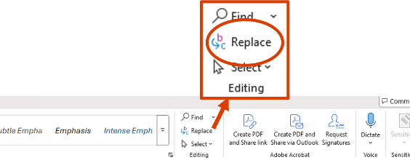
Setting the font format of the ciphertext  Ensure your curser is in the Find what box, then click on More > > > Format > Font.... This allows you to set the format of the font of the original ciphertext that you paste into Word. Only text formatted in this way will be searched. | 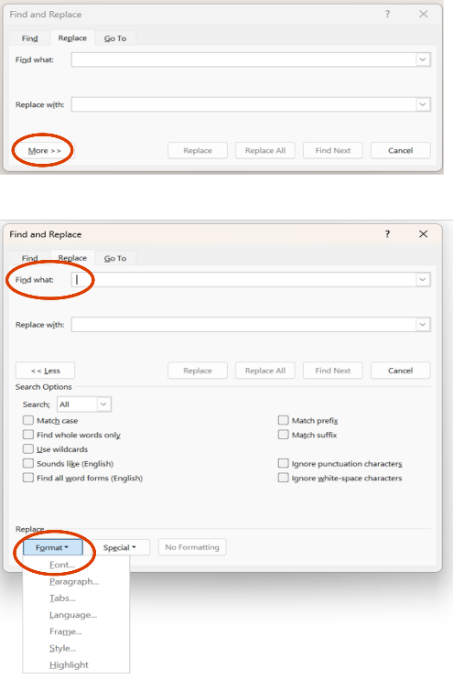
Set the font style and colour to match the format of the ciphertext. In most cases the font style will be Regular and the colour will be Automatic. Then click OK. | 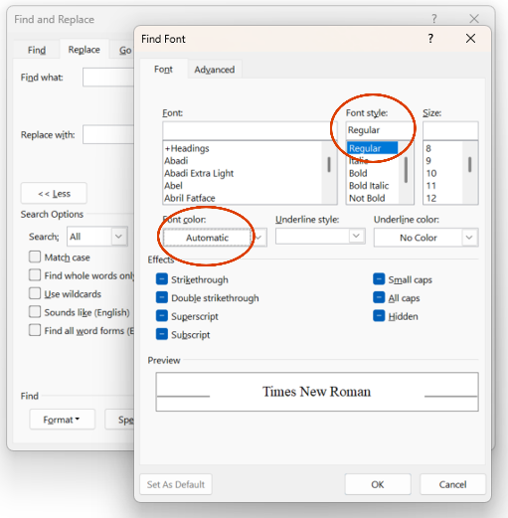
Setting the font format of the deciphered plaintext  Next, ensure your cursor is in the Replace with box and click Format > Font. Set the font formatting for the replacement plaintext. Make sure it stands out! For example, bolding the text and changing the colour will help distinguish this text. Click OK. | 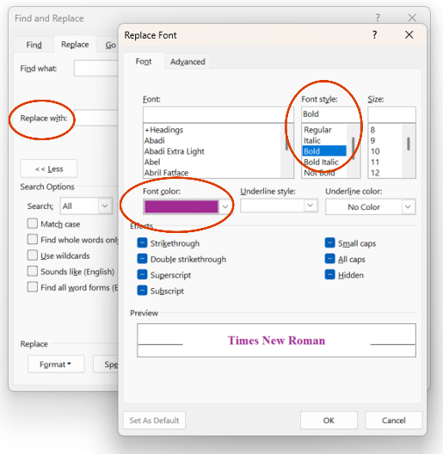
You will see the format of the font now for the text that will be searched and the replacement text. | 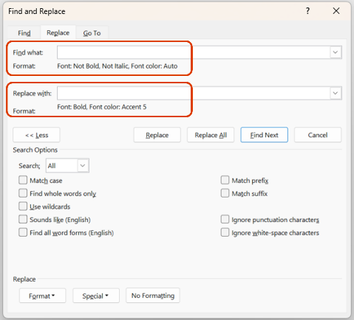
Use your deciphering strategies such as letter frequency, common words, and letter patterns to change letters in a coded piece of text. Your decoded text will stand out from the ciphertext to help you decide on which letters you would like to substitute. | 