Name:

Grandma’s soup
(Y1)

My last handful
Draw a picture of how you counted your last handful.
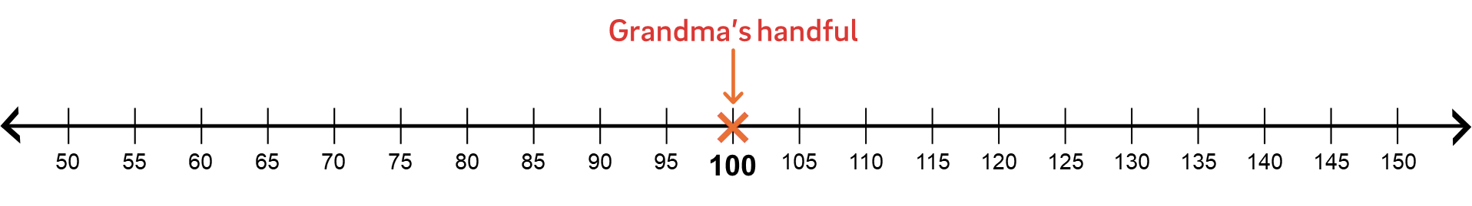
How many pieces of macaroni were in your last handful? How does your handful compare to Grandma’s handful of macaroni?

