|  |
| --- |
|  |

Lesson 1 • Best design

**Lesson 1**

**(Y6)**

|  |
| --- |
| To read the most recent version of this lesson, download associated resources, and view embedded professional learning including classroom videos and work samples, visit: [https://resolve.edu.au/teaching-sequences/year-6/statistics-loopy-aeroplanes/lesson-1-best-design](https://resolve.edu.au/teaching-sequences/year-6/statistics-loopy-aeroplanes/lesson-1-best-design?utm_source=docx&utm_medium=lesson_1&utm_campaign=loopy_aeroplanes) |

# Lesson overview

Students make a loopy aeroplane using a small and large loop. They explore if the plane flies further when thrown with the small loop or large loop at the front.

## Learning goals

Our definition for what makes one thing better than another informs the context of our investigation.

## Resources

**Whole class**

* **Loopy aeroplanes PowerPoint**

**Each student**

* A paper straw
* Coloured paper
* Scissors
* Tape
* Ruler

|  |  |  |
| --- | --- | --- |
| Lesson phase | Estimated time | Lesson type |
| **Problem | Making aeroplanes** | 25 minutes | Whole class/Individual |
| **Problem | Flying planes** | 25 minutes | Whole class/Individual |

# Teach this lesson

## Problem | Making aeroplanes

Discuss with students their experiences of making paper aeroplanes. Ask them to describe their best designs and why they believe these designs are good.

**Discuss:** *What does “best” mean when we are talking about paper aeroplanes?*

* “Best” can mean various things, such as planes that fly a long way, fall closest to a target, planes that do loops while flying, or the best-looking planes. Establish with the students that in this sequence, “best” means aeroplanes that fly a long way.

Explain that you have found an interesting design for an aeroplane. Show students the picture of a loopy aeroplane on slide 6 of **Loopy aeroplanes PowerPoint**. Alternatively, you could make a loopy aeroplane prior to the lesson and show this to the students. Invite them to share what they notice about it.

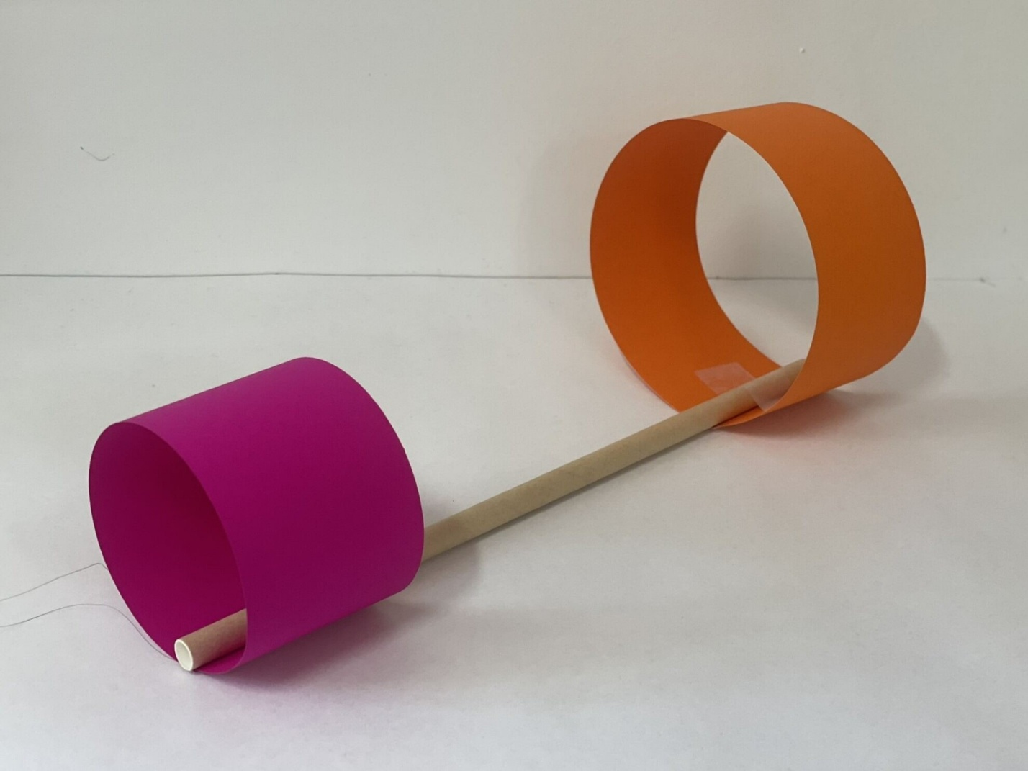

Explain that this plane can be flown two different ways: throwing it with the small loop at the front or with the large loop at the front.

**Ask:** *What is the best design for a loopy aeroplane?*

Explain to the students that they are going to make their own loopy aeroplanes, and they will investigate which design is best; the small loop in front or the large loop.

Provide each student with the equipment needed: paper, a straw, scissors and sticky tape. Ensure students also have a ruler and pencil. Show students the instructions for making the planes on slide 6 of **Loopy aeroplanes PowerPoint**.

Allow time for students to make their own plane. There is likely to be great variability in students’ production of planes, such as accuracy in constructing and attaching the loops and sticky tape usage. These differences introduce sources of variability into the data. These issues are addressed in the following lesson.

## Problem | Flying planes

Take the students to an open space and allow them to fly their planes. Encourage students to experiment with throwing their plane with the big loop at the front and then the small loop at the front.

After some time flying planes, gather the students together for a class discussion.

**Discuss:** *What did you notice as you were flying your planes?*

* Students might share their thoughts on whether the small loop should be at the front or the back. If they do, ask them what their evidence is for their claim. It is likely that students will have differing claims.

Discuss the variability in the flight distances, and other factors that could influence the flight of planes (e.g. wind or a fan, the quality of construction). These variabilities make it difficult to work out what design is best. This is where statistics can help! Establish the need to collect data as evidence.

Discuss the amount of data that is needed to determine which aeroplane design is best (e.g., “If it flies a different distance each time, is one throw enough?”). Establish that at least two throws of each design are needed.

|  |
| --- |
| To read the most recent version of this lesson, download associated resources, and view embedded professional learning including classroom videos and work samples, visit: [https://resolve.edu.au/teaching-sequences/year-6/statistics-loopy-aeroplanes/lesson-1-best-design](https://resolve.edu.au/teaching-sequences/year-6/statistics-loopy-aeroplanes/lesson-1-best-design?utm_source=docx&utm_medium=lesson_1&utm_campaign=loopy_aeroplanes) |

|  |
| --- |
|  |

Lesson 2 • Aeroplane protocols

**Lesson 2**

**(Y6)**

|  |
| --- |
| To read the most recent version of this lesson, download associated resources, and view embedded professional learning including classroom videos and work samples, visit: [https://resolve.edu.au/teaching-sequences/year-6/statistics-loopy-aeroplanes/lesson-2-aeroplanes-protocols](https://resolve.edu.au/teaching-sequences/year-6/statistics-loopy-aeroplanes/lesson-2-aeroplanes-protocols?utm_source=docx&utm_medium=lesson_2&utm_campaign=loopy_aeroplanes) |

# Lesson overview

Students create protocols to control variables when flying their planes.

## Learning goals

It is important to limit possible variables to ensure a test is fair.

## Resources

**Whole class**

* **Loopy aeroplanes PowerPoint**

**Each group**

* Various tools used for measuring distance such as tape measures, rulers, and trundle wheels

**Each student**

* Testing aeroplanes Student sheet
* Loopy aeroplanes made in the previous lesson

|  |  |  |
| --- | --- | --- |
| Lesson phase | Estimated time | Lesson type |
| **Plan | Making plans** | 10 minutes | Small group |
| **Plan | Piloting data collection** | 30 minutes | Whole class/Small group |
| **Plan | Establishing protocols** | 10 minutes | Whole class |

# Teach this lesson

## Plan | Making plans

Revise the question being investigated: *What is the best design for a loopy aeroplane?.* Revisit students’ experience flying planes in the previous lesson, focusing on how there was no conclusion on whether the small or large loop first was a better design.

Explain to students that they will work in groups, and that each group will collect data from four throws--two throws with the small loop at the front and two throws with the large loop at the front.

Divide the students into groups of 3-4. Provide each student the **Testing aeroplanes Student sheet** and ask them to plan to collect the required data. This sheet provides the following list of prompts to help groups plan their investigation:

* What data do we need to collect?
* How will we record our data?
  + This should include identifying equipment for measuring and recording their data.

## Plan | Piloting data collection

Explain to the students that they will pilot their data collection plan—this means doing a small test run to see if the plan works, and noticing problems and opportunities.

Return to the open space for flying planes. Students should have with them their loopy aeroplanes and the equipment they identified in their plan for measuring and recording their data. Allow students to start to collect their data.

The purpose of piloting data collection is to help students to become aware of some of the problems and opportunities that may arise as they collect data from their loopy aeroplanes.

Take note of some of the inconsistencies that you notice across the groups in how students are throwing their planes and measuring the distance travelled by the planes. The following Checkpoint focuses on the need to agree on some throwing and measurement protocols for all students to use.

### Checkpoint – Fair test

**Discuss:**

* *Did you notice any problems or inconsistencies as you tested your data collection plan?*
  + Possible inconsistencies/variables include:
    - Production—Lack of accuracy in constructing and attaching the loops, variation in sticky tape usage
    - Throwing style—Leaning forward to throw, strength of throws, not starting from the same throwing point, throwing loops down versus loops up, height of thrower/height plane released from
    - Measurement—inaccurate measurement, inaccurate recording, inconsistent or incorrect units of measure
    - Environmental conditions—breeze/wind gusts, hitting/flying into obstacles
* *Are these issues and inconsistencies a problem? Why, or why not?*
  + This will affect the data that is collected and so affect the final conclusions made on the best plane design. Highlight observations that suggest there needs to be consistency in plane design and how groups throw, measure and record in similar ways to ensure a fair test.

Discuss the importance of removing possible sources of variability and error to ensure the test is a fair test. You can read more about fair tests in the embedded professional learning.

## Plan | Establishing protocols

Use slide 11 of **Loopy aeroplanes PowerPoint** as the stimulus for a whole class discussion. The purpose of this discussion is to elicit and help students to establish testing protocols in three key areas to reduce variability and error:

* Production—Establish protocols for making aeroplanes, specifically how to make and attach the loops, and the type and amount of tape used. An example protocol:
  + *How to create and attach loops: a small loop measures 5cm x 15cm and a large loop measures 5cm x 30cm; measure and cut the loops carefully; make the loops by touching the two ends together (not overlapping) and use a single piece of sticky tape to join the two ends; use a single piece of clear tape to attach the loops to the straw; attach the loops at the ends of the straw and make sure that it is at right-angles to the straw.*
* Throwing—Establish protocols for throwing aeroplanes, specifically how to stand when throwing (e.g. not leaning forward or taking a step), a common throwing point and direction, and whether the loops are up or down when thrown. Also consider where to throw planes to avoid unexpected wind gusts and flying into obstacles. An example protocol:
  + *How to throw the planes: planes will be thrown in a large indoor space to avoid wind gusts and obstacles; throwers will stand along a common throwing line and take turns to throw their planes so there are no crashes; all planes will be thrown with the loops facing up; the throwers must throw with two feet on the ground and cannot take a step or lean forward*
* Measurement—Establish protocols for measuring aeroplane throws, specifically consistent use of tools, units and recording methods. An example protocol:
  + *How to measure throws: two people in each group will measure the throws using a tape measure (one person at either end of the tape); the measurement will be taken as a straight line from where the plane was thrown (point on the throw line) to where it landed (part of the plane furthest from the throw line); the measurements will be recorded in metres with one decimal point (rounded to the nearest 10 cm or 0.1 m).*

|  |
| --- |
| To read the most recent version of this lesson, download associated resources, and view embedded professional learning including classroom videos and work samples, visit: [https://resolve.edu.au/teaching-sequences/year-6/statistics-loopy-aeroplanes/lesson-2-aeroplanes-protocols](https://resolve.edu.au/teaching-sequences/year-6/statistics-loopy-aeroplanes/lesson-2-aeroplanes-protocols?utm_source=docx&utm_medium=lesson_2&utm_campaign=loopy_aeroplanes) |

|  |
| --- |
|  |

Lesson 3 • Testing aeroplanes

**Lesson 3**

**(Y6)**

|  |
| --- |
| To read the most recent version of this lesson, download associated resources, and view embedded professional learning including classroom videos and work samples, visit: [https://resolve.edu.au/teaching-sequences/year-6/statistics-loopy-aeroplanes/lesson-3-testing-aeroplanes](https://resolve.edu.au/teaching-sequences/year-6/statistics-loopy-aeroplanes/lesson-3-testing-aeroplanes?utm_source=docx&utm_medium=lesson_3&utm_campaign=loopy_aeroplanes) |

# Lesson overview

Students use established protocols to collect data on their loopy plane designs.

## Learning goals

We collect data to answer questions that we are investigating. Adhering to testing protocols means the data we collect is reliable.

## Resources

**Each group**

* Equipment to make a loopy aeroplane:
  + a paper straw
  + coloured paper
  + scissors
  + tape
  + a ruler
* Various tools used for measuring distance such as tape measures, metre rulers, and trundle wheels

|  |  |  |
| --- | --- | --- |
| Lesson phase | Estimated time | Lesson type |
| **Data | Following protocols** | 50 minutes | Small group |

# Teach this lesson

## Data | Following protocols

Explain to the students that everyone will need to make new aeroplanes adhering to the protocols established. Each group will select a single plane to use for their data collection.

Provide the students with all the equipment needed to make new aeroplanes. Also ensure the production protocols on slide 11 are displayed in the classroom.

Allow students to make new planes following the protocol. Have each group select one plane to be used for the data collection phase.

Review the throwing and measuring protocols established by the class. Remind students that they need to collect the data from four throws: two throws with the small loop at the front and two throws with the large loop at the front.

Allow students time to collect and record their data.

|  |
| --- |
| To read the most recent version of this lesson, download associated resources, and view embedded professional learning including classroom videos and work samples, visit: [https://resolve.edu.au/teaching-sequences/year-6/statistics-loopy-aeroplanes/lesson-3-testing-aeroplanes](https://resolve.edu.au/teaching-sequences/year-6/statistics-loopy-aeroplanes/lesson-3-testing-aeroplanes?utm_source=docx&utm_medium=lesson_3&utm_campaign=loopy_aeroplanes) |

|  |
| --- |
|  |

Lesson 4 • Small or large first?

**Lesson 4**

**(Y6)**

|  |
| --- |
| To read the most recent version of this lesson, download associated resources, and view embedded professional learning including classroom videos and work samples, visit: [https://resolve.edu.au/teaching-sequences/year-6/statistics-loopy-aeroplanes/lesson-4-small-or-large-first](https://resolve.edu.au/teaching-sequences/year-6/statistics-loopy-aeroplanes/lesson-4-small-or-large-first?utm_source=docx&utm_medium=lesson_4&utm_campaign=loopy_aeroplanes) |

# Lesson overview

Students determine the best loopy aeroplane design using their data as evidence.

## Learning goals

We use data as evidence to inform predictions about what is likely and to answer questions.

## Resources

**Whole class**

* **Loopy aeroplanes PowerPoint**

**Each group**

* 4 sticky notes: 2 of one colour, 2 of a different colour
* Loopy aeroplanes made in previous lessons
* Various tools used for measuring distance such as tape measures, metre rulers, and trundle wheels

|  |  |  |
| --- | --- | --- |
| Lesson phase | Estimated time | Lesson type |
| **Data | Representing data** | 15 minutes | Whole class |
| **Analyse | Which is best?** | 10 minutes | Whole class |
| **Analyse | Testing predictions** | 25 minutes | Small group |

# Teach this lesson

## Data | Representing data

Provide each group with four sticky notes, two notes in one colour and two in a different colour. On the first two sticky notes, students write the distance of the two throws with the small loop at the front. On the second two sticky notes, students write the distance of the two throws with the large loop at the front.

Have students stick their sticky notes randomly onto the board.

**Discuss:**

* *We have all of our data up on the board. Now can we answer which design is best?*
  + This will be a mess of data, and it will be very hard to make predictions or draw conclusions using the data. Establish the need to organise and represent the data in a way that it makes it easier to analyse.
* *How might we organise and represent this data so that it is easier to analyse?*
  + Follow students’ suggestions. If students suggest sorting the sticky notes into two groups according to the two different designs, follow their directions and discuss if the data is easy to compare and analyse. Establish the need for all data to be organised on one common representation to allow comparison.

Discuss with students how graphs are one helpful way to represent and see patterns in data. Create a dot plot using the sticky notes on the board. An example dot plot is shown below.

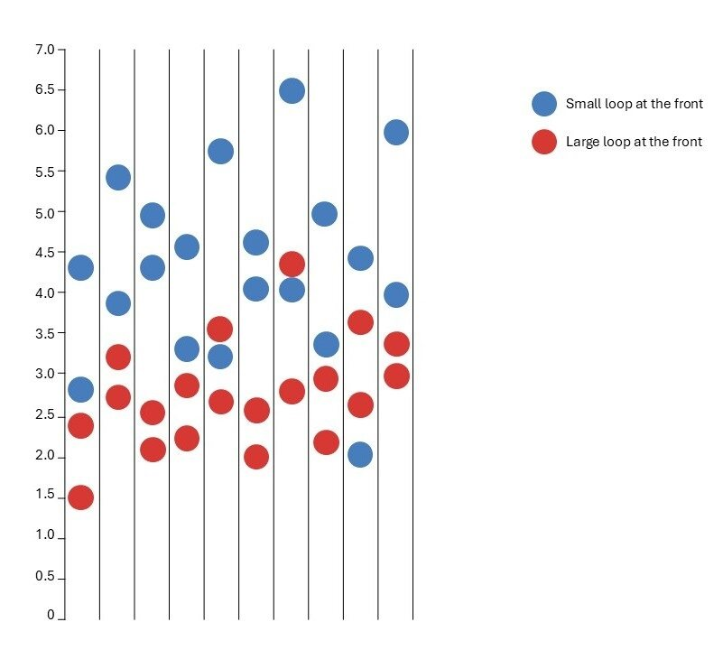

## Analyse | Which is best?

Discuss with the students what they notice about the data display. As students make claims or predictions, make sure they use evidence from the data to support their claims and predictions.

**Discuss:**

* *What do you notice from the data?*
  + Most of the planes with the small loop at the front went further than the large loop planes.
* *Can we say for certain that flying the plane with the small loop at the front will always go further than flying the plane with the large loop at the front?* 
  + It is likely that some throws with the large loop at the front went further than some throws with the small loop at the front. It is important that observations are expressed as likelihoods rather than certainties, such as “when the small loop is at the front the plane is **likely** to fly further”.
* *If I threw my loopy aeroplane with the small loop first, how far do you predict it will go? What if I threw it with the large loop first? How far do you predict it will go?*
  + Make sure students use evidence from the data to support their predictions. These questions can be answered using a precise measurement (e.g. 3.4m) or using a range (3-6m). Discuss with students that answering with a range allows a more reasonable prediction to capture the variability in flight distance.

## Analyse | Testing predictions

Revise the throwing and measuring protocols and return to an open space. Allow the students to test their predictions about how far their planes will fly with the different loops at the front of the plane. Take the time to converse with different groups of students, asking:

* *How far do you predict your plane will fly with the small/large loop at the front? What makes you say that?* 
  + As students collect more data, their predictions are likely to change. The greater volume of data may mean their predictions will become more accurate.
* *Do you predict that when the small loop is at the front your plane will always fly further?*
  + The data indicates that it is “likely” that the plane will fly further with the small loop at the front, however it is not certain. The use of conditional language is important.

Take a photo of the class dot plot for use in Lesson 7.

|  |
| --- |
| To read the most recent version of this lesson, download associated resources, and view embedded professional learning including classroom videos and work samples, visit: [https://resolve.edu.au/teaching-sequences/year-6/statistics-loopy-aeroplanes/lesson-4-small-or-large-first](https://resolve.edu.au/teaching-sequences/year-6/statistics-loopy-aeroplanes/lesson-4-small-or-large-first?utm_source=docx&utm_medium=lesson_4&utm_campaign=loopy_aeroplanes) |

|  |
| --- |
|  |

Lesson 5 • New loopy aeroplanes

**Lesson 5**

**(Y6)**

|  |
| --- |
| To read the most recent version of this lesson, download associated resources, and view embedded professional learning including classroom videos and work samples, visit: [https://resolve.edu.au/teaching-sequences/year-6/statistics-loopy-aeroplanes/lesson-5-new-loopy-aeroplanes](https://resolve.edu.au/teaching-sequences/year-6/statistics-loopy-aeroplanes/lesson-5-new-loopy-aeroplanes?utm_source=docx&utm_medium=lesson_5&utm_campaign=loopy_aeroplanes) |

# Lesson overview

Students identify ways to modify the design of a loopy aeroplane, and they make a plan to test these modifications.

## Learning goals

Introducing new variables into an investigation means that we need to collect more data.

## Resources

**Each group**

* Equipment to make loopy aeroplanes:
  + paper straws
  + coloured paper
  + scissors
  + tape
  + ruler

**Each student**

* **New loopy aeroplanes Student sheet**

|  |  |  |
| --- | --- | --- |
| Lesson phase | Estimated time | Lesson type |
| **Problem | Changing the design** | 15 minutes | Small group |
| **Plan | Making our own plane** | 35 minutes | Small group |

# Teach this lesson

## Problem | Changing the design

**Revise:** *We are investigating what is the best design for a loopy aeroplane. What have we learnt so far about different designs?*

Discuss with students what they have learnt so far in the investigation.

**Discuss:** *What are some other possible design modifications that we could investigate to determine what is “best”?*

Allow students to offer different ideas about how the loopy aeroplane could be modified. Some modifications might include:

* using a medium sized loop with a large or small loop.
* using two loops the same size—two small loops, two medium loops, or two large loops.
* changing the width of the loops to create wide loops, normal loops and narrow loops.
* adjusting the placement of the loops, for example one loop at the front and one loop half-way along the straw.
* using a different length straw.
* using different lighter or heavier paper/card to make the loops.

Discuss with students how testing all of these different modifications could require hundreds of experiments, and as a class agree on only two modifications to investigate. We use loop size and width as the two selected modifications in these lesson notes.

Explain to students that the class will focus on two modifications:

* The size of the loops—small, medium or large
* The width of the loops—narrow, normal, or wide loops

Explain to students that both loops on their planes will be the same this time. This allows students to ensure all designs can be tested by the class.

As a class work out the different plane designs that need to be made. A tree diagram is a helpful way to show all the different loops for planes that need to be tested.

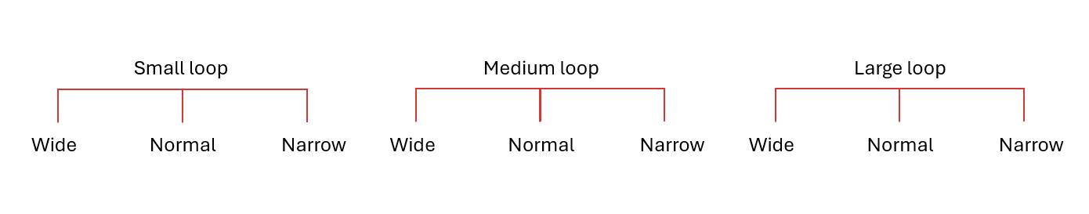

## Plan | Making our own plane

Revisit the class protocols for making planes on slide 11 of **Loopy aeroplanes PowerPoint**. You will need to add protocols for the new designs that you are testing. For example:

|  |  |
| --- | --- |
| **Length of card** | **Width of card** |
| Small loop – 15cm  Medium loop – 20cm  Large loop – 30cm | Narrow loop – 3cm  Normal loop – 5cm  Wide loop – 10cm |

Allocate each student a plane design to make and test. Ensure that each of the nine possible designs are being made by at least one student.

Provide students with **New loopy aeroplanes Student sheet**. Ask students to work in their small groups to plan their investigation. This sheet provides the following list of prompts to help groups plan their investigation:

* What planes will we make?
* What data do we need to collect?
* How will we record our data?

When they have developed their plan, provide the students with the necessary equipment and allow them time to make their new planes.

|  |
| --- |
| To read the most recent version of this lesson, download associated resources, and view embedded professional learning including classroom videos and work samples, visit: [https://resolve.edu.au/teaching-sequences/year-6/statistics-loopy-aeroplanes/lesson-5-new-loopy-aeroplanes](https://resolve.edu.au/teaching-sequences/year-6/statistics-loopy-aeroplanes/lesson-5-new-loopy-aeroplanes?utm_source=docx&utm_medium=lesson_5&utm_campaign=loopy_aeroplanes) |

|  |
| --- |
|  |

Lesson 6 • Testing again

**Lesson 6**

**(Y6)**

|  |
| --- |
| To read the most recent version of this lesson, download associated resources, and view embedded professional learning including classroom videos and work samples, visit: [https://resolve.edu.au/teaching-sequences/year-6/statistics-loopy-aeroplanes/lesson-6-testing-again](https://resolve.edu.au/teaching-sequences/year-6/statistics-loopy-aeroplanes/lesson-6-testing-again?utm_source=docx&utm_medium=lesson_6&utm_campaign=loopy_aeroplanes) |

# Lesson overview

Students collect data on their modified loopy aeroplane designs.

## Learning goals

We collect data to answer questions that we are investigating.

## Resources

**Whole class**

* **Loopy aeroplanes PowerPoint**

**Each group**

* Loopy aeroplane made the previous lesson
* Various tools used for measuring distance such as tape measures, metre rulers, and trundle wheels

|  |  |  |
| --- | --- | --- |
| Lesson phase | Estimated time | Lesson type |
| **Data | Collecting new data** | 50 minutes | Small group |

# Teach this lesson

## Data | Collecting new data

Remind students that they will be collecting data to determine the best aeroplane design in the class. Each student will need to collect the data from two throws of their aeroplane.

Use slide 11 of **Loopy aeroplane PowerPoint** to revise the throwing and measuring protocols established by the class.

Allow students time to collect their data according to the throwing and measuring protocols.

|  |
| --- |
|  |

Lesson 7 • What is the best design?

**Lesson 7**

**(Y6)**

|  |
| --- |
| To read the most recent version of this lesson, download associated resources, and view embedded professional learning including classroom videos and work samples, visit: [https://resolve.edu.au/teaching-sequences/year-6/statistics-loopy-aeroplanes/lesson-7-what-best-design](https://resolve.edu.au/teaching-sequences/year-6/statistics-loopy-aeroplanes/lesson-7-what-best-design?utm_source=docx&utm_medium=lesson_7&utm_campaign=loopy_aeroplanes) |

# Lesson overview

Students analyse data on the modified loopy aeroplanes to determine the best design.

## Learning goals

Data provides evidence to inform our answers to questions.

## Resources

**Whole class**

* **Loopy aeroplanes PowerPoint**

**Each student**

* Two sticky notes

|  |  |  |
| --- | --- | --- |
| Lesson phase | Estimated time | Lesson type |
| **Data | Representing new data** | 25 minutes | Whole class/Small group |
| **Analyse | Looking at the data on the best design** | 25 minutes | Small group |
| **Analyse | What is a good design?** | 10 minutes | Whole class |

# Teach this lesson

## Data | Representing new data

Discuss with the students some of their noticings flying the new planes. Some questions to help prompt the discussion include:

* *How did the size of the loops affect the flight?*
* *How did the width of the loops affect the flight?*

Provide each student with two sticky notes to record the distance of their two throws (one throw recorded on each note).

Create a new dot plot on the board (as shown below). We used the x-axis to indicate distance in metres and the y-axis to indicate the type of loops on the planes. Ask students to stick their sticky notes in the correct place.

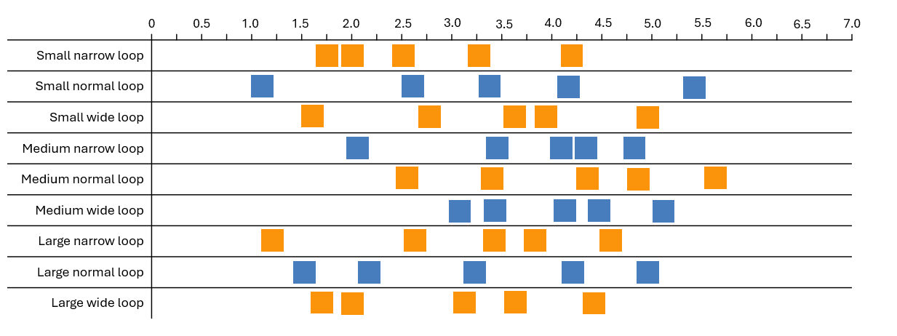

## Analyse | Looking at the data on the best design

Show students **Loopy aeroplanes PowerPoint** slide 20, which poses the following questions to guide students’ analysis of their data:

* If we went outside again now and flew our planes again, which one do you predict will fly the furthest? Why?
* Which plane is the most unpredictable? What makes you say that?
* How does the size of the loops impact the flight of a plane?
* How does the width of the loops impact the flight of a plane?
* Based on this data, what is the best design for a loopy aeroplane? Can you say this for certain?

Discuss with the students the answers to these questions.

### Noticing students’ thinking

* **Are students using evidence from the data to support their inferences and conclusions?**
  + Make sure the students provide evidence from the data as they answer each question. Ask questions like: *What evidence from the data makes you say that?*
* **Are students using probabilistic language as they answer questions?**
  + Ensure that students are using conditional and likelihood language where needed. For example, if you hear a comment like “*Planes with a small loop at the front go further*”, you might ask the question “*Will they always go further? How can you be certain?*”.

## Analyse | What is a good design?

Conduct a class discussion.

**Discuss:**

* *What did your group decide?*
  + It is likely that groups will have slightly different answers to the questions.
* *Why is there difference in our answers?*
  + Each group's answers will be unique to the planes that they tested and the data that they collected.
* *What evidence helped us decide?*
* *What are some general features of a “good” loopy aeroplane?*
  + Look across the analyses shared by each group and see if there are common features.

|  |
| --- |
| To read the most recent version of this lesson, download associated resources, and view embedded professional learning including classroom videos and work samples, visit: [https://resolve.edu.au/teaching-sequences/year-6/statistics-loopy-aeroplanes/lesson-7-what-best-design](https://resolve.edu.au/teaching-sequences/year-6/statistics-loopy-aeroplanes/lesson-7-what-best-design?utm_source=docx&utm_medium=lesson_7&utm_campaign=loopy_aeroplanes) |

|  |
| --- |
|  |

Lesson 8 • Fly-off

**Lesson 8**

**(Y6)**

|  |
| --- |
| To read the most recent version of this lesson, download associated resources, and view embedded professional learning including classroom videos and work samples, visit: [https://resolve.edu.au/teaching-sequences/year-6/statistics-loopy-aeroplanes/lesson-8-fly](https://resolve.edu.au/teaching-sequences/year-6/statistics-loopy-aeroplanes/lesson-8-fly?utm_source=docx&utm_medium=lesson_8&utm_campaign=loopy_aeroplanes) |

# Lesson overview

Students use the evidence gathered to design and build a loopy aeroplane for a class fly-off.

## Learning goals

Data provides evidence to inform our decisions.

## Resources

**Whole class**

* **Loopy aeroplanes PowerPoint**

**Each student**

* **Fly-off Student sheet**
* Equipment to make a loopy aeroplane – a paper straw, coloured paper, scissors, tape, and a ruler

|  |  |  |
| --- | --- | --- |
| Lesson phase | Estimated time | Lesson type |
| **Conclusion | Fly-off** | 50 minutes | Whole class/Individual |

# Teach this lesson

## Conclusion | Fly-off

Revise with students their conclusions from the investigation so far. Make sure they provide evidence from the data. For example, students may have observed from the data that:

* planes with a smaller loop at the front are likely to fly further.
* small- and medium-sized loops tend to work better than larger loops.
* normal and wide loops tend to be better than narrow loops.

Explain to the students that they will each get to make one last aeroplane. They need to use what they have learnt through the investigation to design and make a loopy aeroplane that they think will fly the furthest. The aeroplane that they make will be used in a class fly-off. Each person will be able to throw their plane twice, and the plane that goes the furthest will be judged the winner.

Provide students with the equipment and the time to make their final loopy aeroplane.

Hold a class fly-off to decide on the winner of the loopy aeroplane competition.