
LESSON 1

(Y9)

Lesson 1 • Bushfire behaviour
To read the most recent version of this lesson, download associated resources, and view embedded professional learning including classroom videos and work samples, visit: https:/resolve.edu.au/teaching-sequences/year-9/mathematical-modelling-playing-fire/lesson-1-bushfire-behaviour

Lesson overview
Students sort diagrams of fire simulations (non-typical data representations) to determine how temperature, humidity and wind influence fire behaviour.

Learning goals
Visually representing data helps us observe variation.
Varying one factor while keeping others constant allows us to observe the specific impact of that factor.

Resources
Whole class
- Playing with fire PowerPoint
- Optional video: Spark: A better way to predict the spread of bushfires (2:10)
Each group
- Playing with fire Bushfire cards

Lesson phase | Estimated time | Lesson type
Problem in context | Bushfires in Australia | 5 minutes | Whole class
Problem in context | Fire behaviour triangle | 10 minutes | Whole class
Problem in context | Fire simulations | 10 minutes | Small group
Problem in context | Making generalisation | 10 minutes | Small group

Teach this lesson

Problem in context | Bushfires in Australia
Use slides 4 and 5 of the Playing with fire PowerPoint to introduce the context of bushfires. Explain that Australia is one of the most bushfire-prone countries due to its hot, dry climate and flammable vegetation like eucalyptus. Note that bushfires have become more frequent and severe in recent years.
Explain that emergency services use models, including mathematical models, to predict how fires will spread, identify areas at risk, and decide when to evacuate. Emphasise that these models rely on understanding key factors that influence fire behaviour.
(Slide 6) Explain that in this investigation, students will act as emergency service experts. They will create and use mathematical models to predict the rate of fire spread and use this to decide when a town should evacuate. To do this, they will need to understand the key factors that influence fire behaviour.

Problem in context | Fire behaviour triangle
Ask: What factors do you think influence how a fire behaves?
Invite students to discuss in small groups, then share ideas with the class. Record responses on the board to create a class list and identify any common themes.
Show slide 7 of the Playing with fire PowerPoint, which introduces the fire behaviour triangle: weather, topography, and fuel. Prompt students to link their themes to this model.
Note: The fire behaviour triangle differs from the fire triangle (heat, fuel, and oxygen), which relates to combustion.
Explain to students that they will explore how weather and topography influence fire behaviour, beginning with weather. Over the course of this exploration, the fuel type, dry eucalypt forest, will stay constant.
Establish that temperature, humidity, and wind are the key weather factors on fire. Discuss how each might affect fire behaviour, especially the rate of spread. Don’t confirm answers at this point.

Problem in context | Fire simulations
Introduce Spark, a fire behaviour simulation tool developed by the CSIRO. Explain that Spark uses topographical and weather data, along with mathematical models, to simulate how a bushfire spreads over time. You may show the video Spark: A better way to predict the spread of bushfires (2:10) to introduce Spark and show how it is used in the field.
Show slide 8 of the Playing with Fire PowerPoint, which shows the output of two fires simulated using Spark. Point out the coloured rings, called isochrones, which show the fire’s perimeter at one-hour intervals and help visualise the fire’s speed and direction.
Discuss what students notice about the two fire simulations, such as differences in weather conditions and fire size.
(Slide 9) Highlight the weather factors involved. Discuss students’ predictions in response to:
- How might each factor influence fire behaviour?
- Which factor might have the greatest impact on the rate of spread?
Divide students into groups of 2-3. Provide each group with a full set of the nine Bushfire cards.
Pose the challenge: Organise your cards to show how different weather factors affect bushfire behaviour. How might you organise them using one category? How might you organise them using multiple categories?
Ask students, in their groups, to explore different ways of sorting the cards. Encourage them to consider how their chosen method of sorting highlights the influence of different weather factors on fire behaviour.
Questions to prompt student thinking
- What does a change in humidity affect?
  - Humidity influences the size of a fire.
- What does a change in temperature affect?
  - Compared to wind and humidity, temperature has relatively low influence on fire behaviour.
- What does a change in wind speed affect?
  - Wind influences the shape and rate of spread of a fire.
- How do these factors interact?
  - Humidity, air temperature and windspeed interact in different ways to influence bushfire behaviour.
Sorting the bushfire cards
Sorting the cards by a single weather factor
A set of three cards has been created for each weather factor, showing low, medium, and high conditions while the other two remain constant. This allows students to visually observe how changes in a single factor influence fire behaviour:
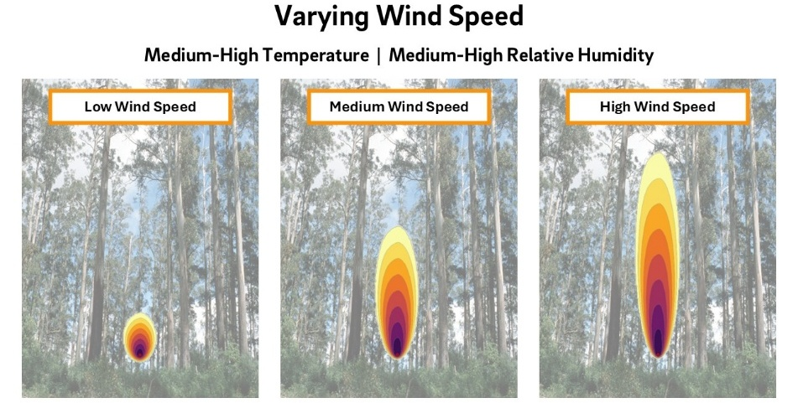
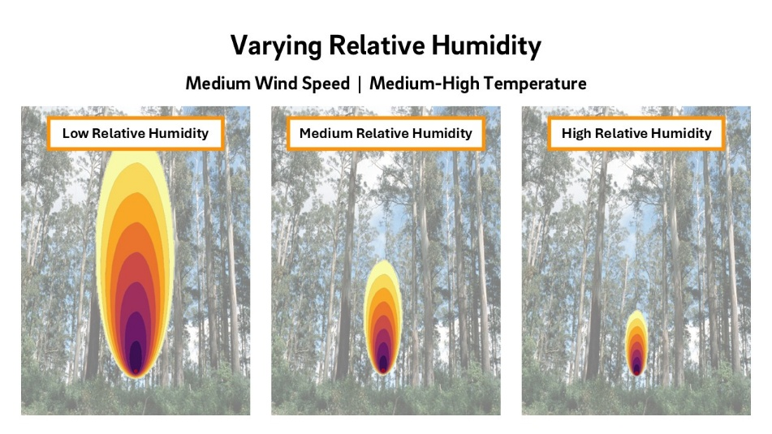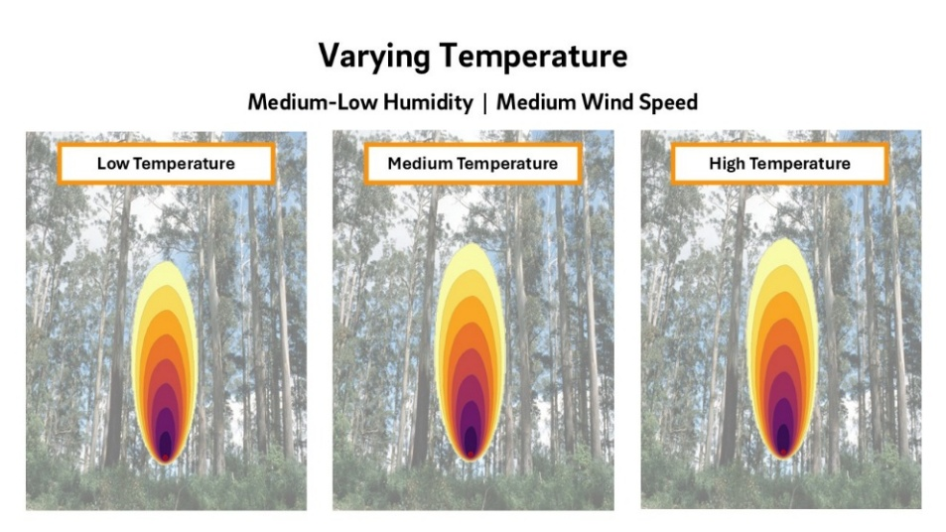
Sorting the cards by all three weather factors
The cards can also be sorted as a 3x3 grid, aligning the low, medium, and high conditions for each weather factor.
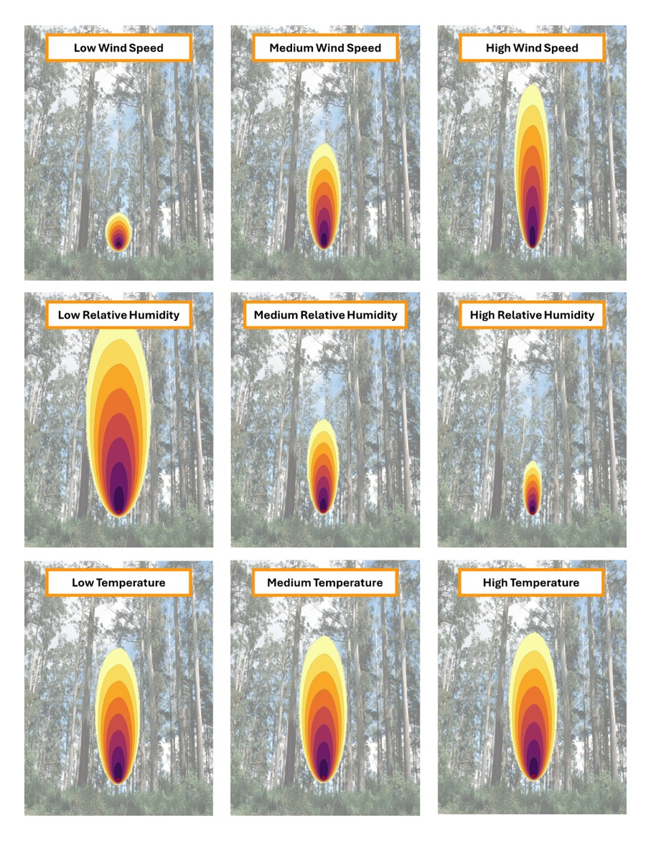
The card sort shows that humidity and wind significantly influence fire behaviour. In the humidity sequence, lower humidity results in the fire becoming both wider and longer. In the wind sequence, higher wind speeds cause the fire to extend further in length rather than width.

Problem in context | Making generalisation
Ask some students to share the way they sorted their cards, and the observations they were able to make based on their sorting.
Conduct a whole class discussion. Slides 10-13 may be used to support the discussion.
Discuss:
- How does humidity influence how a fire behaves? Why might this be?
  - Humidity has a big impact on the size of a bushfire.
  - Discuss that low humidity dries out vegetation, making fuels more flammable, while high humidity can slow fire behaviour by keeping fuels moist.
- How does temperature influence how a fire behaves? Why might this be?
  - Temperature has less impact on the size and spread of a fire than humidity and wind.
  - Heat dries out vegetation, making it easier to ignite and causing fires to spread more quickly.
- What impact might prolonged periods of low humidity and high temperature have on fire behaviour?
  - Extended periods of low humidity and high temperature dry out vegetation, making it more flammable. This increases the drought factor and leads to faster-spreading, more intense, and harder-to-control fires.
- How does wind influence how a fire behaves? Why might this be?
  - Wind makes fires spread faster and more unpredictably.
  - Wind supplies oxygen to the fire, pushes flames into new fuel, and can carry embers ahead of the fire, starting spot fires.
- What combination of factors to you think might lead to the most extreme and dangerous fire conditions? Why?
  - The most catastrophic fire conditions happen when high temperatures, low humidity, and strong winds occur together. These conditions make vegetation extremely dry, help fires ignite easily, and cause them to spread rapidly and unpredictably.
  - Slide 13 presents a simulation using high temperatures, low humidity, and strong winds.
Conclude by asking: Which weather factor has the greatest impact on how quickly a fire spreads and when a town might need to evacuate? Why might this be?
- Humidity and wind both strongly influence fire behaviour: lower humidity makes fires spread wider and longer, while higher wind speeds extend the fire’s length.
- Wind is unpredictable and can change quickly, pushing flames toward unburnt fuel, drying it out, and carrying embers ahead to start spot fires. This means that stronger winds make fires spread faster and less predictably.

LESSON 2

(Y9)

Lesson 2 • The influence of wind
To read the most recent version of this lesson, download associated resources, and view embedded professional learning including classroom videos and work samples, visit: https://resolve.edu.au/teaching-sequences/year-9/mathematical-modelling-playing-fire/lesson-2-influence-wind

Lesson overview
Students use data to generate a rule of thumb for estimating the impact of wind on fire behaviour.

Learning goals
In bivariate data, a trend line helps show the relationship between two variables and is useful for making predictions.
A rule of thumb is a practical estimate based on observed data rather than precise calculation.

Resources
Whole class
- Playing with fire PowerPoint
- Playing with fire Spreadsheet (Teacher)
Each group
- Playing with fire Spreadsheet (Student)
- Access to computers, at least 1 between 3 students

Lesson phase | Estimated time | Lesson type
Mathematical problem | Is there a relationship? | 5 minutes | Whole class
Mathematical problem | Fire data | 25 minutes | Small group
Mathematical problem | Looking at relationships | 10 minutes | Whole class

Teach this lesson

Mathematical problem | Is there a relationship?
Refer to slide 16 of Playing with fire PowerPoint and discuss the generalised statements constructed in the previous lesson. Show slide 17 to review that wind speed significantly influences the rate at which a fire spreads.
Pose the question: Is there a mathematical relationship between wind speed and the rate of spread of a fire?

Mathematical problem | Fire data
Divide students into pairs and provide each pair with access to a computer and the Playing with fire Spreadsheet (Student). Ask students to open the first sheet, Fire data. Explain that this sheet contains data collected by researchers on the observed rates of spread and other characteristics of selected bushfires in dry eucalypt forests in southern Australia from 1974-2003.
Briefly discuss the data that is provide, noting in particular the different units that are used.
Understanding the different variables in the spreadsheet
The spreadsheet data used in this activity is sourced from a research article by Cheney, Gould, McCaw, and Anderson (2012). Each fire is named according to the location of the fire. The date and time of the fire are also listed. The other variables in the table are listed and explained below:
- 10m wind speed (km/h): Weather stations typically measure the wind speed at a height of 10 metres above ground level, measured in kilometres per hour.
- Temperature (degrees Celsius): This is the average temperature for the time period listed.
- Relative humidity (%): The the amount of moisture in the air expressed as a percentage.
- Fuel moisture content (%): The measure of the amount of water present in fuel (e.g., vegetation) expressed as a percentage of the fuel's dry weight.
- Fuel age (years): The time that has elapsed since the last significant disturbance (e.g., fire, logging, or clearing) that removed or consumed the fuel sources (e.g., vegetation) in an area.
- Surface fire hazard score: A value given to indicate the potential for a fire to spread along the ground's surface, driven by weather conditions and fuel availability.
- Observed rate of spread (m/h): The actual rate of spread of the fire as observed in the field. This has been measured in metres per hour.

Explain to students that they will need to identify the relevant data from the table, then organise and represent this data to investigate whether there is a mathematical relationship between wind speed and the rate of fire spread.
Allow students time to conduct the investigation.
Finding a relationship between rate of spread and windspeed
For this investigation, students only need the wind speed and rate of fire spread data. Wind speed is measured in kilometres per hour (km/h) and the rate of spread in metres per hour (m/h). Students may convert one measure to match the other before graphing; if not, their graphs will have the same shape but different axis units. This naturally leads to a discussion on the need to compare like units when expressing the relationship as a rule of thumb.
One way to represent the data is to convert the rate of fire spread to kilometres per hour and then graph it against the 10m wind speed for fires in dry eucalypt forests. A trend line suggests that the forward rate of spread of an established fire is approximately 10% of the average 10 m open wind speed for dry Eucalypt Forests. This rule of thumb is commonly used in the field to support decision-making in time-critical situations.
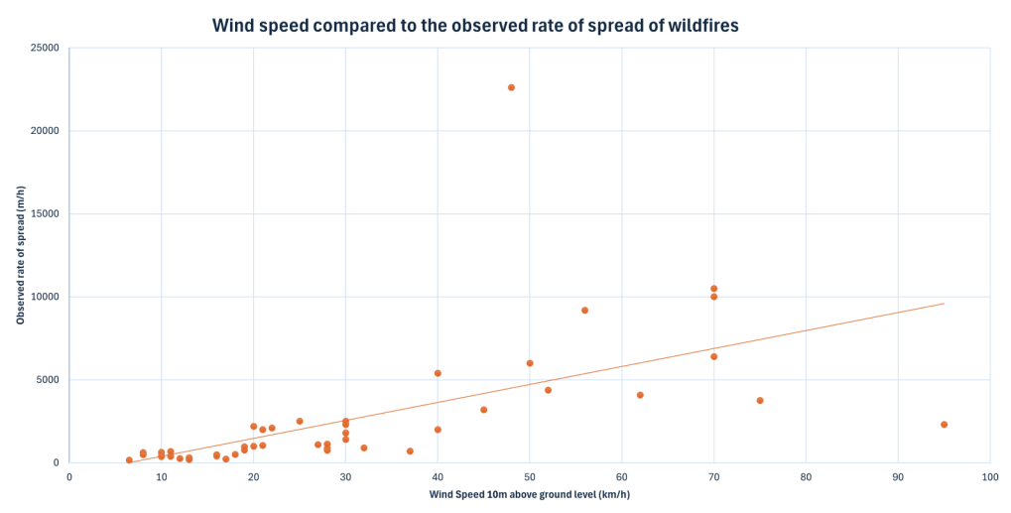
Further information on the rule of thumb is available from the CSIRO’s PyroPage:
- A rule of thumb for estimating a bushfire’s rate of forward spread using just the speed of the wind
- Evaluating the 10% wind speed rule of thumb for estimating a wildfire’s forward spread rate

Mathematical problem | Looking at relationships
Select several groups to share their data representations and describe the relationship they observe between wind speed and the forward rate of fire spread. If students have not used a trendline, show how this can be added to approximate the relationship between wind speed and the rate of spread.
The Fire data sheet in the Playing with fire Spreadsheet (Teacher) contains a completed data representation for reference, which is also shown on slide 18 of the Playing with fire PowerPoint. This example uses a linear trendline to approximate the relationship between wind speed and the rate of spread. These resources may be helpful in guiding the class discussion.
Discuss:
- If the wind speed was 60km/h, what is the approximate forward rate of spread of a fire? What if the wind speed was 25km/h? What about 100km/h?
- If the forward rate of spread of a fire was approximately 5km/h, what do you predict the wind speed to be? Why?
  - Students can use the trendline to approximate the forward rate of spread of a fire.
  - These questions help to highlight that the forward rate of spread of a fire is close to 10% of the wind speed. Don't point to this as yet; allow students to create this general statement for themselves.
To conclude, pose the questions:
- What general statement describes the mathematical relationship between wind speed and the forward rate of spread of a fire?
  - Establish that the forward rate of spread of an established fire in dry eucalypt forests is approximately 10% of the average 10 m open wind speed.
  - Explain to students that this approximation is referred to as a rule of thumb.
- How accurate is this rule of thumb?
  - The forward rate of spread for most fires in this dataset is slightly lower than the estimate, which is useful because it is safer to err on the side of caution when making evacuation decisions.
  - Discuss the outliers, particularly those fires that spread far more rapidly than the rule of thumb would predict.

LESSON 3

(Y9)

Lesson 3 • Rate of spread estimates
To read the most recent version of this lesson, download associated resources, and view embedded professional learning including classroom videos and work samples, visit: https://resolve.edu.au/teaching-sequences/year-9/mathematical-modelling-playing-fire/lesson-3-rate-spread-estimates

Lesson overview
Students compare the rate of spread values generated using a rule of thumb with those produced by a formal mathematical model.

Learning goals
A rule of thumb is a quick and simple way to make an estimate; however, a mathematical model provides greater precision.

Resources
Whole class
- Playing with fire PowerPoint
- Playing with fire Spreadsheet (Teacher)
Each group
- Playing with fire Spreadsheet (Student)
- Access to computer, at least 1 between 3 students

Lesson phase | Estimated time | Lesson type
Mathematical result | Using wind to predict rate of spread | 10 minutes | Whole class/Small group
Results in context | Comparing results | 10 minutes | Whole class
Mathematical result | Which is more accurate? | 20 minutes | Small group/Individual
Mathematical result | Reflecting on results | 5 minutes | Whole class

Teach this lesson

Mathematical result | Using wind to predict rate of spread
Show students slide 21 of Playing with Fire PowerPoint to review the previous lesson. Discuss how wind speed influences the rate of fire spread and explain how we can estimate the forward rate of spread using a rule of thumb based on this relationship.
Provide students with computer access and the Playing with fire Spreadsheet (Student). Ask students to open the second sheet titled Wind estimates, which contains the same table they used in the previous lesson. Ask students to, in the relevant column, create a formula based on the rule of thumb that the forward rate of fire spread is 10% of the wind speed measured at 10 m above ground level.
Using Excel to calculate using the rule of thumb
The sheet titled Wind estimates in the Playing with fire Spreadsheet (Teacher) is completed for reference.
To calculate the rate of spread based on the rule of thumb, we can use the following formula:
$$Wind speed×0.1×1000$$
This formula multiplies the wind speed by 0.1 to apply the rule of thumb, and then multiplies the result by 1000 to convert from kilometres per hour to metres per hour.
To use this formula in the spreadsheet, enter the following formula into cell L4, the first cell in the Rule of thumb column. The table is set up so that entering the formula in the top cell will automatically populate the rest of the column.
=0.1 * E4 * 1000
Where E4 = 10m wind speed (km/h)
This provides a good opportunity for discussion with students about simplifying formulas. Since 0.1×1000 is equal to 100, the formula can be simplified to:
=100 * E4
Both versions produce the same result. Exploring this equivalence can help reinforce students’ understanding the commutative property of multiplication.

Results in context | Comparing results
Ask: Compare the predicted rate of spread to the observed forward rate of spread. How accurate are our predictions when using the rule of thumb? Students can compare values visually, or they can add an extra column to their sheet and use a formula to calculate the difference between the observed and predicted rates of spread.
Invite students to share their observations and prompt them to use data to justify their claims.
Ask students to use the other data in the table to explain why some fires may be considered outliers. Encourage them to identify which fires are outliers and factors that could account for unusually fast rates of spread. For example:
- fires that spread more rapidly often occurred under conditions of higher temperatures, lower humidity, low fuel moisture content, and high fuel age.
- the rule of thumb only accounts for the influence of wind. Topography and fuel have not been considered.

Mathematical result | Which is more accurate?
Explain to students that more complex mathematical equations have been developed to estimate the rate of fire spread. These equations take environmental variables such as temperature, wind speed, relative humidity, and fuel conditions, and convert them into an estimated rate of spread.

Show slide 22 of Playing with Fire PowerPoint, which contains the following formula:
$$Rate of spread= \frac{2.518 ×wind speed}{60-temperature+humidity}$$
Explain that this equation models how environmental conditions influence the forward rate of fire spread, offering a more precise alternative to the rule of thumb. It is typically used by fire managers to calculate the rate of spread for bushfires. Discuss how the equation is similar to and different from the rule of thumb.
Ask students to write a formula based on this equation in the appropriate spreadsheet column to calculate the rate of fire spread. Then, have them compare the results produced by their formula with those obtained using the rule of thumb and the actual observed rates of spread.
About this formula
This formula was shared with us by Professor Jason Sharples (University of New South Wales, Canberra) and is also included in the Mathematics of Bushfires Year 9 classroom resources authored by Professor Sharples and published by the University of Melbourne. These resources complement and can be used alongside this learning sequence.

Using Excel to calculate using the mathematical model
The sheet titled Wind estimates in the Playing with fire Excel workbook (Teacher) is completed for reference.
To calculate the rate of spread using the mathematical model, enter the following formula into cell M4, the first cell in the Rate of spread based on formula (m/h) column:
=ROUND(2.518 * (E4 * 1000) / (60 - F4 + G4), 0)
Where:
- E4 = Wind speed at 10 m (km/h)
- F4 = Temperature (°C)
- G4 = Relative humidity (%)
This formula:
- multiplies the wind speed by 1000 to convert from kilometres per hour to metres per hour.
- applies the given equation.
- rounds the result to the nearest whole number using ROUND(…, 0).
The table is set up so that entering the formula in the top cell automatically fills the entire column.

Mathematical result | Reflecting on results
Discuss:
- What do you notice about the estimates using the equation and those using the rule of thumb? How do these results compare to the actual observed rate of spread?
  - The estimates using the formula are typically closer to the observed rate of spread.
- What might account for some of the difference between the predicted and actual values?
  - The calculations take into consideration weather factors and fuel (dry eucalypt forest). The calculations do not take into consideration topography, which is the third aspect of the fire behaviour triangle (shown on slide 23 of Playing with fire PowerPoint as a reminder).
- If we have a proper formula that's close to the observed rate of spread, what's the point of having a rule of thumb?
  - The rule of thumb is simple and quick to use in emergency situations where there is no time or technology available to apply the full mathematical model. It provides a rough estimate that can guide initial decisions before more precise data or calculations are available.
- When might the rule of thumb be 'close enough'?
The rule of thumb may be adequate when conditions are relatively stable (e.g., flat terrain, typical dry fuel conditions) and decisions need to be made rapidly. It can also be useful when high precision is not critical, such as in training scenarios or when confirming trends predicted by other models.

LESSON 4

(Y9)

Lesson 4 • The influence of topography
To read the most recent version of this lesson, download associated resources, and view embedded professional learning including classroom videos and work samples, visit: https://resolve.edu.au/teaching-sequences/year-9/mathematical-modelling-playing-fire/lesson-4-influence-topography

Lesson overview
Students use data to generate a rule of thumb estimating the impact of topography on fire behaviour.

Learning goals
A rule of thumb is a practical estimate based on observed data rather than precise calculation.
Repeated doubling of a fire’s speed leads to exponential growth rather than a simple linear increase, greatly amplifying outcomes such as impact and spread.

Resources
Whole class
- Playing with fire PowerPoint
- Playing with fire Spreadsheet (Teacher)
Each student
- Playing with fire Spreadsheet (Student)
- Access to computer, at least 1 between 3 students

Lesson phase | Estimated time | Lesson type
Mathematical result | Faster or slower? | 5 minutes | Whole class
Results in context | Looking at data | 10 minutes | Small group/Individual
Results in context | 10 degrees incline | 5 minutes | Whole class
Results in context | Comparing results | 20 minutes | Small group
Results in context | Reflecting on results | 5 minutes | Whole class

Teach this lesson

Mathematical result | Faster or slower?
Show students slide 26 of Playing with fire PowerPoint to review the fire behaviour triangle. Remind students that they are investigating the influence of weather and topography (variables) on fire in dry eucalypt forests (constant).
Show slide 27 and explain that it presents the weather conditions for three separate Spark fire simulations. For each simulation (Fire 1, Fire 2, and Fire 3), the fire was modelled on flat ground (0°), then on downward slopes (-5°, -10°, -15°, -20°), and finally on upward slopes (5°, 10°, 15°, 20°).
Discuss:
- Do you think fire would go faster, slower, or about the same speed when it is moving uphill? Why?
- If you predict the rate of spread will be faster or slower, by how much do you think it will change? What makes you think that?
- What might happen when the fire is moving downhill? Why?
- Do you think different weather conditions could further affect the rate of fire spread on slopes? Why or why not?
Allow students to share and discuss their thinking, without confirming whether their ideas are correct. These questions are the focus of investigation.
Remind me—What is Spark?
Spark is a wildfire simulation toolkit designed by the CSIRO. It simulates bushfires using topographical and weather data in conjunction with a range of mathematical models. Spark is designed to be used by bushfire researchers and also for emergency management agencies across Australia.
Spark uses a variety of mathematical models based on the latest research and fire conditions. Mathematical models for Spark are constantly being updated and redesigned. For example, Spark comes packaged with three different models for calculating the rate of spread of a bushfire, based on whether the environment is grassland, urban, or dry eucalypt forest.

Results in context | Looking at data
Provide students with computer access and the Playing with fire Spreadsheet (Student). Ask students to open the third sheet, Topography data. This sheet displays data from the three Spark simulations, showing how the rate of spread changes with varying slope.
Show students slide 28 of Playing with fire PowerPoint. Ask students to discuss the questions by first looking at the numbers in the tables.
Next ask students to represent the data to show the relationship between the slope and the rate of spread of each fire. Allow students time to revise their answers to the questions on slide 28 if needed. The sheet Topography data in the Playing with fire Spreadsheet (Teacher) has a completed representation for reference.

Results in context | 10 degrees incline
Discuss:
- Does a fire spread faster, slower, or at about the same speed when moving uphill/downhill? By how much does the speed change on an upward/downhill slope?
  - The speed of a fire tends to double for every 10 degrees of uphill slope.
  - Fires spread more slowly downhill, however, the decrease in speed is small. For every 10 degrees of downhill slope, a fire can decrease in speed by approximately 20%.
- Do different weather conditions further affect the rate of fire spread on slopes?
  - While weather conditions such as wind, temperature, and humidity strongly influence fire spread more broadly, their effect on the relative rate of spread on slope is minimal. The doubling rule remains consistent across different weather conditions.
- Is it possible to develop a rule of thumb for how slope affects a fire’s rate of spread?
  - Show slide 29 of Playing with fire PowerPoint. Establish the rule of thumb that the speed of a fire doubles for every 10 degrees of uphill slope.
- How does the shape of this graph compare to the shape of the graph for the first rule of thumb? Why are the two graphs different?
  - Show slide 30 of Playing with fire PowerPoint. The first graph suggested a linear relationship between wind speed and the observed rate of spread. The curve in the second graph indicates an exponential relationship between slope and rate of spread, as the rate doubles for every 10° of uphill slope but changes more gradually on downward slopes.

Results in context | Comparing results
Show slide 31 of Playing with fire PowerPoint, which shows the following equations:
$$Rate of spread \left(upward slope\right)=R_{0}×2^{\left(0.1×slope angle\right)}$$
$$Rate of spread \left(downward slope\right)=\frac{R_{0}×2^{\left(0.1×slope angle\right)}}{2^{0.1×(slope angle+10)}-1}$$
Explain that these equations are used by fire managers to calculate the rate of spread on upward and downward slopes for forest fires. Discuss how the equations are similar to and different from the rule of thumb.
About these formulae
These formulae were shared with us by Professor Jason Sharples (University of New South Wales, Canberra). They are also included in the Mathematics of Bushfires Year 9 classroom resources, authored by Professor Sharples and published by the University of Melbourne. These resources complement and can be used alongside this learning sequence.

Ask the students to open the sheet Topography estimates in the Playing with fire Spreadsheet (Student). Ask them to use Excel to calculate the rate of spread of fire using the rule of thumb and using the formula. For downward slopes, students can use the approximation that fires decrease in speed by 20% for each 10 degrees decline.
Using Excel to calculate using the rule of thumb and the mathematical equations
The sheet titled Topography estimates in the Playing with fire Spreadsheet (Teacher) is completed for reference.
This spreadsheet is more complex because the rate of change is not constant. Two different formulas are required—one to model fire spread on an upward slope, and another for a downward slope.
Rule of thumb
To calculate the forward rate of spread using the rule of thumb, we will be using the following formula:
$$Rate of spread \left(upward slope\right)=Rate of spread on flat ground×2^{\left(incline×0.1\right)}$$
$$Rate of spread \left(downward slope\right)=Rate of spread on flat ground×{0.8}^{(incline×0.1)}$$
To apply these formula in the spreadsheet, we can use the following formula:
=ROUND(IF(G5 >= 0, H9 * 2^(G5 / 10), H9 * (0.8)^(-G5 / 10)), 0)
Where:
- G5 = Slope in degrees
- H9 = Rate of spread on flat ground (0° slope).
  - Note: A different H cell number will be needed for each fire. In the spreadsheet provided, H9 is the rate of spread on flat ground for Fire 1, H18 is Fire 2, and H27 is for Fire 3.
This formula:
- applies different formula depending on whether the slope is upward or downward.
  - For upward slopes (G5 ≥ 0): The formula H9 * 2^(G5 / 10) models the rate of spread doubling for every 10° of incline.
  - For downward slopes (G5 < 0): The formula H9 * (0.8)^(-G5 / 10) models the rate of spread slowing by 20% for every 10° of decline.
- uses ROUND(…, 0) to round the result to the nearest whole number.

Mathematical model
To calculate the forward rate of spread using the mathematical model, we will be using the following formula:
$$Rate of spread \left(upward slope\right)=R_{0}×2^{\left(0.1×slope angle\right)}$$
$$Rate of spread \left(downward slope\right)=\frac{R_{0}×2^{\left(0.1×slope angle\right)}}{2^{0.1×(slope angle+10)}-1}$$

To apply these formula in the spreadsheet, we can use the following formula:
=ROUND(IF(G5 >= 0, H9 * 2^(0.1 * G5), H9 * 2^(0.1 * -G5) / (2^(0.1 * (-G5 + 10)) - 1)), 0)
Where:
- G5 = Slope in degrees
- H9 = Rate of spread on flat ground (0° slope)
  - Note: A different H cell number will be needed for each fire. In the spreadsheet provided, H9 is the rate of spread on flat ground for Fire 1, H18 is Fire 2, and H27 is for Fire 3.
This formula:
- applies different formula for upward and downward slopes.
  - For upward slopes (G5 ≥ 0): The formula H9 * 2^(0.1 * G5) models exponential growth, with the rate doubling approximately every 10° of incline.
  - For downward slopes (G5 < 0): The formula H9 * 2^(0.1 * -G5) / (2^(0.1 * (-G5 + 10)) - 1) slows the rate of spread more gradually, reflecting a decreasing but non-linear relationship as slope declines.
- uses ROUND(…, 0) to round the result to the nearest whole number.

Results in context | Reflecting on results
Discuss:
- What do you notice about the estimates using the equations and the observed rate of spread of fires?
  - The results produced by the formula are the same as, or very close to, the observed rates of spread. This is because the simulations themselves are based on these underlying formulas.
- What do you notice about the approximations using the approximation that fire decreases by about 20% for each 10 degrees decline?
  - The approximation that fire speed decreases by 20% for every 10° decline shows a noticeable discrepancy, indicating that it is not accurate.
- What do you notice about the approximations using the rule of thumb? Why might this be the case?
  - For uphill slopes, the rule of thumb approximations are the same as the results produced by the formula, because they are (essentially) the same equation. Students can prove this by replacing the "slope angle" value with 10° and simplifying the equation.

- Comparing our two rules of thumb, which would you feel more confident using?
  - Both rules of thumb are useful depending on the context they are used.
  - While this rule of thumb appears more accurate than the rule of thumb regarding wind speed, it is important to note that the observed rate of spread is from fire simulations based on mathematical models, not actual fires. Real fires are very unpredictable.

LESSON 5

(Y9)

Lesson 5 • Evacuate!
To read the most recent version of this lesson, download associated resources, and view embedded professional learning including classroom videos and work samples, visit: https://resolve.edu.au/teaching-sequences/year-9/mathematical-modelling-playing-fire/lesson-5-evacuate

Lesson overview
Students apply their learnings to determine when two small towns should evacuate in response to an approaching fire.

Learning goals
Mathematical models help us make informed decisions by providing useful estimates and predictions. There are also practical factors that influence our decisions and must be considered alongside the mathematics.

Resources
Whole class
- Playing with fire PowerPoint
- Playing with fire Spreadsheet (Teacher)
Each group
- Playing with fire Excel notebook (Student)
- Access to computers, at least 1 between 3 students

Lesson phase | Estimated time | Lesson type
Results in context | Two towns | 5 minutes | Small group
Results in context | When should we evacuate? | 30 minutes | Small group
Results in context | Time to evacuate | 10 minutes | Whole class

Teach this lesson

Results in context | Two towns
Teacher note: While written as a single lesson, this activity could be delivered over two sessions. In the first, students determine when towns should evacuate; in the second, they present their findings to the class.
Explain to students that in this lesson they will take on the role of emergency services experts responsible for deciding when to evacuate. In the scenarios provided, bushfires start 20 km away from the towns. Students must determine when an evacuation should be announced (how long after the fire starts). Emphasise that the townspeople are reluctant to leave their homes and will only evacuate when they feel there is no other option, so immediate evacuation is not possible.
To make their decision, students need to draw on the rules of thumb and/or the mathematical equations they have learned throughout the sequence.
Each group will present their findings to the class, and in their presentation, they must justify both the methods they used (rules of thumb and/or equations) and the timing of their evacuation decision. Their reasoning should reflect an understanding of fire behaviour and the impact of environmental conditions on the rate of spread.
Show students slides 34-35 of Playing with fire PowerPoint which presents the two town scenarios:
- Town 1: On flat ground surrounded by dry eucalypt forest.
- Town 2: On top of a hill surrounded by dry eucalypt forest.

Results in context | When should we evacuate?
Allow students to work in their groups to determine when each town should evacuate. Students should also have access to the Playing with fire Spreadsheet (Student) if they believe it will be useful.
As they work, prompt students to consider additional factors that could influence their decision, such as:
- The uncertainty in estimating the rate of spread, due to the complex and often unpredictable nature of fire behaviour.
- The time needed for a safe evacuation, including possible delays, traffic congestion, and the importance of issuing early warnings.
Remind students that leaving immediately is not an option because the townspeople are reluctant to abandon their homes until they feel they have no other choice.
Encourage students to weigh these factors alongside their calculations to make well-reasoned, realistic recommendations.

Results in context | Time to evacuate
Invite each group to present their decision on how long after a fire starts should an evacuation be announced. Ask them to justify their decisions using their calculations and reasoning.
As a class, compare the different solutions and discuss the justifications each group provided. Highlight the similarities and differences in their approaches and explore how uncertainty and safety considerations influenced their decisions.
Conduct a final discussion to evaluate whether the rules of thumb and the equations offer adequate and sensible solutions for determining when a town should evacuate. Consider the contexts in which rules of thumb may be appropriately applied and those where the use of equations would be more important.

