
LESSON 1

(Y8)

Lesson 1 • Comparing footprints
To read the most recent version of this lesson, download associated resources, and view embedded professional learning including classroom videos and work samples, visit: https://resolve.edu.au/teaching-sequences/year-8/mathematical-modelling-screentime-footprint/lesson-1-comparing-footprints

Lesson overview
Students calculate rates to interpret CO₂ emission data by country and consider the extent to which Australia generates CO₂ emissions.

Learning goals
Single measurements may not give a complete picture about an issue.
Rates compare two different measurements in different units.

Resources
Whole class
- Screentime footprint PowerPoint
- Optional: Screentime footprint data Spreadsheet
Each student
- Comparing footprints Student sheet

Lesson phase | Estimated time | Lesson type
Problem in context  | CO₂ emissions by country | 10 minutes | Whole class
Mathematical problem and result | CO₂ emissions per person | 20 minutes | Individual
Results in context | Comparing countries | 20 minutes | Whole class/Small group

Teach this lesson
Problem in context | CO₂ emissions by country
Show students slide 6 of Screentime footprint PowerPoint. Explain that the graph displays the results of a 2025 report investigating CO₂ emissions per country.
Discuss:
- What do you notice?
  - Of these 12 countries, China is producing the most CO₂ emissions while Australia is producing the least.
  - CO₂ emissions are measured by weight (tonnes).
- What factors do you think drive emissions rates across different countries?
  - Suggestions might include the country’s size, population or wealth.
- How do you think these countries have been selected? Which are here? Which are missing?
  - Countries with the largest population and possibly with the largest CO₂ emissions have been included.
Show slide 7, which includes a second graph of the same countries in the same order, this time showing their populations.
Discuss:
- What relationships do you notice between CO₂ emissions and population?
  - Countries with higher populations seem to produce more total CO₂ emissions, however, India (largest population) and Indonesia (4th largest) do not appear to fit the trend.
- Which country would you expect to have the highest CO₂ emissions per person? Justify your answer.
  - Allow students to offer their own predictions, challenging them to justify their answer using evidence from the displays.

Data sources and updating the PowerPoint graphs
The data presented in the two graphs on the PowerPoint slides is from 2024. You can update the data using the Excel document Screentime footprint data Spreadsheet. Enter the updated data into the table/s and the graph/s in the spreadsheet will automatically update. The new graphs can be copied and pasted into the PowerPoint.
- The Emissions Database for Global Atmospheric Research website provides data on CO₂ emissions for countries around the world. Simply search for each country or hover your mouse over the map. The numbers provided are in kilotonnes and need to be divided by 100 000 to align with the scale used in the PowerPoint graph.
- The United Nations Data Portal website provides data on populations of countries around the world. Search for each country and enter the population estimate.
References
Emissions Database for Global Atmospheric Research. (n.d.). EDGAR. https://edgar.jrc.ec.europa.eu/
United Nations Department of Economic and Social Affairs, Population Division. (n.d.). World Population Prospects. https://population.un.org/wpp/

Mathematical problem and result | CO₂ emissions per person
Using slide 7 of Screentime footprint PowerPoint, select any country as an example and ask students to calculate CO₂ emissions per person, in kg, for a country from the given data.

Using the graphs to calculate CO₂ emissions
The graphs used on this slide have an unusual scale as both CO₂ emissions and population are displayed in hundreds of millions ('00 000 000). These scales have been used so that the values shown are manageable numbers. Care must be taken to apply the scaling to find the underlying values for CO₂ emissions and population.
Selecting Japan as an example, we can see that the CO₂ emissions are recorded as 9.7 and that the units used are 100 000 000 tonnes.
This means that Japan’s CO₂ emissions are 9.7×100 000 000=970 000 000 tonnes.
As 1 tonne=1000 kilograms, Japan’s CO₂ emissions per year are 970 000 000×1000=970 000 000 000 kg.
From the second graph, we can see that Japan’s total population is recorded as 1.24 and that the units used are 100 000 000 people.
This means that Japan’s population is 1.24×100 000 000=124 000 000 people.
Calculating a rate of CO₂ emissions per person
The annual rate of CO₂ emissions per person for a country equals the total emissions per year divided by the population of the country.
For example, based on the given data, the rate of annual CO₂ emissions per person in Japan is:
970 000 000 000kg÷124 000 000 people ≃ 7823kg per person.
For each person in Japan, 7823kg/year of CO₂ is produced.

Provide students with Comparing footprints Student sheet. Explain that the total CO₂ emissions and total populations from the graphs have been recorded in the table.
Ask students to complete the table, calculating the CO₂ rate per person for each country.

CO₂ rate per person for each country
Country | CO₂ emissions per year (kg) | Population | Rate (kg/person)
China | 13 120 000 000 000 | 1 420 000 000 | 9 239
United States | 4 630 000 000 000 | 345 000 000 | 13 420
India | 3 150 000 000 000 | 1 450 000 000 | 2 172
Russia | 2 000 000 000 000 | 144 000 000 | 13 889
Japan | 970 000 000 000 | 124 000 000 | 7 823
Iran | 830 000 000 000 | 92 000 000 | 9 022
Indonesia | 810 000 000 000 | 283 000 000 | 2 862
Saudi Arabia | 650 000 000 000 | 34 000 000 | 19 118
South Korea | 590 000 000 000 | 52 000 000 | 11 346
Germany | 580 000 000 000 | 85 000 000 | 6 824
Canada | 580 000 000 000 | 40 000 000 | 14 500
Australia | 380 000 000 000 | 27 000 000 | 14 074

Results in context | Comparing countries
Explain that we would like to know how Australia compares with other countries in the world in terms of CO₂ emissions.
Ask students to work in small groups to order the countries by CO₂ emissions per person, then identify a measure that describes how Australia compares with other countries. Examples might include:
- finding percentages that illustrate how much higher/lower CO₂ emissions per person are in Australia versus other countries.
- preparing calculations such as “what would Australia’s CO₂ emissions be if it had the same population as China?”.
To close the lesson, conduct a class discussion.
Discuss:
- Which comparative measure do you think is the most useful? Which was the easiest to understand?
  - Have students justify why particular measures were more useful or easier to understand.
- Are there any surprises from the calculations you have made?
  - Countries with higher populations like India and Indonesia have significantly lower rates of CO₂ emissions per person, while some countries with lower populations, including Australia, have much higher rates of CO₂ emissions per person.
- Where does Australia rank compared to the other 11 countries in this dataset?
  - Australia ranks third behind Saudi Arabia and Canada, with almost double the emissions per person of China.
- If Australia had the same population as China, what would happen?
  - Australia would then potentially produce close to double the CO₂ emissions produced by China.
- What does this mean for Australians? What do we need to do?
  - While this data is concerning, be aware that these are simplistic measures. A country’s CO₂ emissions cannot be solely attributed to the size of their population or their lifestyles. Countries may produce exports largely used by foreign countries, such as fossil fuels, contributing significantly to CO₂ emissions but not directly related to the country’s population, which could skew the data.
  - However, this data does indicate that Australia is a significant CO₂ emitter and that lifestyle and policy changes in areas such electricity use, transport and renewable energy could help reduce our carbon footprint.

LESSON 2

(Y8)

Lesson 2 • Looking to the future
To read the most recent version of this lesson, download associated resources, and view embedded professional learning including classroom videos and work samples, visit: https://resolve.edu.au/teaching-sequences/year-8/mathematical-modelling-screentime-footprint/lesson-2-looking-future

Lesson overview
Students develop a linear model to predict the future digital download behaviour of individuals and calculate the impact on CO₂ emissions.

Learning goals
Linear models can be used to predict future outcomes.
Mathematical models will always have limitations when used practically.

Resources
Whole class
- Screentime footprint PowerPoint
Each group
- Access to a computer or tablet and the Desmos interactive tool Digital download trends

Lesson phase | Estimated time | Lesson type
Problem in context | Downloaded data as CO₂ emissions | 10 minutes | Whole class/Individual
Mathematical problem and result | Where is Australia headed? | 10 minutes | Whole class/Individual
Mathematical problem and result | Predicting with greater accuracy | 15 minutes | Small group
Mathematical result | Why are our answers different? | 10 minutes | Whole class
Results in context | Future implications | 15 minutes | Small group

Teach this lesson

Problem in context | Downloaded data as CO₂ emissions
Show students slide 10 of Screentime footprint PowerPoint displaying the rate of CO₂ emissions produced per gigabyte of data downloaded for video streaming. Explain that this value is an estimate only, as real-world emissions vary depending on factors such as the type of network connection and the efficiency of the data centres involved.

Determining CO₂ emissions for 1 GB of data
There is no single value for the CO₂ emissions produced from downloading 1 GB of data. Different studies use different assumptions about network efficiency, data-centre operations, and the carbon intensity of electricity.
Two useful sources:
- Sphera (2022) estimates about 11 g CO₂ per GB, based on measured energy use in data centres and networks combined with an average global grid emission factor.
- Sustainable Web Design (2023) – Models 0.07–0.12 kWh per GB using data-centre PUE and network energy use. With an average grid factor, this equates to 35–60 g CO₂ per GB.
These variations show that CO₂ emissions depend on factors such as network type, data-centre efficiency, and electricity sources. In this lesson, students use a mid-range estimate to support their modelling, focusing on how assumptions affect results rather than identifying a precise real-world value.
Discuss:
- What is a reasonable estimate to use for how much data one hour of high-definition (HD) video streaming requires, given a typical download range of 1.5GB to 3GB?
  - Students may choose values like 2GB or 2.5GB as being towards the middle of the range, or calculate the average as $\frac{\left(1.5+3\right)}{2}=2.25$GB.
  - They may select one of the extreme values if they always choose to download in low (1.5GB) or high (3GB) definition.
Ask students to estimate the number of hours that they spend streaming video and hence to approximate the amount of CO₂ they produce in a week, a month and then a year, from streaming high-definition videos. For example, using the average of 47.5g of CO₂ per 1GB of data downloaded, 6 hours of streaming a week would result in 6 hours×2 GB×47.5g of CO₂=570g of CO₂ emissions/week.
Invite students to share their results.

Mathematical problem and result | Where is Australia headed?
Show the students slide 11 of Screentime footprint PowerPoint, displaying the increasing number of gigabytes downloaded by the average premises in a month 2018-2025.

Where did we get this data?
This table shows year-to-year data on how broadband usage in Australia has changed from 2018 to 2025. The figures have been taken from NBN Co and ACCC reporting, which provide consistent and systematic measures of average monthly data downloads per premises. These sources offer a dependable basis for analysing trends over time, showing a clear increase in household data use as streaming, cloud services, and the number of connected devices have grown.
NBN Co. (n.d.). Corporate information and reports. https://www.nbnco.com.au
Australian Competition and Consumer Commission. (n.d.). Telecommunications and internet reporting. https://www.accc.gov.au

Discuss:
- What do you notice? What do you wonder?
  - Students might notice that data downloaded per premises has steadily increased over the years. Interestingly, there was not a significant increase in downloaded data during the COVID pandemic when many people were working and attending school from home.
  - Students might discuss what is meant by ‘premises’ and how it might differ from household usage (includes residential and commercial premises).
- From what you see in the table, in what year do you predict that the data downloaded per premises will reach 850GB/month (approximately double the 2023 amount)? Why?
  - Students may give a wide range of answers to this question, which is valid, given that they are being asked to predict an (unknown) future event. Encourage them to use the data provided as evidence for their predictions.
- From what you see in the table, what do you believe the monthly data download per premises will be in 10 years from now?
  - The answer will vary depending on when the task is completed and on how students interpreted the growth in the previous question.

Mathematical problem and result | Predicting with greater accuracy
Demonstrate how to use the Desmos interactive Digital download trends to develop a linear model of the data downloaded per premises and obtain an improved prediction for:
- when data downloaded will reach 850GB/month.
- for the data downloaded per premises 10 years from now.

How to use the Digital download trends Desmos interactive
The Desmos interactive Digital download trends is designed so that a user can follow the steps on the screen to construct a linear graph that models the data in the table on slide 11 of Screentime footprint PowerPoint.
Instructions for students to follow appear at the top of the screen in blue.
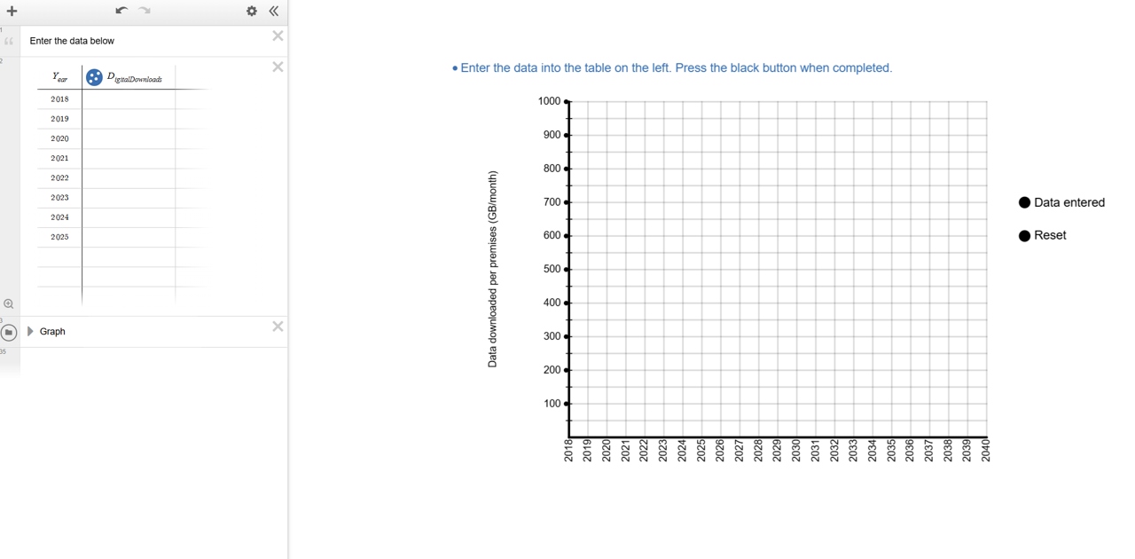
Students enter the data from slide 11 of Screentime footprint PowerPoint in the table on the left of the screen and then click the text on the right of the screen. A green and red point will appear along a green line.
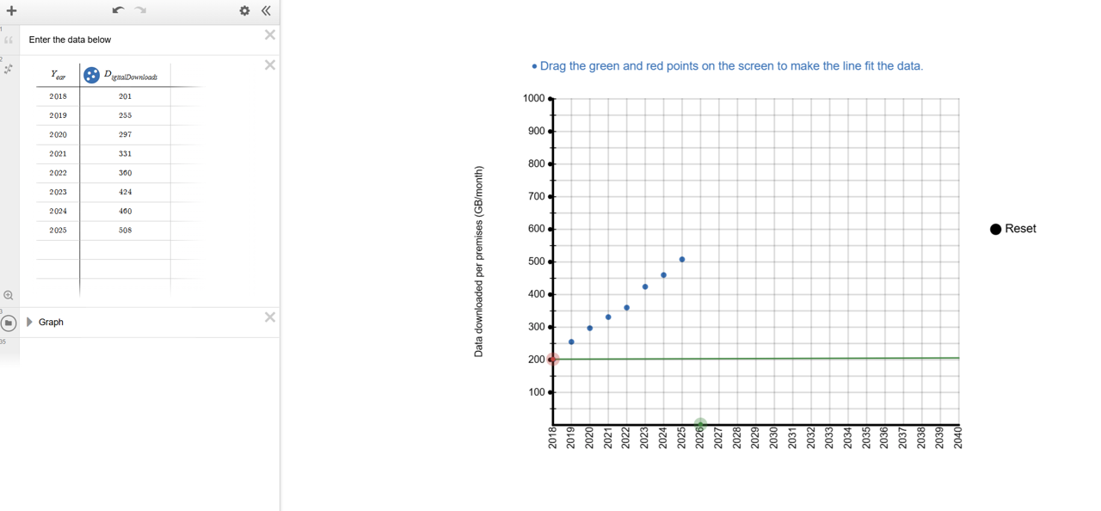
Students drag the green and red points to decide where the line should be placed to best fit the data.
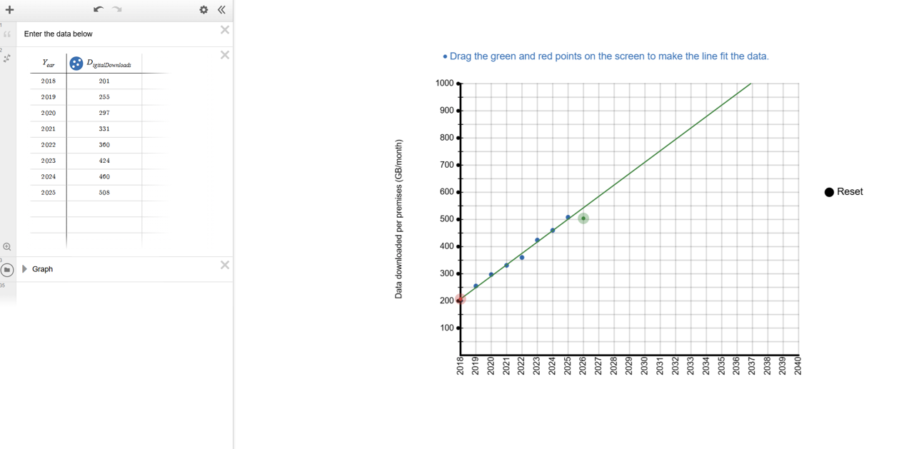

Organise students into groups. Ask them to open Digital download trends. They should follow the instructions to construct the graph and then use it to make accurate predictions about:
- the year in which the average data downloaded per month will reach 850GB per premises per month (approximately double the amount from 2023).
- the monthly digital download per premises per month 10 years from now.

Mathematical result | Why are our answers different?
Discuss with students where they chose to place the line and their answers to the two questions:
- In which year will the average data downloaded reach 850GB per premises per month (approximately double the amount from 2023)?
- What will be the monthly digital download per premises per month 10 years from now?
Select students to show their graph, identifying groups with significantly different answers. Ask groups to explain how they chose where to put their line. Example answers could include:
- going through the first and last point.
- going through as many points as possible.
- following the general flow of the points.
- trying to get the same number of points above and below the line.
Draw attention to the usefulness and limitations of a linear model, specifically:
- A linear model can be used effectively to make predictions about the future based on given data (for some data sets).
- Linear models are approximate, and may not be relevant beyond the data taken.

Results in context | Future implications
Show the students slide 12 of Screentime footprint PowerPoint, displaying the rate of CO₂ emissions produced per gigabyte of data downloaded.
Ask students to calculate/predict CO₂ emissions per premises per month for:
- 2023, using the table.
- the current year, using their model.
- what they think will happen 10 years from now, using their model.
Students should continue to work with the groups they have been working with to make predictions about the amount of digital downloads per premises per month, and the impact this will have on CO₂ emissions. Challenge students to find numbers to support their conclusions.
An example prediction students could make in 2027 could be: in 2037, we predict that the average digital downloads per premises per month will have grown to over 900 GB, more than double the amount in 2023 (the end of the provided data). Therefore CO₂ emissions caused by digital downloads would increase to double the amount, from 424×0.05=21.2 kg (where 1GB produces 50g of CO₂) to around 900×0.05=45 kg.
Following the class discussion, allow students time to change their model if they would like to.

LESSON 3

(Y8)

Lesson 3 • Changing downloads
To read the most recent version of this lesson, download associated resources, and view embedded professional learning including classroom videos and work samples, visit: https://resolve.edu.au/teaching-sequences/year-8/mathematical-modelling-screentime-footprint/lesson-3-changing-downloads

Lesson overview
Students create linear graphs to model the increase in the size of common apps, make predictions about the size of these apps in the future and evaluate the effectiveness of their predictions.

Learning goals
Linear relationships are based on constant rates and can be described by equations.
Linear models can be used to predict future outcomes. These predictive claims goes beyond available data and so the must be expressed with uncertainty.

Resources
Whole class
- Screentime footprint PowerPoint
Each group
- Access to a computer or tablet and the Desmos interactive Graphing app sizes increase
Each student
- Growing downloads Student sheet

Lesson phase | Estimated time | Lesson type
Problem in context | App size over time | 5 minutes | Whole class
Mathematical problem | Linear graphs | 10 minutes | Small group
Mathematical result | Making predictions | 15 minutes | Small group
Mathematical result | Sharing our results | 15 minutes | Whole class

Teach this lesson

Problem in context | App size over time
Show students slide 15 of Screentime footprint PowerPoint, which shows an iPhone 6 which was released back in 2014.
Ask:
- How does the iPhone 6 compare to current mobile phones?
- As our phones have changed, so have app sizes. How significantly do you think these changes have been?
Show slide 16 and explain that this table displays historical data on the size of various popular iOS apps (2015-2017). Explain to students that app sizes do vary by platform (for example Android and iOS) and this is data for iOS.
Pose the question: How have app sizes changed over time and how might this have affected CO₂ emissions from phone usage?

Mathematical problem | Linear graphs
Organise students into small groups. Provide each group access to a device with internet and the Desmos interactive Graphing app size increase, and provide each student with Growing downloads Student sheet.
Either assign one app to each group, or allow groups to select an app to graph. Ask groups to complete Question 1 of Growing downloads Student sheet, graphing the increase of the size of the app over time, using the Desmos interactive Graphing app sizes increase. The Desmos graph will generate a linear equation which can be recorded on the Student sheet.

How to use the Desmos interactive
The Desmos interactive Graphing app sizes increase is designed so that a user can follow the steps on the screen to construct a linear graph that models one row of the data in the table on Growing downloads Student sheet. For this example, we will choose row 2, Instagram.
Instructions for students to follow appear at the top of the screen in blue.
Students enter the data from their selected row from Growing downloads Student sheet in the table on the left of the Desmos interactive screen.
t represents the time in years since May 2015. For example, when t=1.5, this is 1.5 years (or 18 months) after May 2015, which is November 2016. As the data is entered, it will display on the number plane. When all data is entered, students should click ‘Data entered’.
The next instruction asks students to drag two green points on the screen to move the line so that it roughly represents the data.
Once this is completed, students should press ‘Line chosen’. An equation will be displayed on their screen alongside an explanation of how the equation tells us the gradient and y-intercept of the graph. This equation defines the linear graph and allows us to find predicted file sizes (S) for a given time after May 2015 (t).
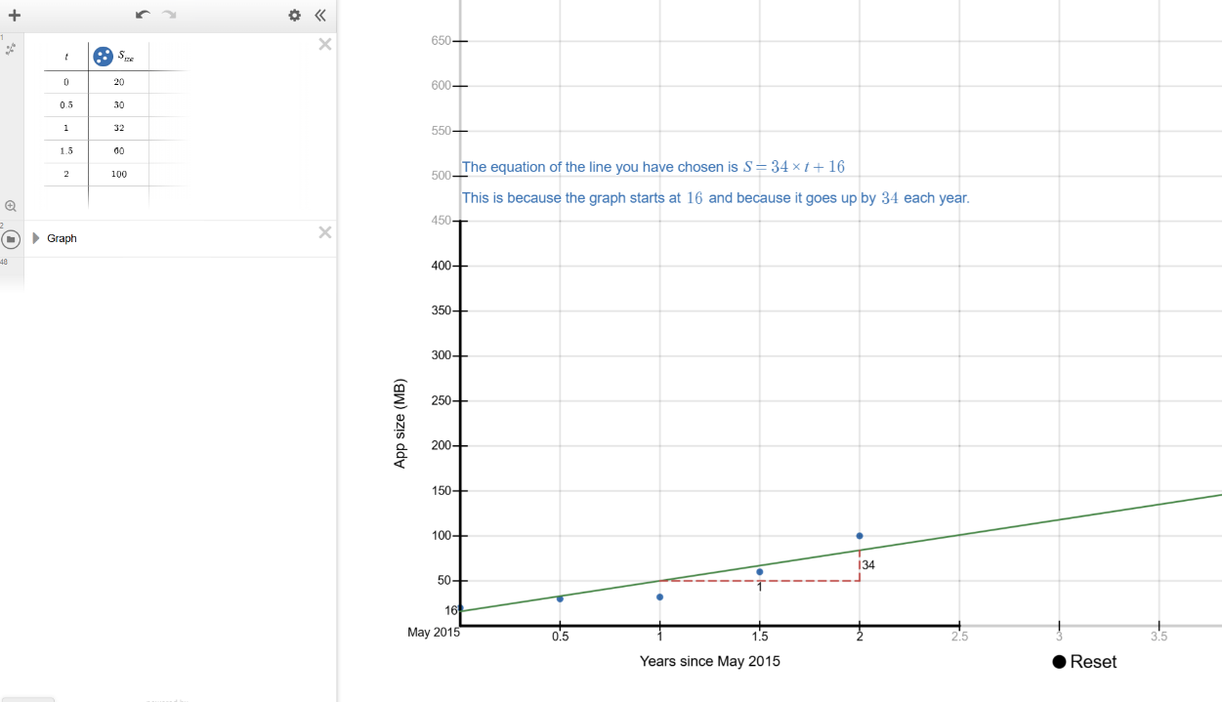

Discuss:
- Where did you start your graph?
  - Students may choose to start their graph at the first point, or somewhere that allows a better line through the other points.
  - Some may not realise that the y-intercept can be moved, so this is worth highlighting.
- How did you choose where to place your linear graph?
  - Making the line go through the first and last point, ensuring the number of points above and below the line are equal, or trying to go through as many points as possible.
- What was difficult about choosing where to place your linear graph?
  - It is impossible to make the line go through all of the points. The points also are unlikely to make a nice straight line and instead curve upwards.

Mathematical result | Making predictions
Explain the meaning of the linear equation generated by the Desmos interactive and that it describes how S (app size) and t (time in years after May 2015) are related for any possible app size and time. Using the equation to find known values (e.g. size after 1 year) may give you a different value to the actual data, because the linear graph does not perfectly fit the underlying data.

How a linear equation and a linear graph are related
The Desmos interactive generates and presents a linear equation that matches the line chosen by the students. In the example presented in the previous step, the interactive generated the equation $S=34×t+16$.
This equation represents every point on the line. If we choose any time, for example $t=3$ which is May 2018 (3 years after May 2015), we substitute$t=3$into the equation $S=34×t+16$.
$$S=34×\left(3\right)+16 \\ =102+16 \\ =118$$
This means that 3 years after May 2015, the predicted size of the app is 121 MB.

Ask students to use the equation to make predictions about the current and future sizes of the app they are studying (e.g. in 2027, a student would find the predicted size of the app in 2027 and 2037). Students can check their predictions by checking the iOS store to find the current size of the app they are researching.

Mathematical result | Sharing our results
Lead a discussion where students present their findings to the rest of the class. Once students have shared their experiences, show the students slide 17 of Screentime footprint PowerPoint displaying graphs of the eight apps on the one screen.
Discuss:
- How do these equations compare with yours? Does a different equation mean you’re wrong?
  - When modelling a data set there is not one ‘right answer’, but rather a range of graphs and equations that reasonably match the underlying data.
- What do you notice? What do you wonder?
  - Students might notice that Facebook had the highest app size in May 2015, the highest app size in May 2017, and the highest rate of growth of any app. They may wonder why YouTube did not increase at a faster rate.
- Which app increased the fastest and how do we know?
  - Facebook increased at the fastest rate, with an increase of approximately 135 MB per year. We can see this from the equation, which in our example was $S=134×t+100$.
  - Interesting, since 2017 Facebook’s file size has only increased by a few MB. This is well below the predicted rate of growth based on the equation. You might discuss why the app has not changed much since 2017.
- How does the rate of increase in the graph relate to the equation?
  - The bigger the number that is multiplying with t, the higher the rate of increase of the line. This the gradient and a higher gradient means a steeper line.
- Looking at your Desmos graphs, is a straight line appropriate for the data?
  - Not for all the data. The data points curve upwards, so a linear model does not fit well.
- What happens when students use their linear equations to predict the current app size and compare it with the real size?
  - They will see that their predictions are quite inaccurate. This isn’t because their equations are wrong—it’s because the apps’ growth is not linear. In reality, the growth appears to level off over time, meaning a different shaped graph. Ask students to explain the shape of a graph that would better for the data. For example, a curve that rises more steeply at first and then levels off.

LESSON 4

(Y8)

Lesson 4 • My screentime footprint
To read the most recent version of this lesson, download associated resources, and view embedded professional learning including classroom videos and work samples, visit: https://resolve.edu.au/teaching-sequences/year-8/mathematical-modelling-screentime-footprint/lesson-4-my-screentime-footprint

Lesson overview
Students investigate their own carbon footprint based on average rates and determine the most effective method for reducing their CO₂ emissions.

Learning goals
Data analysis can help identify major issues/trends to support effective decision-making.

Resources
Whole class
- Screentime footprint PowerPoint
- Access to Student CO₂ emissions data Spreadsheet via a shared drive (as students need to load their data into this common spreadsheet)
Each group
- Access to a computer or tablet
Each student
- My digital CO₂ footprint Student sheet

Lesson phase | Estimated time | Lesson type
Mathematical problem | What is my daily CO₂ footprint? | 25 minutes | Individual
Mathematical result | Comparing your footprints | 15 minutes | Whole class
Results in context | What can we do? | 25 minutes | Small group/Whole class

Teach this lesson
Mathematical problem | What is my daily CO₂ footprint?
Show the students slide 20 from Screentime footprint PowerPoint. Explain that the table shows the approximate CO₂ emissions by common activities, and that these values can change widely depending on factors such as the type of device being used, the quality of the video or audio stream, the efficiency of the data centres involved, and even the energy mix of the electricity grid that powers their device.

What are our sources?
We have drawn on multiple sources to inform the emission values in this table. These sources include peer-reviewed or institutional research. Although we present a single figure for each activity, actual emissions vary with factors such as device, network type and electricity supply. In many reports, these values are provided as ranges rather than exact numbers.
Activity | CO₂ rate used in lesson | Reported CO₂ rate | Source
Sending a text message | 0.015g/message | ≤0.02g/message | IEA, 2022
Making a mobile phone call | 1.5g/min | ~1-2g/min | Carbon Trust, 2020
Streaming TV/video (HD) | 55g/hr | ~55g/hr | Carbon Trust, 2021; Fraunhofer FOKUS, 2024
Using GenAI | 2g/query | ~2.2g/query | Tomlinson et al., 2023
Online gaming | 78g/hr | ~60-95g/hr | University of Bristol, 2022; IEA, 2022
Listening to a podcast | 8g/hr | ~5-10g/hr | Shift Project, 2019; Obringer et al., 2022
Playing a mobile game | 2g/10 mins | ~25-40g/hr | IEA, 2022
Making a video call | 12g/10 mins | ~50-90 g/hr | IEA, 2022
Scrolling social media | 2g/10 mins | ~1-3g/10 mins | Obringer et al., 2021
Sending an email (no attachment) | 0.3g/email | ~0.2-0.4g/email | Berners-Lee, 2020
Sending an email (with an attachment) | 35g/email | ~20-50g/email | Berners-Lee, 2020; IEA, 2022
Streaming music | 10g/hr | ~8-12g/hr | Shift Project, 2019

References
Berners-Lee, M. (2020). How Bad Are Bananas? The Carbon Footprint of Everything (Rev. ed.). Profile Books.
Anderson, M., Flores, L. D., & Medina, M. K. (2023). Untangling the carbon complexities of the video gaming industry: A way forward [Report]. Playing for the Planet Alliance & The Carbon Trust. https://www.playing4theplanet.org/post/carbon-complexities-report
Carbon Trust. (2020). Mobile networks: Energy and carbon impacts. https://www.carbontrust.com/sites/default/files/documents/resource/public/Mobile%20Carbon%20Impact%20-%20REPORT.pdf
Carbon Trust. (2021). Carbon impact of video streaming. https://www.carbontrust.com/our-work-and-impact/guides-reports-and-tools/carbon-impact-of-video-streaming
Fraunhofer FOKUS. (2024). Green Streaming Whitepaper. https://www.fokus.fraunhofer.de/en/fame/news/whitepaper_green_streaming_24-10.html
International Energy Agency. (2022). Data centres and data transmission networks. https://www.iea.org/energy-system/buildings/data-centres-and-data-transmission-networks
Obringer, R., Rachunok, B., Maia-Silva, D., Arbabzadeh, M., Nateghi, R., & Madani, K. (2021). The overlooked environmental footprint of increasing Internet use. Resources, Conservation & Recycling, 167, 105389.
The Shift Project. (2019). Climate crisis: The unsustainable use of online video. https://theshiftproject.org/en/publications/unsustainable-use-online-video/
Tomlinson, B., Black, R. W., Patterson, D. J., & Torrance, A. W. (2023). The carbon emissions of writing and illustrating are lower for AI than for humans [Preprint]. Scientific Reports. https://doi.org/10.1038/s41598-024-54271-x

Provide students with My digital CO₂ footprint Student sheet. Ask students to calculate the digital CO₂ footprint for a few of the example scenarios—Streaming TV/video and Using GenAI are good examples, as these include a time-based and activity-based calculation.

Calculating the CO₂ footprint using a given rate
For some of the activities included in the table on slide 20 of Screentime footprint PowerPoint, the daily emission amount is quite simple to calculate.
For example, Using GenAI is listed as 2g per query. If I was to ask AI 6 questions in a day, then I would generate $6×2g=12g$ of CO₂ in a day from using AI.
Some activities are more complicated. For example, Streaming TV/video is listed as generating 55g per hour. In the example scenario, the person streams video for 1 hour and 10 minutes in a day. There are a number of ways of representing this in hours, such as $1\frac{1}{6}$ hours or $\frac{70}{60}$ hours.
Multiplying either of these by the rate 55g/hr will give the amount of CO₂ produced:
$$\frac{70}{60}×55 = 1\frac{1}{6}×55 = 64.17g of {CO}_{2}$$

Ask students to complete the first table of My digital CO₂ footprint Student sheet by calculating the total CO₂ produced by the example scenarios, and to rank the activities from 1 (produces the most emissions) to 12 (produces the least emissions).
Discuss:
- What do you notice? What surprises you?
  - Invite students to share what they notice and what surprises them. For example, some may be surprised that mobile games have a low CO₂ impact because many are played offline. This can prompt a useful class discussion about what drives emissions in digital activities.
- Do you think the values in the column "What if I did this in a day?" are reasonable for the example person?
  - Streaming: 1 hour 10 minutes might seem low, but some people don’t have a streaming subscription and instead watch live TV.
  - Texting: 85 texts per day is 5 texts per hour (assuming 8 hours of sleep), which seems a lot.
  - Video calls: 50 minutes per day might seem very high, but if we include online business meetings it could be accurate as an overall average.
  - Emails: 30 emails without attachments and 2 with attachments might seem high (particularly for Year 8 students), but might include spam email or marketing emails.
- Which activities have the highest rate of CO₂ emissions?
  - It’s hard to compare rates in different units—some rates are per hour, others per minute, others per text, email etc.
  - The highest emissions are video calls (0.5kg), followed by scrolling social media (0.24kg).
Ask students to estimate the time they spend on each activity in this table and record their estimates in the second table of My digital CO₂ footprint Student sheet. Students then calculate their total digital CO₂ footprint, recording this in the second table, ranking their activities and reflecting on how their emissions might compare to the example person.
Provide students with access to Student CO₂ emissions data Spreadsheet. To ensure anonymity, assign each student a letter from A to Z and then AA, AB, AC and AD (depending on the number of students). Ask students to enter their final data into the spreadsheet row marked with their letter.

Mathematical result | Comparing your footprints
Display the Student CO₂ emissions data Spreadsheet with all student data included and scroll to the right to display the stacked column graph.
Discuss:
- What do you notice about our class data?
  - Depending on the data from the class, it is likely they will notice some colours are frequently larger than others.
  - Discuss the distribution of data: the patterns of similarity and difference. For example, you might discuss which activities appear to be producing the largest amounts of emissions, the overall range of the data, the shape of the data and other features such as clumps, gaps and/or atypical values.
- Which activities are commonly producing the largest amounts of emissions?
  - The colours that commonly take up the most space represent the largest amounts of emissions.
- What is helpful about this graph?
  - It allows us to display a lot of data on one graph and to see the whole class at once.
  - We can compare different people and identify the activities that generate a lot of CO₂ emissions for many people.
- What is less helpful about this graph?
  - Because it contains such a lot of data, it could be confusing and the data labels are quite small and hard to read.
  - You can easily read the height of the first category (streaming) for each person, but you can’t easily read the heights of the other activities as they are stacked (not starting from zero) in each column.

Reading the stacked column graph
The image below shows an example of a stacked column graph that could represent a class.
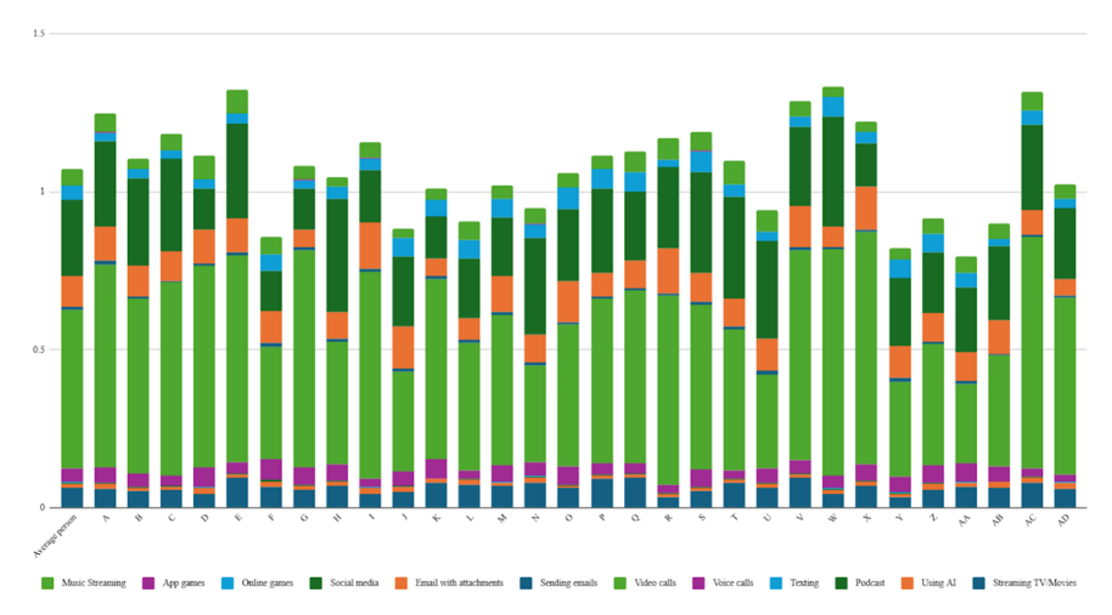
Each vertical column represents a student. The height of the column represents the total amount of CO₂ emissions produced by that person from the activities in the table. A higher column therefore means that more CO₂ emissions have been produced. In this example, student E is producing the most CO₂ emissions. Student F is producing the least.
The different colours in each column represent the amount of CO₂ emissions that are being produced by each activity, with the key at the bottom. The large light green section in each column represents video calls, indicating that this activity generates a lot of CO₂ for many people.

Results in context | What can we do?
Show slide 21 of Screentime footprint PowerPoint, which shows Australia’s estimated CO₂ emissions data and population in 2024 used in Lesson 1. Remind students that these are estimates.
Ask students to calculate the rate of CO₂ emissions per person per year (in kilograms), and then use this figure to determine the approximate proportion of their own annual CO₂ emissions that could be attributed to their online activity.

Calculating my annual screentime footprint
The example person in the table produces 0.34kg/day of CO₂ emissions from online activity, which equates to approximately 124kg/year.
In Australian, the total national emissions are approximately 380 million tonnes of CO₂ for a population of 27 million.
Per-person annual emissions:
380,000,000 tonnes/27,000,000 tonnes = 14.07 tonnes of CO₂/person/year
Proportion of emissions from online activity:
0.126 tonnes/14.07 tonnes = 0.009 = 0.9%
This means that online activity accounts for about 1% of this person’s annual CO₂ emissions.

Discuss with students that our online activity represents a very small proportion of our total annual emissions. However, even small actions have measurable impact. Emphasise that taking simple, practical steps to reduce emissions (e.g. adjusting device settings, limiting unnecessary streaming, or choosing lower-impact options) can still contribute to meaningful change when adopted collectively.
Show the students slide 22 from Screentime footprint PowerPoint, displaying a table of the digital activities we have been considering. Lead a discussion asking students to propose methods for each strategy that could reduce the CO₂ emissions from that activity. Some suggestions are included on the next slide.
Organise students into small groups and ask them to discuss which data saving initiatives they think would give the greatest CO₂ emission reduction across the class. Students should consider:
- How likely is it that you (and others) would take the steps described?
- How prevalent is this activity within the group currently? Did this activity appear a lot in the stacked column graph?
- How much of the activity would be reduced by taking the steps described?
- What is the total CO₂ reduction that you predict would occur per person?
Ask groups of students to produce a recommendation for the best way to reduce the CO₂ emissions from this class, giving any numbers possible to support their recommendation.
To conclude the investigation, ask students to share their recommendations and any justifications they have produced to support their recommendation.

