Start | End |  | Start | End |  | Start | End |  | Start | End
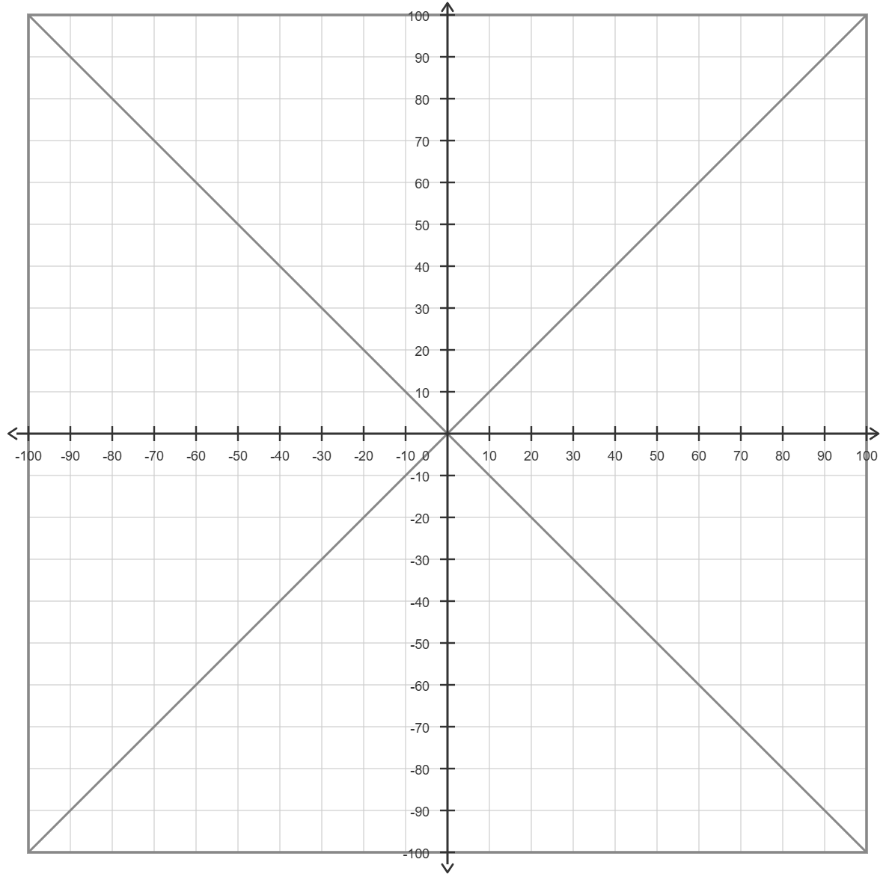
$$x$$
$$-x$$
$$-y$$
$$y$$
(Y6)

