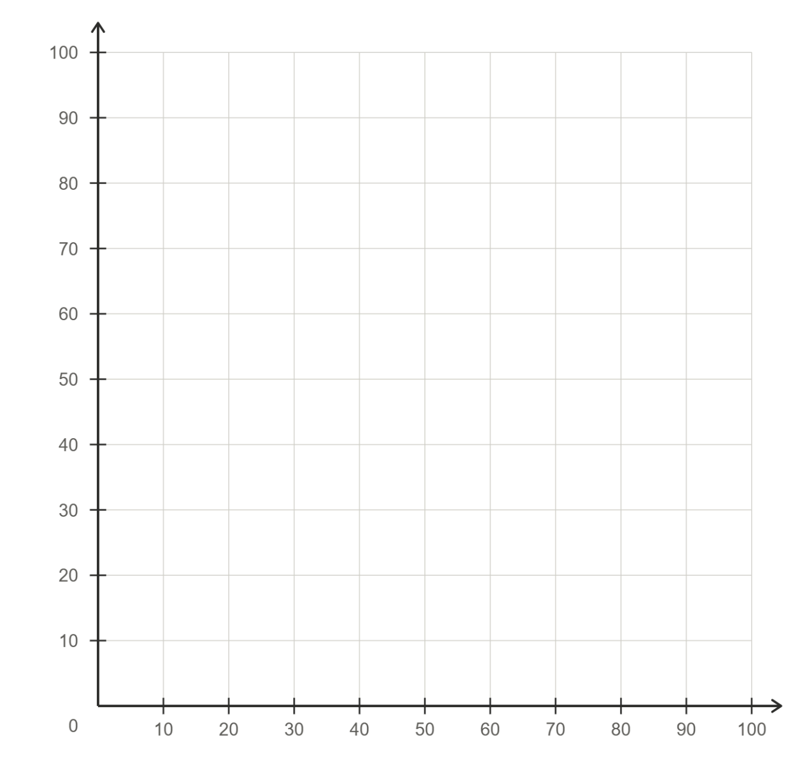
String art | Quadrant 1
$$x$$
(Y6)

$$y$$
Start coordinate | End coordinate
(100, 0) | (0, 0)
(90, 0) | (0, 10)

