Start coordinate | End coordinate
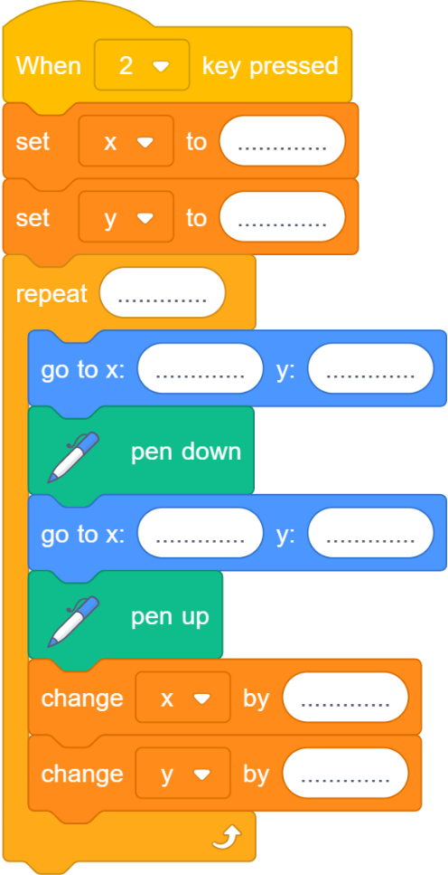
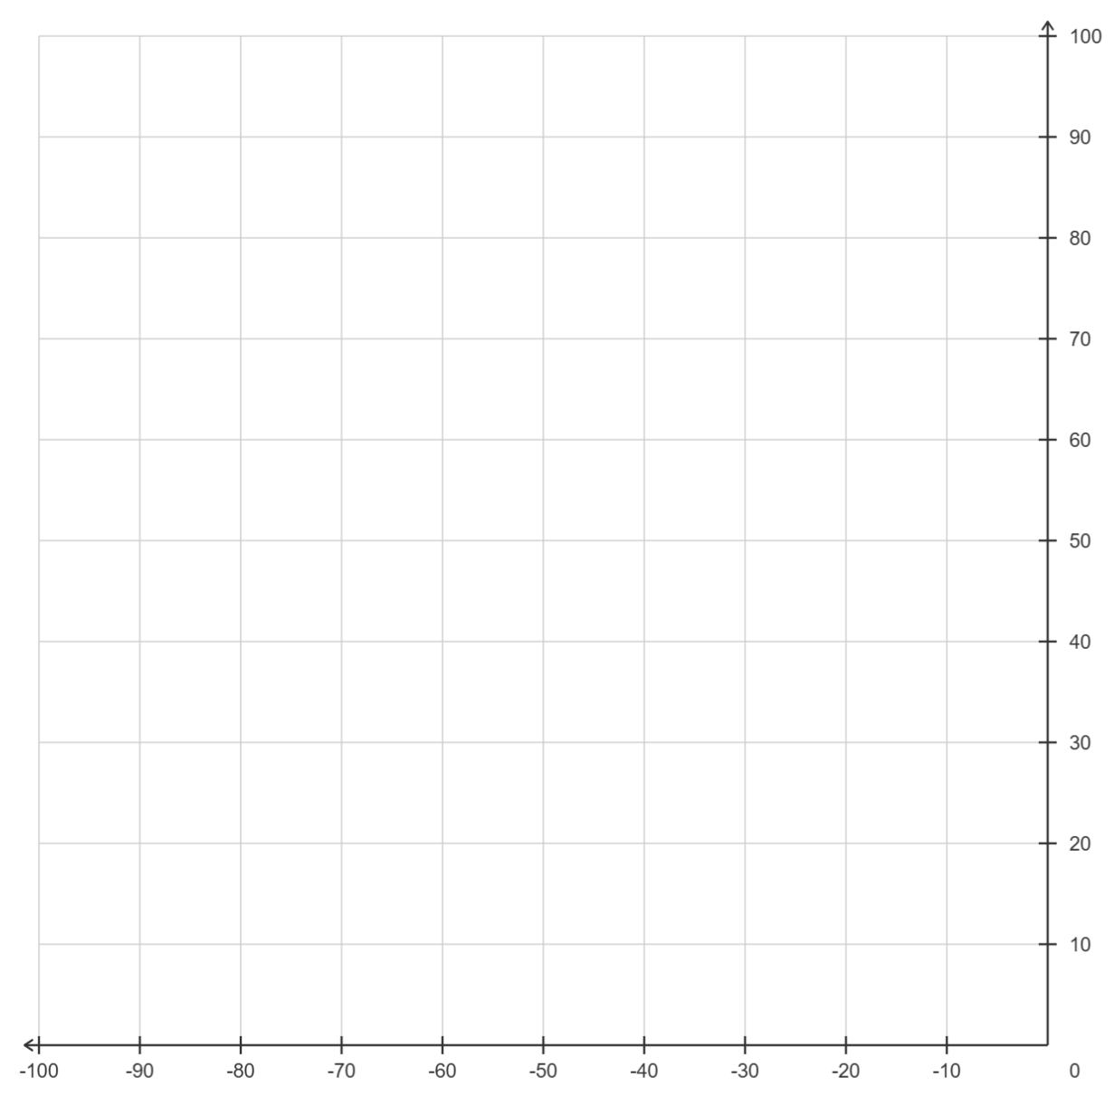
$$x$$
$$y$$
(Y6)

What is happening to the start coordinate as you go down the table?

What is happening to the end coordinate? | What values do the start and end coordinates begin at?

