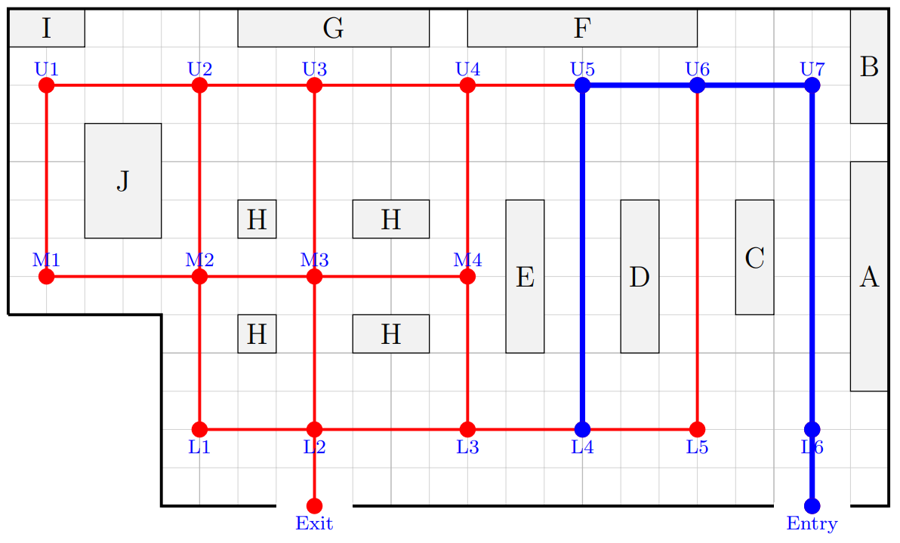
Supermarket Navigation – Group 3
Entry to Exit with no repeated vertices

- Start at Entry
- Move to a connected vertex that has not already been used in that path
- If there is only one possible next move, follow it
- If there is more than one possible next move, create a new branch for each option
- If a branch reaches Exit, record the full path
- If a branch gets stuck, go back to the last choice point
- Continue until every branch has been explored

Find all paths that travel from Entry to Exit that start with:

Entry → L6 → U7 → U6 → U5 → L4 →

