Supermarket navigation
(Y10)

Supermarket network design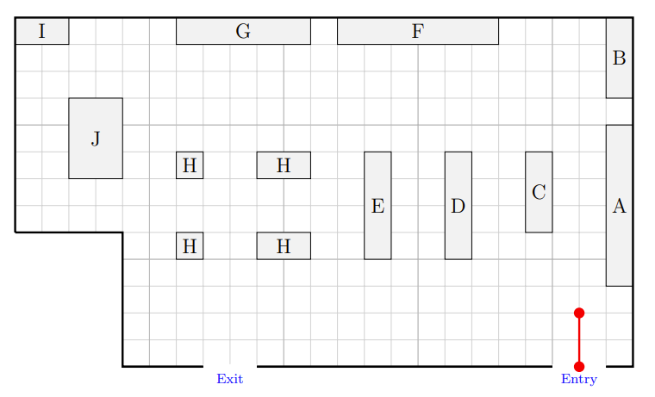
Create a network for the supermarket. Use vertices to show decision points and edges to show possible movements. Label your vertices clearly. Then use your network to describe a route that collects the four items listed.

Item | Shelf | Location
Soap | D | Aisle between D and E, halfway along D
Yoghurt | F | Halfway along F
Bread | J | Bottom left corner of J
Ice cream | A | Halfway along A

