Supermarket paths
(Y10)

Paths from entry to exit

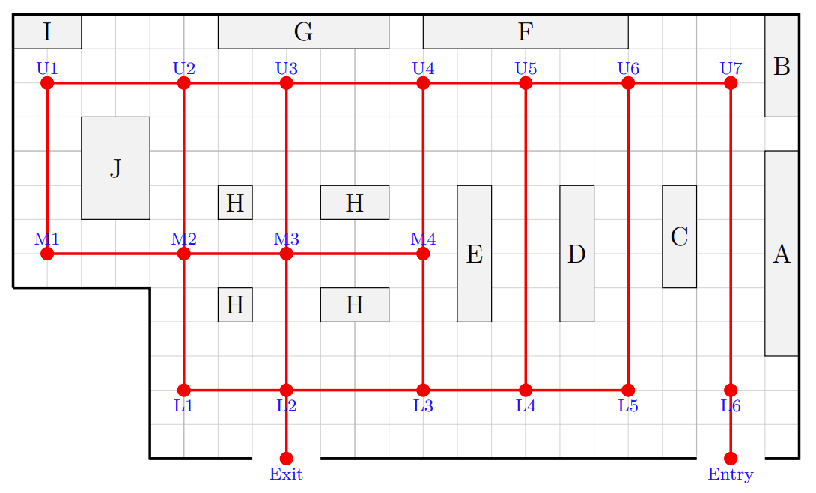
List three paths from the entry vertex to the exit vertex that do not pass through any vertex more than once.

Entry →

Entry →

Entry →

What is the same in the paths you have listed? Where do they start to branch?

