Supermarket road networks
(Y10)

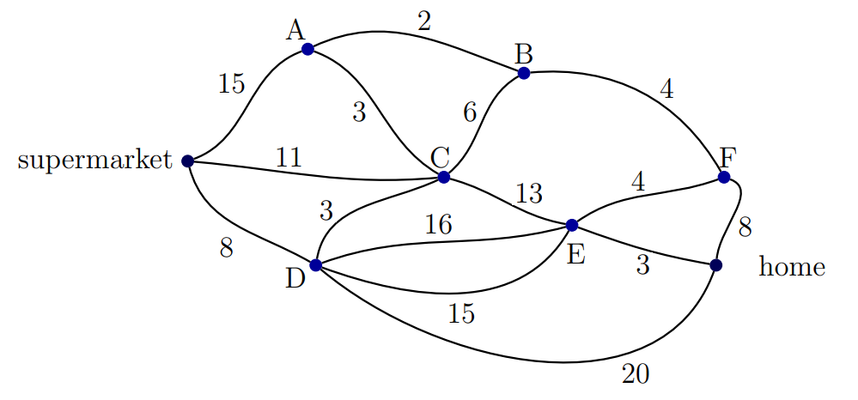
Road network 1

Quickest time to travel from the supermarket to home = ____ minutes

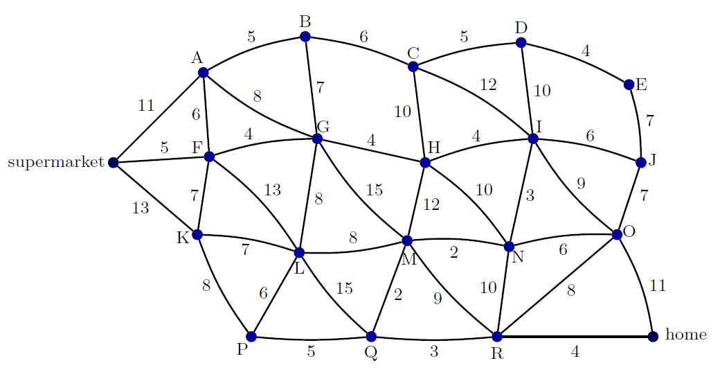
Road network 2

Quickest time to travel from the supermarket to home = ____ minutes

