Supermarket shortest path
(Y10)

Edge distances
Label the distance of each edge. Each grid square represents 1 metre.
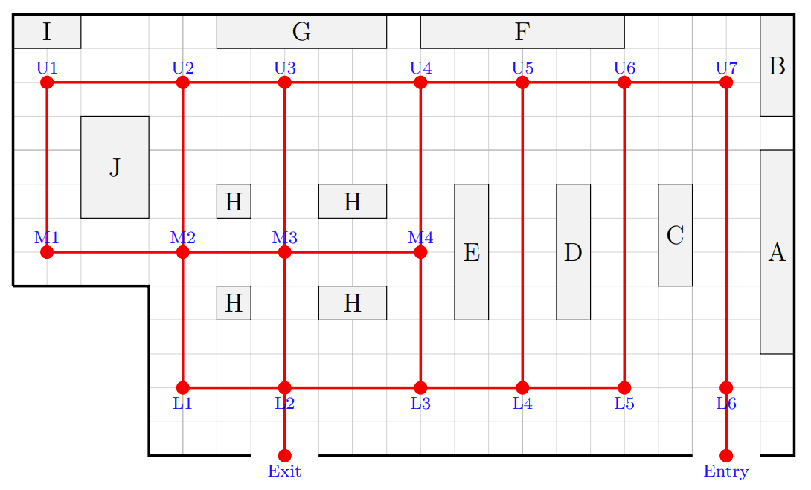

Shortest path(s)

Find the shortest path (or paths) between the Entry and the Exit.

Shortest distance

Find the shortest distance from Entry to Exit. How can you be sure this is shortest?

Greedy algorithm

- Start at the Exit vertex.
- From your current vertex, choose the shortest connected edge to an unused vertex.
- Move to that next vertex.
- Repeat until you reach the Car vertex.

Carpark network 1  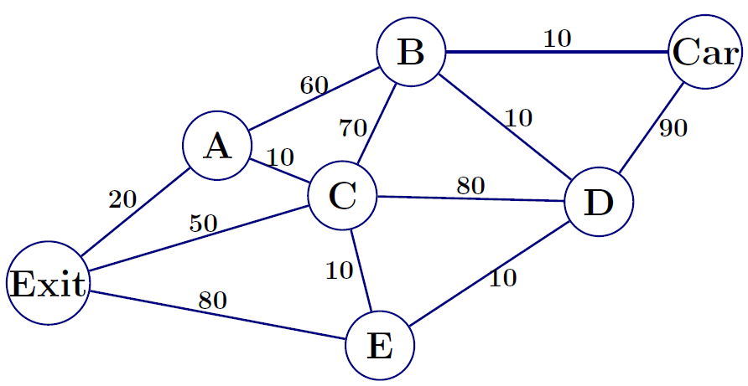  Distance using greedy algorithm = _____  Actual shortest distance = _____ | Carpark network 2  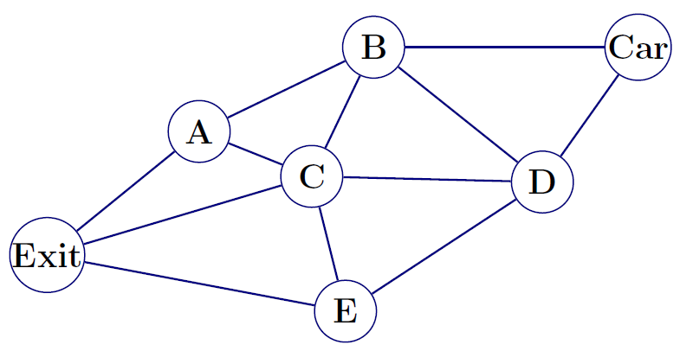  Distance using greedy algorithm = _____  Actual shortest distance = _____

Improving the greedy algorithm
The greedy algorithm does not always find the shortest path. Write changes that would make the algorithm more reliable.

