Task 1 • How many cupcakes?

**(Y4)**

|  |  |
| --- | --- |
| **Name:** |  |

# Zachary and Maddie’s strategies

Look at Zachary and Maddie’s strategies. How are they similar and how are they different?

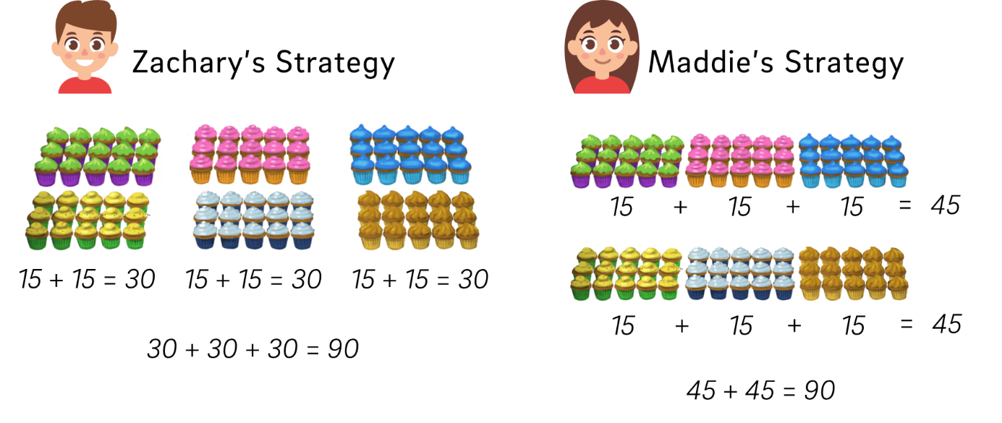

|  |  |
| --- | --- |
| Similar | Different |
|  |  |