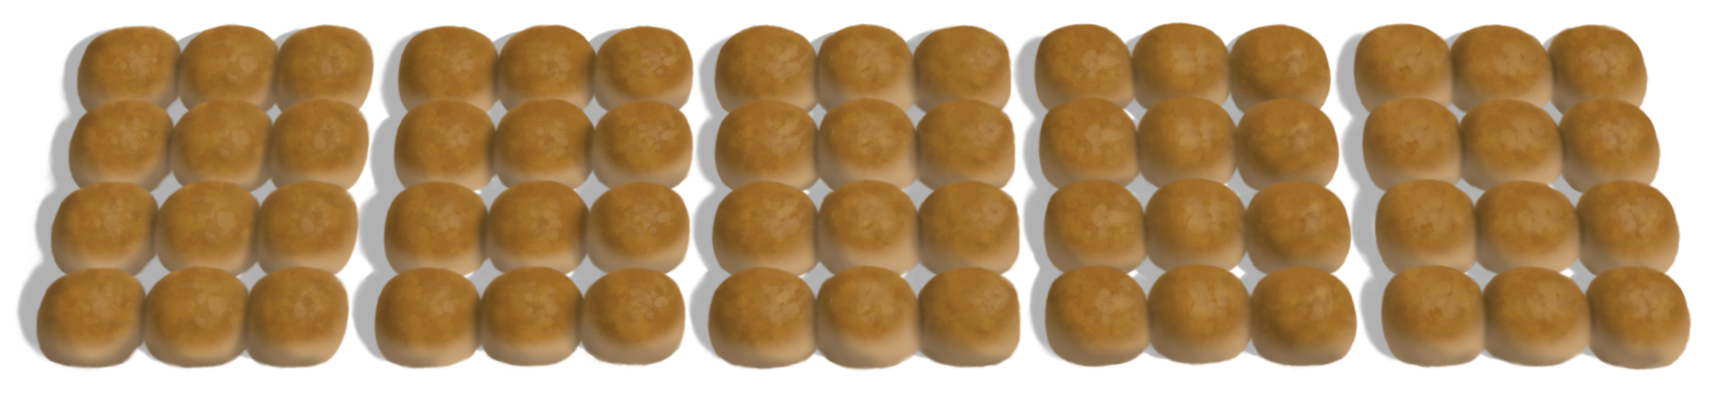Trays of Bread Rolls

**(Y4)**