 | 8 x 7 = (8 x 5) + (8 x 2)
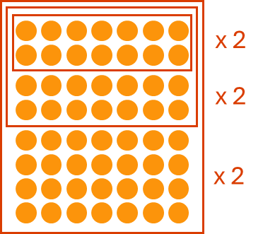 | 8 x 7 = 2 x 2 x 2 x 7
 | 8 x 7 = (5 x 7) + (3 x 7)
 | 6 x 9 = (5 x 9) + (1 x 9)
 | 6 x 9 = (6 x 10) – (6 x 1)
 | 6 x 9 = (6 x 5) + (6 x 4)
 | 5 x 12 = (5 x 10) + (5 x 2)
 | 5 x 12 = (10 x 12) ÷ 2
 | 5 x 12 = (5 x 6) + (5 x 6)
 | 7 x 4 = (5 x 4) + (2 x 4)
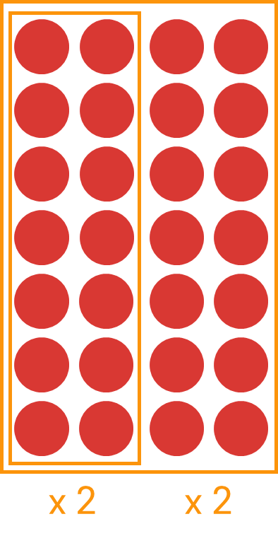 | 7 x 4 = 7 x 2 x 2
 | 7 x 4 = (7 x 2) + (7 x 2)

