What makes us happy?
(Y10)

Correlation or causation? Interpreting relationships in data
Sort the graph cards into three groups:
- Causation: one variable could influence the other.
- Correlation: the variables are related but not causal.
- There is not enough information to decide.
For each card, be ready to explain why you placed it in that group. Your explanation should use both the graph and real-world reasoning, not just the appearance of the line.
There is no single correct answer, but your reasoning must be clear and defensible.

Graph 1: Education vs lack of access to improved water  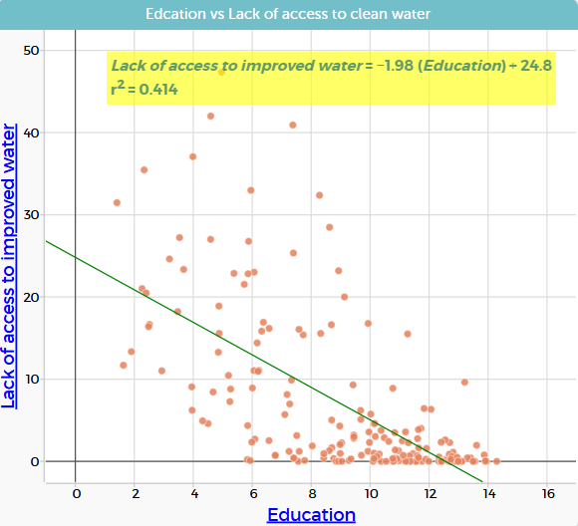 | Graph 2: Life expectancy vs happiness  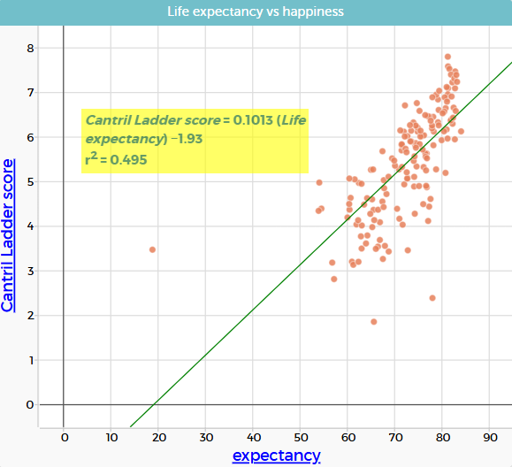
Graph 3: Urbanisation vs happiness  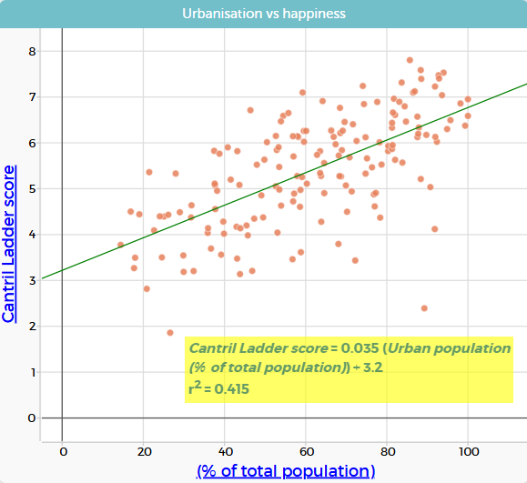 | Graph 4: Hunger vs happiness  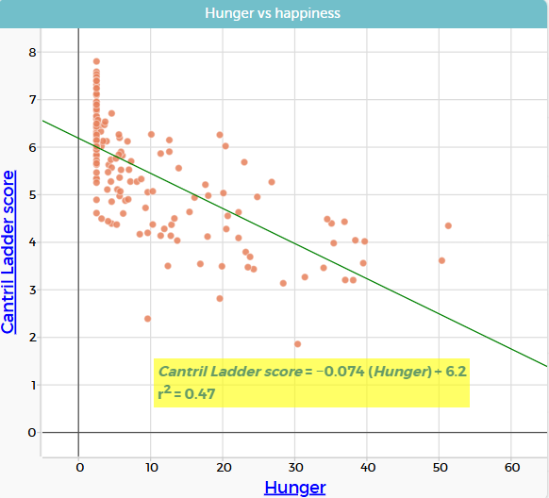
Graph 5: Urbanisation vs lack of access to clean water  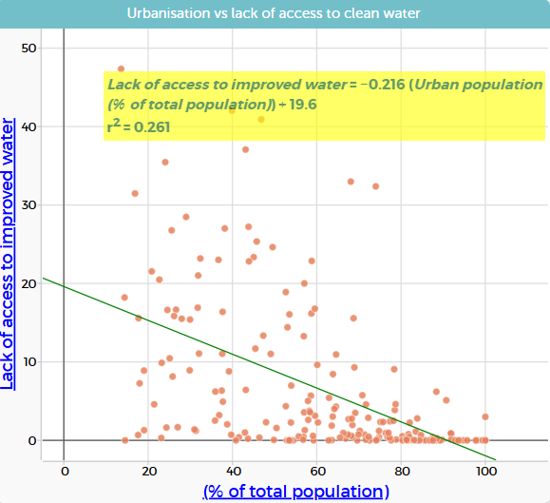 | Graph 6: Lack of access to improved water vs life expectancy  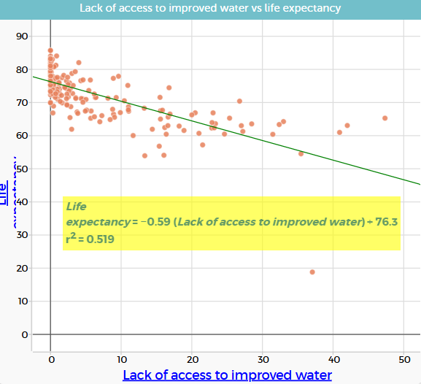
Graph 7: GDP per capita vs education  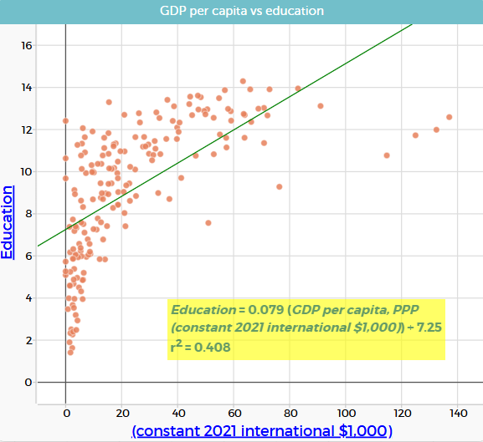 | Graph 8: Hunger vs life expectancy  