What makes us happy?
(Y10)

Lines of good fit
A line of good fit is used to show the overall relationship in a scatterplot. Draw a single straight line that best represents the overall pattern in each data set.

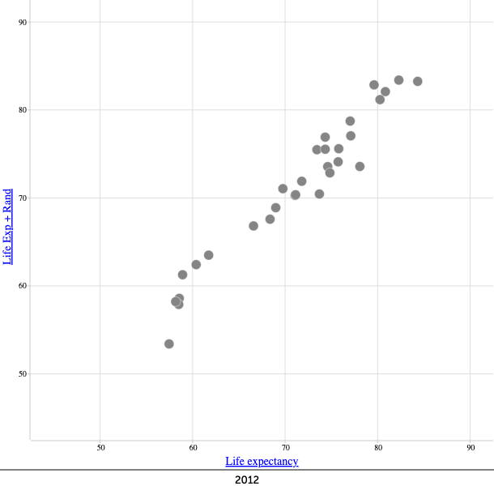  Graph 1 | 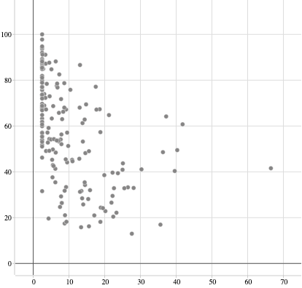  Graph 2
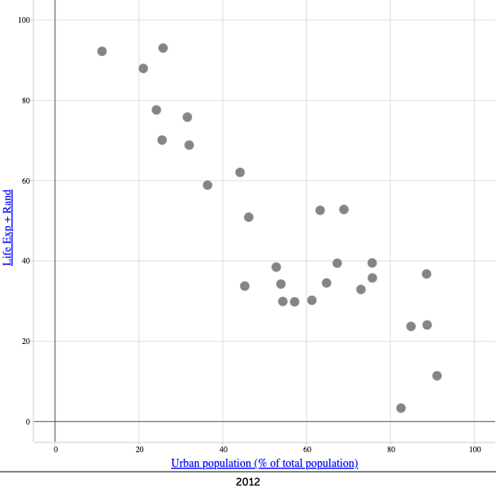  Graph 3 | 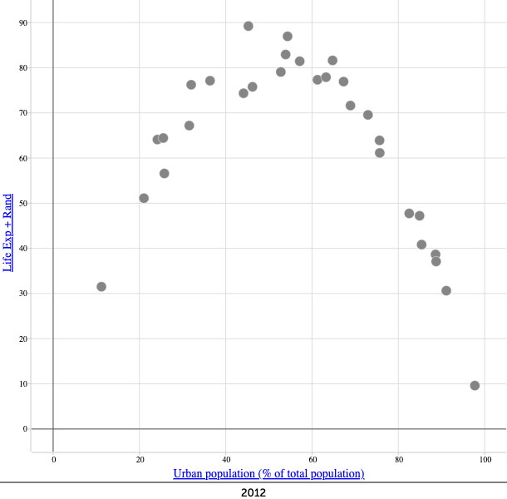  Graph 4

