
Lesson 1

(Y10)

Lesson 1 • Measuring happiness
To read the most recent version of this lesson, download associated resources, and view embedded professional learning including classroom videos and work samples, visit: https://resolve.edu.au/teaching-sequences/year-10/mathematical-modelling-what-makes-us-happy/lesson-1-measuring-happiness

Lesson overview
Students consider factors they believe may influence happiness and consider how we might measure happiness numerically.

Learning goals
Statistical investigations begin with questions that we can explore using data.
Scatterplots help us see relationships between two numerical variables.

Resources
Whole class
- What makes us happy? PowerPoint
Each group
- Sticky notes
Each student
- Access to a computer and the online data analysis tool CODAP (https://codap.concord.org/). Alternatively, students can work together in pairs with a shared computer.

Lesson phase | Estimated time | Lesson type
Problem in context | What makes you happy? | 15 minutes | Whole class/Small group
Mathematical problem | How do you measure happiness? | 15 minutes | Whole class/Small group
Results in context | How happy is Australia? | 20 minutes | Whole class/Small group

Teach this lesson

Problem in context | What makes you happy?
Pose the question: What makes you happy?
Arrange students in groups and give each group a set of sticky notes. Responding to the question “What makes you happy?”, students generate as many ideas as they can, writing one idea per sticky note. Once they have a good collection, they sort and cluster their sticky notes into common themes. For example, “spending time with friends” and “talking to family” might both fit under a “relationships” category. After sorting their ideas, each group shares their categories with the class so the class can build one combined list of themes.
Discuss:
- What similarities do you notice between the categories that different groups created?
- Are there categories that everyone seems to agree are important?
- Are there any categories where there’s very little agreement?
- What might explain the differences between groups’ ideas, and what does this tell us about the range of factors that contribute to happiness?

Mathematical problem | How do you measure happiness?
Pose the question: How might we measure happiness?
Discuss how statisticians take a set of possible factors, such as the ones generated through clustering, and treat them as “hunches” that need to be tested using data. Numerical data is especially useful because it allows us to make clear comparisons, helps us to generate patterns, and makes it possible to measure how strong relationships might be, even though qualitative data can still add depth and context.
Based on the categories each group has identified, students create questions with numerical answers that could be asked to a wide range of people to evaluate how happy they are.
Noticing students’ thinking
- Are students creating questions that don’t actually produce numerical data?
  - For example, open-ended “Why…” questions.
- Are students choosing measures that don’t really match the category?
  - For example, measuring “exercise” with a yes/no instead of asking “How many minutes per week?”.
- Are students combining multiple ideas into one question, making it unclear what is being measured?
  - “How often do you exercise and eat healthy food each week?” mixes two different behaviours into a single response.
- Are students offering too few or too many response options, limiting choice or making the scale feel arbitrary?
  - For example, giving only “1, 2, or 3” as options for happiness, or offering a 1–100 scale that feels excessive.
- Are students choosing scales with an odd or even number of scale points, and do they understand that an odd number creates a neutral middle?
  - A 1–4 scale has no neutral point, versus a 1–5 scale with a neutral point of 3.
Show slide 6 of What makes us happy? PowerPoint. This slide introduces the World Happiness Report. Explain that this is an annual report that compares levels of happiness across countries based on data from the Gallup World Poll.
Show slide 7 and introduce the Cantril Ladder, a tool used in social research. Explain that the Cantril Ladder is used in the Gallup World Poll to measure happiness globally. You can learn more about the Cantril Ladder in the embedded professional learning Quantifying happiness on this lesson’s webpage.
Discuss:
- How is this poll similar to and different from the questions that we proposed as a class?
  - The Cantril Ladder score is a direct, overall measure of a person's life satisfaction (happiness itself), whereas many of the student-generated questions are likely to focus on specific factors that may influence happiness, rather than measuring happiness directly.
  - Many of the student-generated questions will likely use a numerical scale, while the ladder uses a visual metaphor and measures the outcome rather than the causes.
- Do you think this is a valid way to measure happiness? Why, or why not?
  - The Cantril Ladder score provides a consistent, comparable measure that works well for large groups of international surveys.
- What issues could there be with asking this question?
  - The Cantril Ladder score is a self-reported, subjective measure, and therefore cannot capture the reasons behind someone’s rating.
  - Terms like “best possible life” may be interpreted differently by different people. Responses can be influenced by mood, culture, or context, and a single question may oversimplify a complex idea.

Results in context | How happy is Australia?
Provide students with access to computers and ask them to access the World Happiness map. Allow time for students to investigate how happiness ratings vary across countries.
Discuss:
- How does Australia’s happiness rating compare to other countries around the world? Why might this be?
  - Australia has a comparatively high happiness rating. Students might attribute this to factors such as wealth, security, and education.
- What factors do you think contribute to the happiness of a country? What makes you say this?
  - Students may notice that wealthier countries tend to be happier. These countries typically have greater access to resources and education which may also contribute to happiness.
Let students know that these initial observations suggest that measurable factors, such as wealth or access to resources, may be related to reported happiness, and these relationships can be explored using data.

Lesson 2

(Y10)

Lesson 2 • Does wealth make us happy?
To read the most recent version of this lesson, download associated resources, and view embedded professional learning including classroom videos and work samples, visit: https://resolve.edu.au/teaching-sequences/year-10/mathematical-modelling-what-makes-us-happy/lesson-2-does-wealth-make-us-happy

Lesson overview
Students use scatterplots to explore the relationship between wealth and happiness for different countries around the world.

Learning goals
Scatterplots help us see relationships between two numerical variables and notice patterns, trends, and variation.
Direction, strength, and overall form help us describe relationships between two variables.
Data allow us to investigate and evaluate claims about relationships in real-world contexts.

Resources
Whole class
- What makes us happy? PowerPoint
Each student
- Access to a computer and the online data analysis tool CODAP (https://codap.concord.org/). Alternatively, students can work together in pairs with a shared computer.
- What makes us happy? Spreadsheet

Lesson phase | Estimated time | Lesson type
Mathematical problem | Happiness factors | 5 minutes | Whole class
Mathematical result | Creating scatterplots | 20 minutes | Whole class/Individual
Results in context | Strength, direction, and linearity | 10 minutes | Whole class/Small groups
Results in context | Looking at Australia | 10 minutes | Whole class/Small groups

Teach this lesson

Mathematical problem | Happiness factors
Show slide 10 of What makes us happy? PowerPoint which shows the World Happiness map. Invite students to suggest factors they believe may contribute to higher happiness ratings in countries around the world. Ask students to justify their suggestions using evidence from their exploration of the map in the previous lesson.
Explain to students that throughout this sequence they will look more closely at wealth and investigate whether being wealthier is associated with a country being happier.
Pose the question: Is there a relationship between the wealth of a country and its happiness rating?

Mathematical result | Creating scatterplots
Explain to students that Gross Domestic Product (GDP) is commonly used to estimate a country’s economic wealth. Tell students that they will analyse GDP per capita (PPP), which takes into account both population size and differences in the cost of living, allowing for fairer comparisons between countries.
Read more about GDP and PPP in the What is GDP and PPP? professional learning attached to this step on the lesson webpage.
Explain to students that they will create a scatterplot to explore whether there is a relationship between the wealth of a country and its happiness rating. Explain that in a scatterplot:
- the independent variable is the variable we choose to investigate. In this instance, the independent variable is GDP per capita, and it is placed on the horizontal ($x$) axis.
- the dependent variable is the variable being measured or observed. In this instance, the dependent variable is the Cantril Ladder score, and it is placed on the vertical ($y$) axis.
Provide students with access to computers and the What makes us happy? Spreadsheet. Ask students to open the first sheet, 2023 GDP per capita, using the tabs at the bottom of the window.
Explain to the students that this sheet contains the Cantril Ladder score and the GDP per capita (PPP) collected from different countries in 2023 (retrieved from the World Happiness Report). The units reported are “in constant 2021 international dollars”, meaning they have been adjusted for inflation, so comparisons are not affected by changes in prices over time.
Ask students to copy the dataset into CODAP and create a scatterplot with GDP per capita on the horizontal axis and the Cantril Ladder score on the vertical axis. Explain that each point in the scatterplot represents a data point (a country), where the horizontal axis shows GDP per capita (the independent variable) and the vertical axis shows the Cantril Ladder score (the dependent variable).

What is CODAP?
CODAP is a freely available browser-based powerful statistics tool designed to support learners in developing skills and understanding in data analysis. While spreadsheet software like Microsoft Excel and Google Sheets are familiar to many teachers and students, CODAP promotes better data hygiene and requires less technical work to perform statistical calculations. Unlike professional statistics tools (e.g. R or SPSS), CODAP is simple to learn, allowing students to get into analysing statistical results quickly.
CODAP can be found at https://codap.concord.org/.

The developers of CODAP have made a number of tutorials, guides, and videos available to help get users up to speed. You can access these on the Get Started page.

How to copy a dataset and create a scatterplot in CODAP
Copying a dataset into CODAP
Open the What makes us happy? Spreadsheet and copy all the data in the first sheet, 2023 GDP per capita.
On the CODAP website, click “Launch CODAP” then “Create new document”.
Click on the Tables icon in the top left and select “--new from clipboard--”.
Your clipboard data should appear in a table within CODAP. You may need to “Allow” the website to access your clipboard.
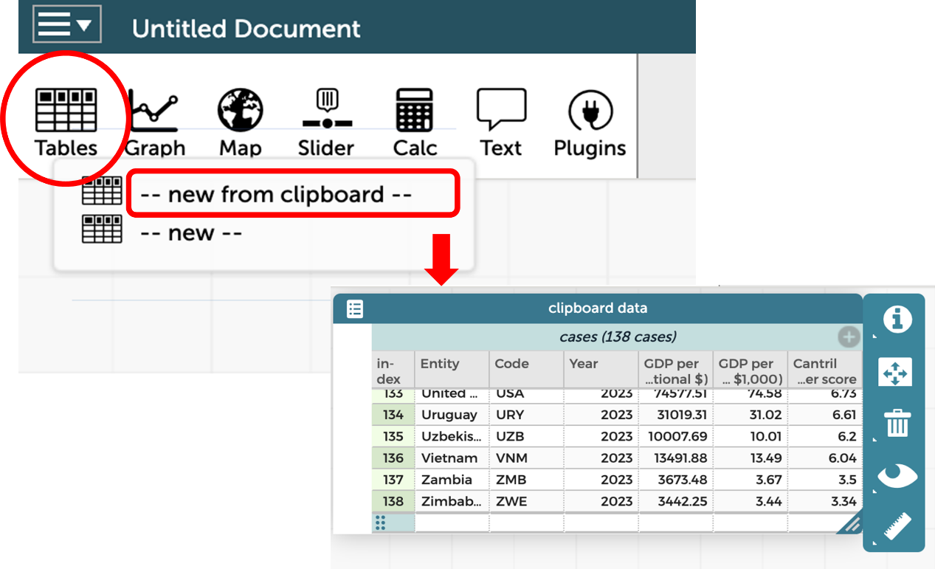]
Creating a scatterplot in CODAP
Follow these steps to create a scatterplot with the variable “2023 GDP per capita (PPP)” on the horizontal axis and “Cantril Ladder score” on the vertical axis.
Click the graph icon in the top left and a blank scatterplot will appear.
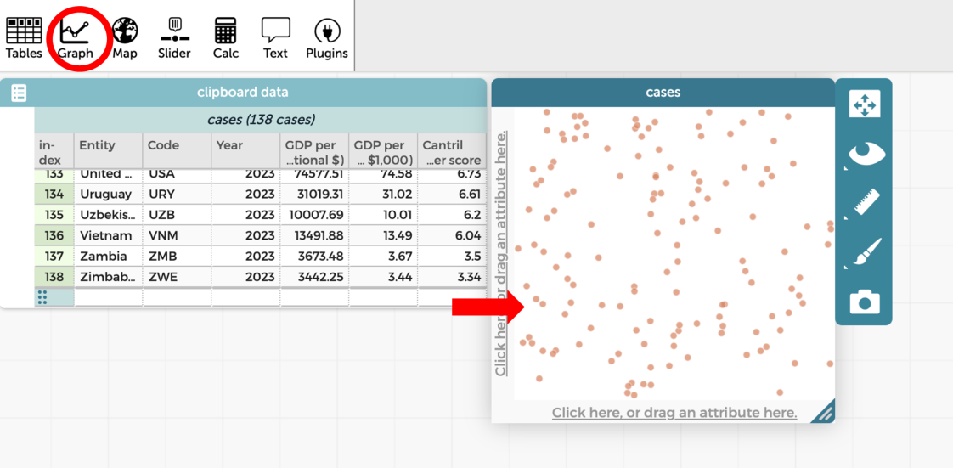
Click in the header cell of the fifth column “2023 GDP per capita (PPP)” and drag it onto the horizontal axis in the blank scatterplot.
Click in the header cell of the seventh column “Cantril Ladder score” and drag it onto the vertical axis in the blank scatterplot.
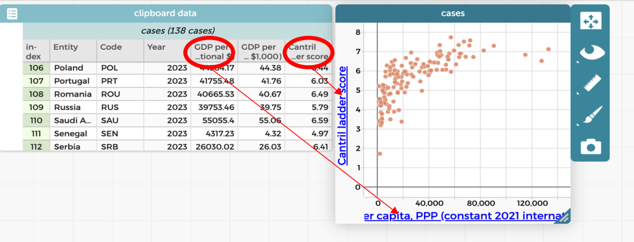
Note that CODAP may truncate long variable names on the axes. If this causes confusion, students can check the full name in the data table or temporarily shorten the variable label.

Results in context | Strength, direction, and linearity
Display slides 11 to 14 of What makes us happy? PowerPoint. Explain that the relationship between two variables in a scatterplot is described in terms of direction, strength, and linearity. Slides 12-14 show how direction and linearity can be identified from the overall pattern in the data. In this lesson, the strength of the relationship can be judged visually. Later, this visual judgement can be compared with a computer-generated measure of correlation.
Ask students to return to the scatterplot they have created, showing happiness on the vertical axis and wealth on the horizontal axis, and consider the question: Is there a relationship between the wealth of a country and its Cantril Ladder score? Prompt them to describe the relationship they see in terms of direction, strength, and linearity.
Discuss:
- How would you describe the direction of this scatterplot? How do you know?
  - There is a positive correlation between GDP per capita (PPP) and Cantril Ladder score, with Cantril Ladder scores generally increasing as GDP per capita (PPP) increases. The data form an upward-sloping pattern, indicating a positive relationship, where countries with lower Cantril Ladder scores tend to have lower GDP per capita (PPP) and those with higher Cantril Ladder scores tend to have higher GDP per capita (PPP).
- What is the strength of this relationship?
  - There is a moderate correlation. You can see that there is a pattern, but the points do not form a very close approximation of a straight line.
- Would you describe this as a linear relationship?
  - The points form a line shape at the start sloping upwards from left to right. The line flattens out after around $60 000 in GDP.
Discuss how the graph illustrates correlation, not causation. Wealth and happiness are correlated because changes in one variable are associated with changes in the other. However, this does not mean that wealth causes happiness. This distinction will be explored in more depth in Lesson 5.
Ask students to save their CODAP file.
Saving and re-opening CODAP files
CODAP files are a little unusual. Because CODAP is browser-based, CODAP files can only be opened from within the browser. Many students get confused when they try to open a downloaded CODAP file by double-clicking on it—this won’t work!
Students with Google accounts can connect CODAP to their Google Drive by clicking the menu at the top left then “Save...” > “Google Drive”.
Alternatively, this video demonstrates how to save and open a CODAP file.
https://www.youtube.com/watch?v=nC29Mg80Quk


Results in context | Looking at Australia
Ask students to access the second sheet in What makes us happy? Spreadsheet, titled 2012 GDP per capita. Students copy this dataset into CODAP and create a scatterplot with the variable GDP per capita (PPP) on the horizontal axis and the Cantril Ladder score on the vertical axis. Students then compare the 2012 scatterplot with the scatterplot they created from the 2023 dataset.
The two scatterplots are shown below side by side, with Australia highlighted (to highlight a data point in a scatterplot, select the country’s name in the table).
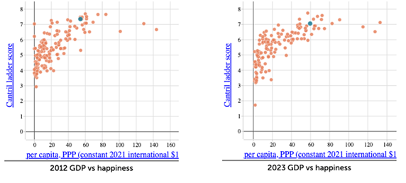
Ask students to compare the strength, direction, and linearity of the two scatterplots. This again helps to answer the question: Is there a relationship between the wealth of a country and its Cantril Ladder score?
Discuss:
- In each graph, does happiness tend to increase, decrease, or stay the same as GDP per capita (PPP) increases?
  - The points are forming a pattern that slopes upwards which indicates a positive correlation. As GDP per capita (PPP) increases, Cantril Ladder scores tends to increase.
- Are there parts of the graph where the relationship appears stronger or weaker? Is this similar in both years?
- How has Australia’s position has changed between 2012 and 2023?
Comparing the 2012 and 2023 datasets reinforces that statistical relationships can persist over time while still varying in strength or distribution, highlighting the importance of careful analysis when interpreting real-world data.

Lesson 3

(Y10)

Lesson 3 • A closer look at wealth
To read the most recent version of this lesson, download associated resources, and view embedded professional learning including classroom videos and work samples, visit: https://resolve.edu.au/teaching-sequences/year-10/mathematical-modelling-what-makes-us-happy/lesson-3-closer-look-wealth

Lesson overview
Students use lines of good fit and regression lines to model relationships in data, interpret gradients and intercepts, and make predictions in context.

Learning goals
Scatterplots help us see relationships between two numerical variables and notice patterns, trends, and variation.
Direction, strength, and overall form help us characterise relationships between two variables.
Data allow us to investigate, support, or challenge claims about relationships in real-world contexts.

Resources
Whole class
- What makes us happy? PowerPoint
Each student
- Lines of good fit Student sheet
- Predicting happiness Student sheet
- Access to a computer and the online data analysis tool CODAP (https://codap.concord.org/). Alternatively, students can work together in pairs with a shared computer.

Lesson phase | Estimated time | Lesson type
Mathematical problem | A line of ‘good’ fit | 10 minutes | Small group/Individual
Results in context | Finding a line of “best” fit | 10 minutes | Whole class/Individual
Problem in context | Using the line of best fit | 20 minutes | Whole class/Individual
Results in context | Making predictions | 10 minutes | Whole class

Teach this lesson

Mathematical problem | A line of ‘good’ fit
Review that the relationship between two variables can be described in terms of direction, strength, and linearity. Explain that one way to summarise the overall pattern in a scatterplot is to draw a line of good fit.
Explain that, in this lesson, the term “line of good fit” will be used to mean “a straight line drawn to approximate linear relationships”. Note that not all relationships are linear, and that in other contexts, a best-fitting model may be curved.
Provide students with the Lines of good fit Student sheet, which includes four scatterplots showing:
- Graph 1: a moderate to strong positive linear relationship
- Graph 2: a weak negative linear relationship
- Graph 3: a moderate to strong negative linear relationship
- Graph 4: a strong but clearly non-linear relationship
Individually, students draw a single straight line of good fit on each scatterplot, by eye, to represent the overall trend in the data.
Have students compare the lines they drew in small groups and discuss similarities and differences.
Discuss:
- For which scatterplots does a straight line hide important features of the relationship?
  - A straight line can hide important features when the relationship is non-linear or very weak, as it may mask curvature or suggest a stronger linear association than actually exists.
- Which scatterplots allow you to make the most reliable predictions using a straight line? Why?
  - Scatterplots with a strong and approximately linear relationship allow for the most reliable predictions, as the data points lie close to the line. When the relationship is weak or non-linear, predictions from a straight line are less reliable.
- In which scatterplots did different students draw very similar lines of good fit? What does this suggest about how consistent or dependable the straight-line model is for that data?
  - When most students draw very similar lines of good fit, this suggests that the straight-line model is consistent and dependable for that data, as small differences in judgement do not change the overall interpretation. This idea is referred to as “reliability”: a model is more reliable when different people applying the same method reach similar conclusions.

Results in context | Finding a line of “best” fit
Ask students to open their CODAP file showing the 2023 GDP per capita (PPP) versus Cantril Ladder score scatterplot.
Explain to students that they are going to model the overall trend in the data by drawing their own line of good fit before comparing it to a calculated model.
Ask students to use the drawing tool in CODAP to sketch a straight line that they think represents the overall pattern in the data. Allow students to compare their lines with a partner and discuss any differences.
Explain that these are examples of lines of good fit. They are drawn using judgement to represent the general trend.

Using CODAP to draw a line of ‘good’ fit
CODAP allows users to draw their own line directly onto the scatterplot.
Click on the camera icon to the right of the scatterplot and select “Open in Draw Tool”.
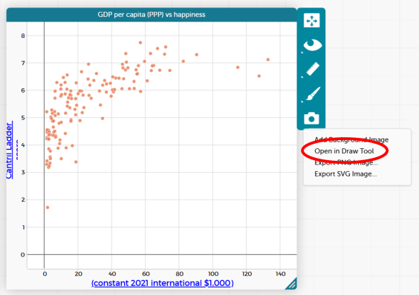
A drawing panel will open. Select the line tool from the toolbar on the left-hand side. The thickness and colour of the line can also be adjusted.
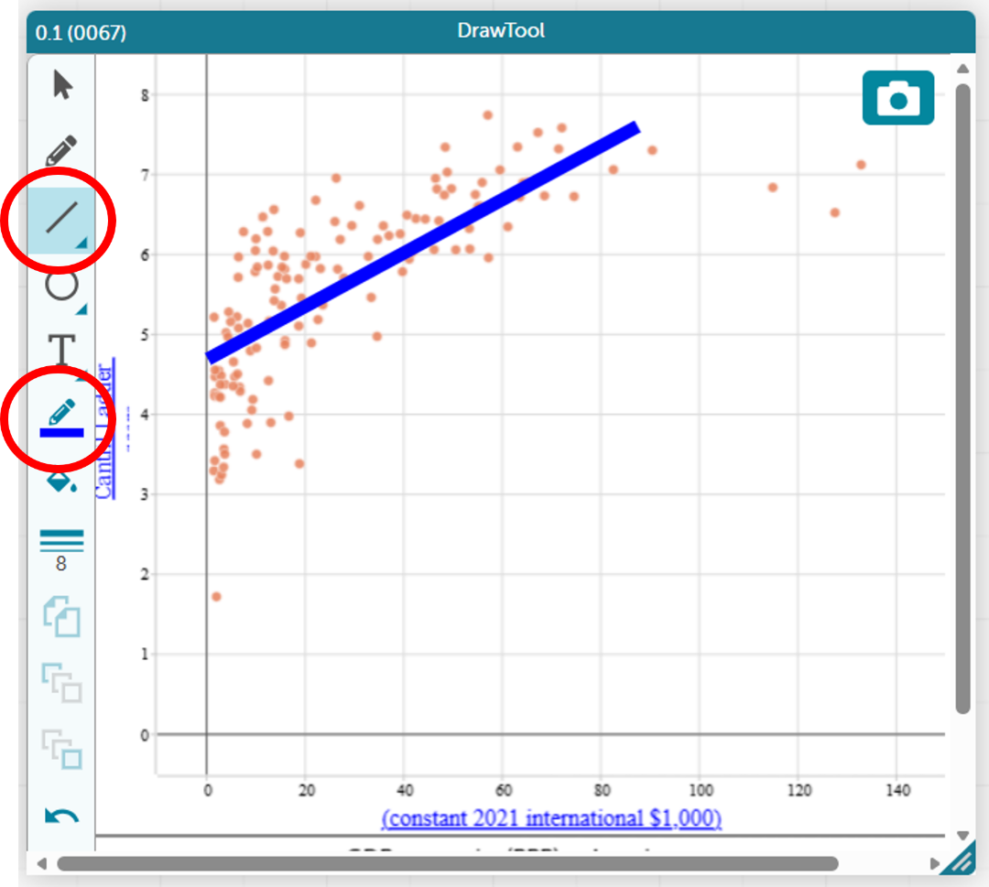
Next, explain that CODAP can calculate a straight-line model using a mathematical method, also known as a least squares regression line. Ask students to add a calculated line to their scatterplot.
Invite students to compare the calculated line with the line they originally drew:
- Where do the lines differ the most, and what might explain those differences?
- If you used each line to make a prediction, would the predictions be the same or different?
Using CODAP to find the line of best fit (least squares regression line)
CODAP uses the least squares regression to find the equation and display the line of best fit. It gives the equation of this line in worded form, which assists students in interpreting and using this line.
Select the scatterplot, then click on the ruler icon to the right of the scatterplot and tick “Least Squares Line”.
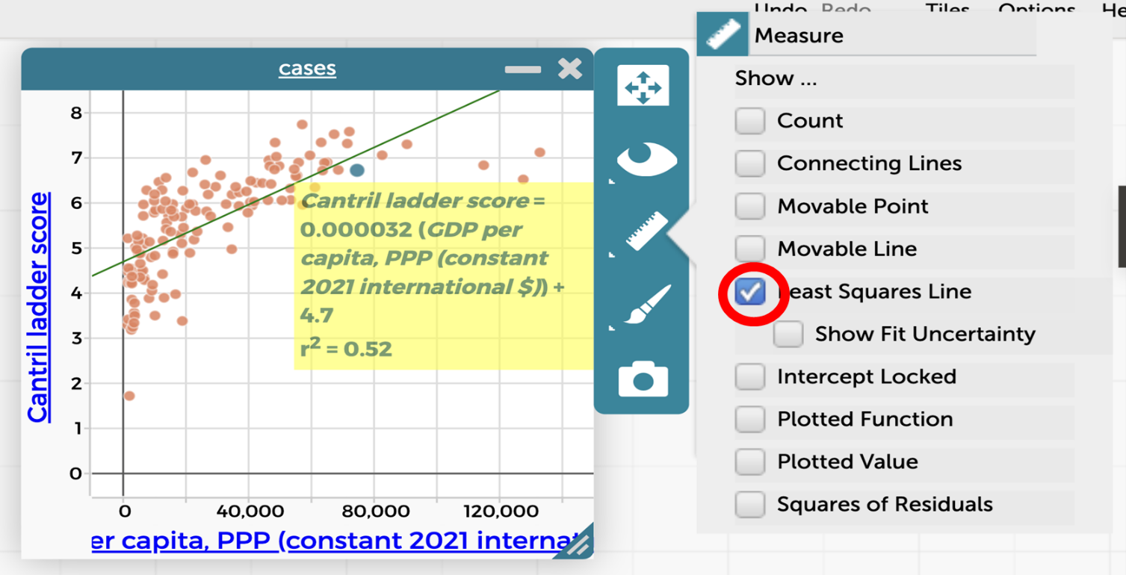
The scatterplot will now look like this:
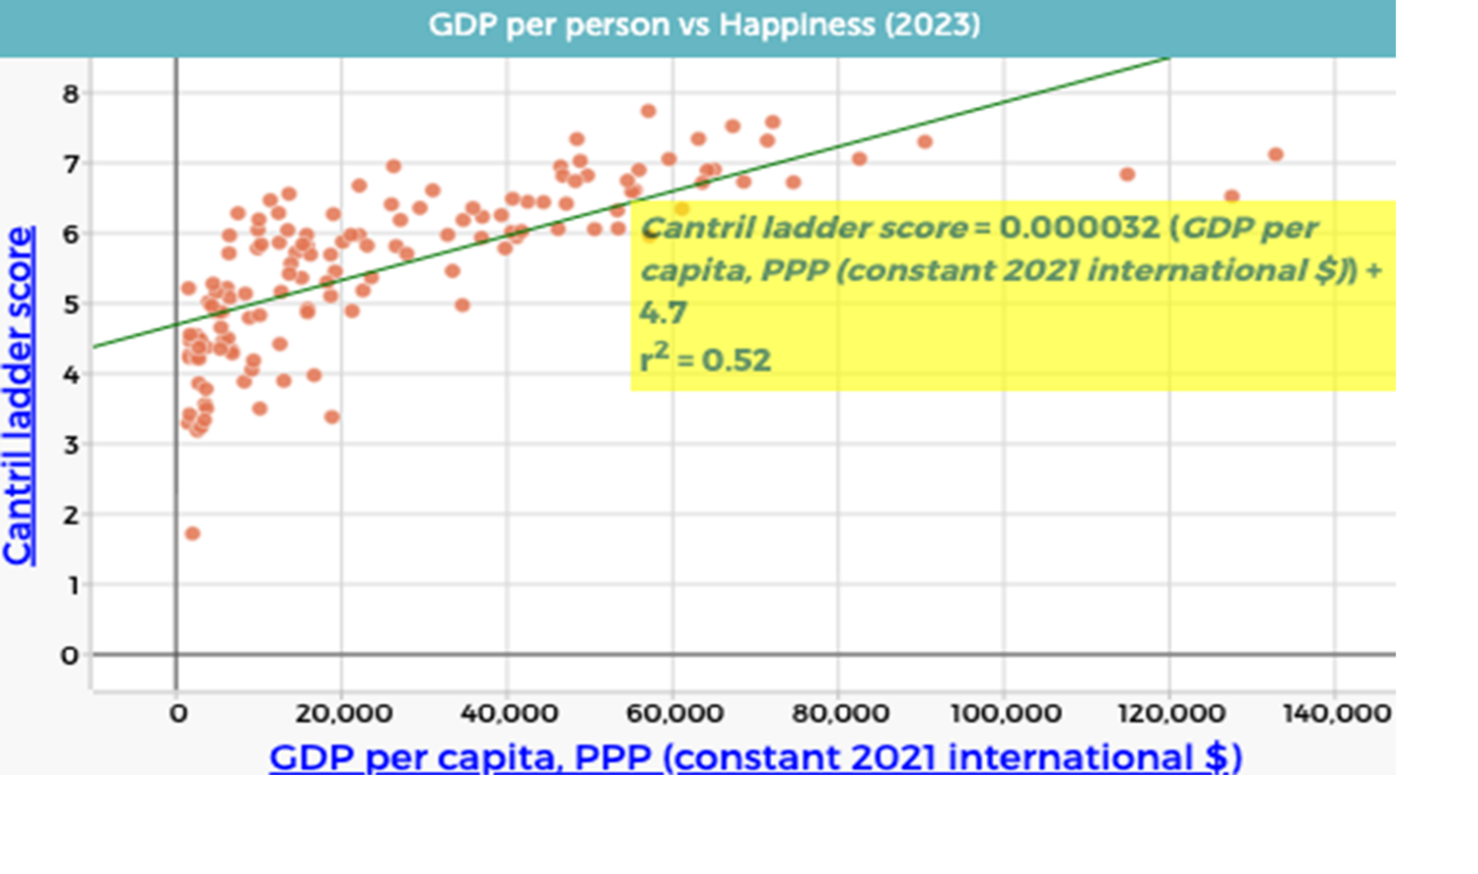As a class agree that CODAP has generated the equation:
$$Cantril Ladder score = 0.000032 × GDP per capita (PPP) + 4.7$$
Remind students that this equation has the same form as $y = mx + c$, where the gradient and intercept have contextual meanings.
Explain that the small gradient reflects the large scale of GDP values. Replace “GDP per capita (PPP) (constant 2021 international $)” with “GDP per capita (PPP) (constant 2021 international $1,000)” by dragging the appropriate column onto the horizontal axis. This results in the equation
$$Cantril Ladder score = 0.032×GDP per capita (PPP) + 4.7$$
which represents the same relationship on a more interpretable scale.
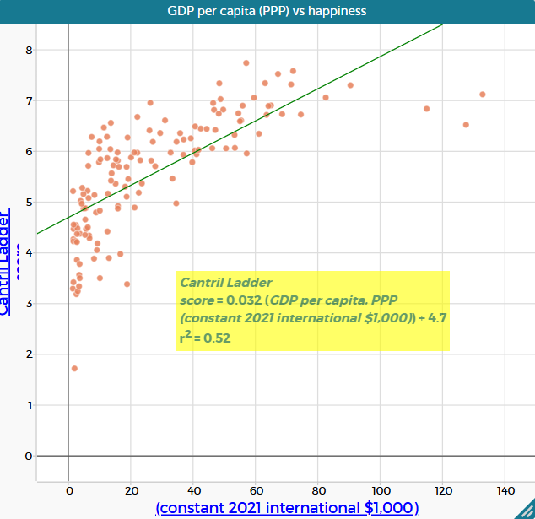

Problem in context | Using the line of best fit
Show slide 17 of What makes us happy? PowerPoint which shows the relationship between GDP per capita (PPP) and the Cantril Ladder score.
Ask:
- What is the gradient for this line of best fit? What does the gradient mean in this context?
  - The gradient is 0.032. This means that for every additional $1 000 in GDP per capita (PPP) (one unit on the horizontal axis), the average happiness score is predicted to increase by about 0.032 points on the Cantril Ladder scale.
- What is the$y$-intercept of the line of best fit? What is the meaning of the $y$-intercept in this context? Is it useful?
  - The $y$-intercept is 4.7. It represents the predicted happiness score when GDP per capita (PPP) is zero. This is not meaningful in this context, as no country has a GDP per capita (PPP) of $0.
- Using the line of best fit, what happiness score would you predict for a country with a GDP per capita (PPP) of $100 000?
  - The predicted happiness score would be approximately 7.8.
- Using the line of best fit, what GDP per capita (PPP) would you predict for a country with a happiness score of 6?
  - The predicted GDP per capita (PPP) would be approximately $40 000.
Provide students with the Predicting happiness Student sheet. This sheet asks students to choose any five countries then use the equation of the least squares regression line to calculate the predicted Cantril Ladder score and compare their predicted results with the actual Cantril Ladder scores according to the data.

Results in context | Making predictions
Ask:
- How closely did your predicted values match the data shown on the scatterplot? Which result(s) are you more confident in?
  - Some predictions using the equation will closely match the actual Cantril Ladder score, some will not. Points on the scatterplot that are far from the line of best fit will have the largest residuals (differences between actual and predicted values).
- Where does Australia fit on this graph and how does it compare to the prediction?
  - Australia has a GDP per capita (PPP) of $59 550 and an actual Cantril Ladder score of 7.06. Using the equation, the predicted happiness score is $0.032 × 59.55 + 4.7 = 6.61$. Australia’s actual score is therefore 0.45 points higher than predicted, which can be seen on the scatterplot—the point for Australia sits above the line of best fit.
  - Explain that this is an example of prediction based on interpolation, that is, estimating values within the range of the observed data.
- What if we used a GDP per capita (PPP) value of $200 000?
  - This would give a Cantril Ladder score of approximately 11.1, which does not make sense as the top of the scale is a score of 10. This suggests that the linear model is not appropriate for predicting happiness at very high GDP per capita values.
  - Explain that this is an example of prediction based on extrapolation, that is, estimating values outside the range of the observed data.
- What GDP per capita (PPP) would produce a happiness score of 10? Is it possible to have a happiness score of 10?
  - When Cantril Ladder score = 10:
$$10=0.032×\text{GDP per capita (PPP)}+4.7 \\ 10-4.7=0.032×\text{GDP per capita (PPP)} \\ 5.3=0.032×\text{GDP per capita (PPP)} \\ \text{GDP per capita (PPP)}=5.3÷0.032 \\ \text{GDP per capita (PPP)}=165.625$$Solving the regression equation gives a predicted GDP per capita (PPP) of $165 625 for a Cantril Ladder score of 10.
  - Note that the three countries with the highest GDP per capita (PPP) (Ireland, Singapore and Luxembourg) all have Cantril Ladder scores that fall noticeably below the line. While, in theory, all citizens in a country could report the highest possible Cantril Ladder score, in reality human experience and life circumstances mean this is unlikely. This also highlights that happiness is not solely determined by economic wealth.
- What GDP level relates to a Cantril Ladder score of 4.5? What does this result mean?
  - When Cantril Ladder score = 4.5:
$$4.5=0.032×\text{GDP per capita (PPP)}+4.7 \\ 44.5-4.7=0.032×\text{GDP per capita (PPP)} \\ -0.2=0.032×\text{GDP per capita (PPP)} \\ \text{GDP per capita (PPP)}=-0.2÷0.032 \\ \text{GDP per capita (PPP)}=-6.25$$As a measure of a country’s total income, GDP per capita cannot be negative.
  - This result suggests that the model begins to fail at lower values of happiness and will never predict a Cantril Ladder score below 4.7 (the $y$-intercept). This is an issue as a number of countries on the graph have a happiness score below this value.
Remind students that the sequence began with the question: Is there a relationship between the wealth of a country and its happiness rating? Based on the data and models explored, invite students to think how they might answer this question now.
Discuss:
- How did using a line of best fit help you move from a general impression of the data to a more evidence-based conclusion?
- What does the line of best fit capture well about the relationship between the two variables, and what does it leave out?
- Why do some countries lie far above or below the line of best fit? What does this tell us about using wealth alone to explain happiness?

Lesson 4

(Y10)

Lesson 4 • The wealth and happiness of continents
To read the most recent version of this lesson, download associated resources, and view embedded professional learning including classroom videos and work samples, visit: https://resolve.edu.au/teaching-sequences/year-10/mathematical-modelling-what-makes-us-happy/lesson-4-wealth-happiness-continents

Lesson overview
Students compare scatterplots across continents to examine how relationships vary between subgroups and how context affects interpretation.

Learning goals
Examining subsets of data can change what we notice about a relationship.
Comparing groups helps us understand whether patterns are consistent.
The context and size of a dataset affect how much we can trust our interpretations.

Resources
Each student
- Access to a computer and the online data analysis tool CODAP (https://codap.concord.org/). Alternatively, students can work together in pairs with a shared computer.
- What makes us happy? Spreadsheet

Lesson phase | Estimated time | Lesson type
Results in context | Scatterplots for continents | 30 minutes | Small group/Individual
Results in context |  How happy are continents? | 15 minutes | Whole class

Teach this lesson

Results in context | Scatterplots for continents
Explain to students that they will use CODAP to create separate scatterplots and lines of best fit for each of the five continents (Africa, Americas, Asia, Europe, and Oceania), and then compare the relationships across continents.
Provide students with access to the What makes us happy? Spreadsheet and ask students to open the sheet titled 2023 continents. This data has been retrieved from the World Happiness Report.
Ask students to use the data to create five separate scatterplots, one for each continent, showing the relationship between GDP per capita (PPP) of each country and the Cantril Ladder score for 2023. For each scatterplot, students should add a line of best fit.
Before students compare the graphs, point out that CODAP automatically adjusts the scales on each scatterplot to suit the data. Explain that this means the axes may not be the same across continents, so patterns can appear more or less pronounced simply because of differences in scale. Emphasise that students should focus on features such as the overall direction of the relationship, the clustering of points around the line, and the consistency of the pattern, rather than the apparent steepness or spread alone.
Ask students to use each graph to make predictions, such as What would the predicted Cantril Ladder score be for a country with a GDP per capita (PPP) of $50 000 in this continent?” Students should make and compare predictions for each continent.
Scatterplots, equations, and calculated Cantril Ladder scores for continents
The examples below show separate scatterplots and lines of best fit for each continent, along with the predicted happiness score for a country with a GDP per capita (PPP) of $50 000. These examples are provided to support comparison across continents.
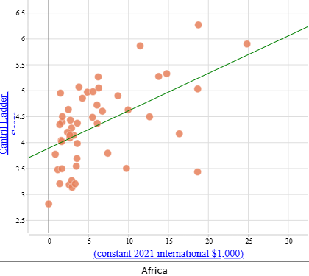 | Cantril Ladder score:  $$0.04 ×GDP per capita (PPP) + 4.27$$  When $\text{GDP per capita (PPP)}=\$50 000:$$$\text{Cantril Ladder score}=0.04×50+4.27 \\ Cantril Ladder score=6.27$$
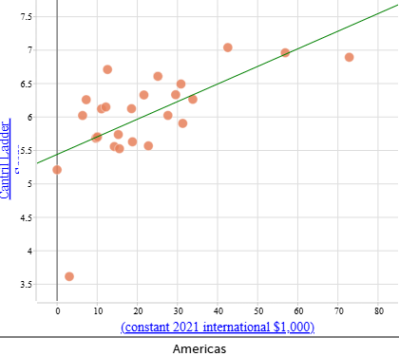 | Cantril Ladder score:  $$0.02 × GDP per capita (PPP) + 5.66$$  When $\text{GDP per capita (PPP)}=\$50 000$:  $$\text{Cantril}\text{ Ladder score}=0.02×50+5.66 \\ \text{Cantril Ladder score}=6.66$$
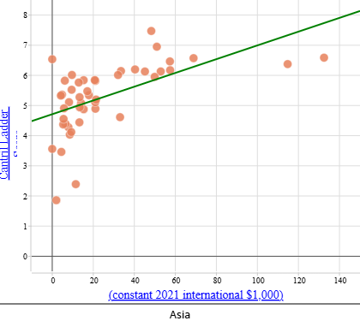 | Cantril Ladder score:  $$0.024 ×GDP per capita (PPP) + 4.8$$  When $\text{GDP per capita (PPP)}=\$50 000$:  $$\text{Cantril}\text{ Ladder score}=0.024×50+4.8 \\ Cantril Ladder score=6.00$$
When comparing the scatterplots, some continents show a clearer relationship between GDP per capita (PPP) and Cantril Ladder score than others. In Europe (not shown above) and the Americas, the data points tend to cluster more closely around the line of best fit, suggesting a stronger and more consistent linear relationship. In contrast, Africa shows a much wider spread of points relative to the line, indicating a weaker relationship between wealth and happiness.
These differences can be identified by looking at how tightly the data points cluster around the line of best fit and how consistently the pattern is followed across the range of GDP per capita (PPP) values, rather than by relying on numerical measures.
Note that the scales on these scatterplots are automatically adjusted to suit each dataset. This means that care must be taken when comparing graphs across continents, as differences in scale (particularly for Asia, which has a wider range of happiness scores) can affect how patterns appear visually.
Creating multiple datasets in CODAP
When you copy multiple datasets into CODAP, they are usually named the same way (‘clipboard data’), which can make it difficult to navigate.
Clicking on the title at the top of a table or graph allows you to edit the title and change the name to something more appropriate.
Watch the video below to see how you can distinguish between your datasets in CODAP.
https://www.youtube.com/watch?v=wZRZFpeyFLg
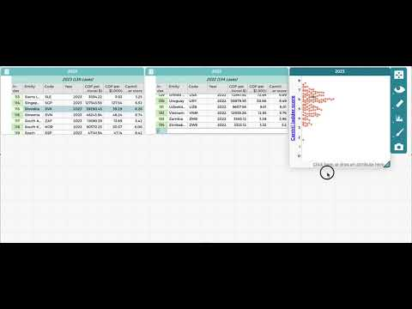

Results in context | How happy are continents?
Remind students that the sequence began with the question: Is there a relationship between the wealth of a country and its happiness rating? Explain that when a line of best fit is drawn for a subgroup of data, such as a continent, it is recalculated using only the data points in that subgroup.
Discuss:
- How does separating out the data for different continents help highlight important differences in relationships between GDP per capita (PPP) and the Cantril Ladder score?
  - Separating the data helps make patterns easier to see compared to when countries are combined into a single scatterplot. This helps show that a single global model may oversimplify the relationship and that regional context matters when interpreting data and making predictions.
- What do you notice about the scatterplot for Oceania? What countries are included/excluded in the data? What does that mean in terms of how you can use these results to make predictions?
  - The Oceania dataset contains only two countries, Australia and New Zealand, most likely because comparable data are not available for many Pacific Island nations. While it is possible to draw a line of best fit that passes perfectly through these two data points, this does not make the model reliable or meaningful. With so little data, there is insufficient evidence to draw conclusions about relationships across Oceania, particularly given that Australian and New Zealand differ substantially from many other countries in the region in terms of income and development.
- Do the scatterplots by continent show the same trends in correlation compared to the scatterplot for all nations? What does this mean in terms of our ability to make predictions?
  - Like the scatterplot for all nations, all scatterplots by continent show a positive correlation, except Oceania, where the very small number of data points makes any assessment unreliable.
  - The strength of correlation varies quite significantly by continent—strongest in Europe and the Americas and weaker in Asia and Africa.
  - We can be more confident using the equations to make predictions for Europe and the Americas because the data show a clearer and more consistent linear pattern, and less confident for Asia and Africa where the relationship is weaker or more variable.
- Why might a regression model fitted to one content be a poor model for predicting happiness in another continent?
  - Different continents show different patterns in the relationship between GDP and happiness. In some continents, countries with similar GDP levels have similar happiness scores, while in others they do not. A regression line is calculated using only the data from the continent being analysed. This means the line depends on how many countries are included, how spread out their GDP values are, and how much variation there is in happiness at similar GDP levels. As a result, a regression model that gives reliable predictions for one continent may give much less reliable predictions for another.

LESSON 5

(Y10)

Lesson 5 • What else makes us happy?
To read the most recent version of this lesson, download associated resources, and view embedded professional learning including classroom videos and work samples, visit: https://resolve.edu.au/teaching-sequences/year-10/mathematical-modelling-what-makes-us-happy/lesson-5-what-else-makes-us-happy

Lesson overview
Students use $r^{2}$ to compare models and evaluate whether observed relationships support prediction, explanation, or causal claims.

Learning goals
The coefficient of determination, $r^{2}$, helps us understand how much of the variation in one variable is explained by a linear model.
Comparing values such as $r^{2}$ helps us judge the relative strength of linear models.
A strong correlation does not necessarily mean that one variable causes change in another.

Resources
Whole class
- What makes us happy? PowerPoint
Each group
- Interpreting $r^{2}$ Student sheet
- Causation vs correlation Student sheet
Each student
- Access to a computer and the online data analysis tool CODAP (https://codap.concord.org/). Alternatively, students can work together in pairs with a shared computer.
- What makes us happy? Spreadsheet
- Factors that influence happiness Student Sheet

Lesson phase | Estimated time | Lesson type
Results in context | Measuring correlation | 10 minutes | Whole class
Mathematical results | Interpreting $r^{2}$ through ranking | 15 minutes | Small group
Mathematical problem | Sketching and comparing interpretations of $r^{2}$ | 10 minutes | Whole class
Problem in context | Measuring the abstract | 25 minutes | Whole class/Small group
Results in context | Comparing factors | 20 minutes | Whole class
Problem in context | Correlation and causation | 20 minutes | Whole class/Small group
Problem in context | Factors with direct impact on happiness | 10 minutes | Whole class

Teach this lesson

Results in context | Measuring correlation
Show slide 20 of What makes us happy? PowerPoint which shows three scatterplots, each with a line of best fit and associated $r^{2}$ value.
Give students time to observe the graphs.
Ask:
- What do you notice about the scatterplots with higher $r^{2}$ values?
- How do the points compare to the line of best fit in graphs with lower versus higher $r^{2}$ values?
- What do you think the $r^{2}$ value might be describing?
Explain that $r^{2}$, called the “coefficient of determination”, is a number that describes how well the line of best fit explains the pattern in the data.
Emphasise that:
- a higher $r^{2}$ value means the line does a better job of matching the pattern in the data.
- a lower $r^{2}$ value means that the line does not match the data as closely.
- when points are more spread out from the line, the $r^{2}$ value is lower.
- $r^{2}$ does not describe how steep the line is or whether the relationship is positive or negative.
Students are not expected to calculate $r^{2}$. The focus at this stage is on interpreting what it tells us about the fit of a linear model.

Mathematical results | Interpreting $r^{2}$ through ranking
Provide students with Interpreting $r^{2}$ Student sheet, which includes six scatterplots, each showing a line of best fit and a different amount of spread around the line. Working in groups, students cut out the individual scatterplots and arrange them in an order from highest to lowest expected $r^{2}$ value.
Ask:
- Which scatterplot do you think has the highest $r^{2}$ value, meaning the straight line fits the data most closely?
- What visual features are you using to make your decisions?
- Are there any graphs that are difficult to rank? Why?
Encourage students to justify their rankings using informal language such as tighter, more clustered, more spread out, or more scattered, rather than numerical or formula-based explanations.
Once students have agreed on a ranking, show slide 21 of What makes us happy? PowerPoint, and reveal the actual $r^{2}$ values. Discuss how closely the group rankings align with the values shown. Emphasise that $r^{2}$ is about how well the line of best fit explains the pattern in the data, not about the steepness or direction of the line.
Draw students’ attention to any pair of scatterplots that appear to have a similar amount of visual spread but noticeably different $r^{2}$ values (e.g. Graphs 4 and 5).
Ask:
- At first glance, these two graphs look similarly “messy”. Why might their $r^{2}$values still be very different?
  - In both graphs, the points wobble up and down by a similar amount around the line. However, in Graph 4, the line itself moves a lot from left to right, while in Graph 5, it only moves a small amount. This means the line in Graph 4 explains much more of the variation in $y$ than the line in Graph 5, despite visually having a similar level of “messiness”.
- Which graph would help you make a more confident prediction of $y$ if you only knew $x$? Why?
  - Graph 4 would support more confident predictions because its line of best fit has a steeper gradient. As $x$ increases, $y$ changes by a larger amount, so knowing $x$ meaningfully narrows the likely values of $y$. In Graph 5, the gradient is shallow, so $y$ changes only a small amount as $x$ increases. As a result, many different $y$-values occur across the same $x$ -values, making predictions less certain.
- What does this comparison tell us about what $r^{2}$ measures?
  - $r^{2}$ does not measure how noisy or messy the data look on their own. It measures how much of that variation is explained by the line of best fit. A graph can look fairly neat but still have a low $r^{2}$ if the line explains very little of the overall variation.

Mathematical problem | Sketching and comparing interpretations of $r^{2}$
Ask students to individually sketch a scatterplot that they think could reasonably have an $r^{2}$ value of 0.75, and then a second sketch that could reasonably have an $r^{2}$ value of 0.25. Students should include a line of good fit on each sketch. Emphasise that there is no single correct sketch.
Invite students to share their sketches by:
- holding them up.
- posting an image on a shared electronic whiteboard.
Discuss:
- What similarities do you notice across sketches for $r^{2} = 0.72$?
- Do any sketches look quite different from one another but still have similar $r^{2}$ values? Why might that be?
- What features seem essential for a sketch to be consistent with a higher or lower $r^{2}$?
Guide the discussion towards the idea that:
- $r^{2}$ describes the overall clustering around the line, not the exact shape or arrangement of points.
- many different scatterplots can be consistent with the same $r^{2}$ value.
Ask students to revisit their original sketches for $r^{2} = 0.75$ and $r^{2} = 0.25$, and make any changes based on this discussion.
Challenge students to sketch two new scatterplots for each $r^{2}$ value that are visibly different from your original sketches but could still reasonably have the same $r^{2}$ value. Each sketch should include a line of good fit.

Problem in context | Measuring the abstract
Pose the question: What other factors make us happy?
Remind students that at the start of the sequence they brainstormed a wide range of factors they believed might influence happiness. Explain that while many of these ideas are important, the following investigation will focus on a small number of factors for which reliable global data are available.
Show slide 22 of What makes us happy? PowerPoint which displays a list of additional factors:
- health (life expectancy)
- education (years of schooling)
- access to clean water
- hunger
- urbanisation
Students can access data for 201 countries on the available factors, as well as GDP per capita (PPP), from the sheet titled Other factors in the How happy are we? Spreadsheet.

How this dataset is measured and our data sources
Health is represented using life expectancy. The data use period life expectancy, which estimates the average length of life for people born in a given year, based on observed and predicted mortality rates. Data is from the World Bank.
Education is represented by the average number of years of formal schooling completed by adults aged 25 years and over. Data is from the World Bank.
Access to clean water is represented by the percentage of the population without access to an improved water source, such as piped water, boreholes, protected wells or springs, or delivered water. Data is from the World Bank.
Hunger is represented by the percentage of the population that is undernourished, meaning their daily food intake does not provide enough energy to maintain a normal, active, and healthy life. Data is from the Food and Agriculture Organization of the United Nations (FAO).
Urbanisation is represented by the percentage of the population living in urban areas. Note that definitions of urban vary between countries, which may affect comparisons. Data is from United Nations Department of Economic and Social Affairs (UN DESA).

Explain that students will use the statistical tools they have developed to investigate which of these measurable factors appears to be the strongest predictor of happiness and how confident they can be in that judgement.
Organise students into small groups. Ask each group to:
- Select one factor from the list that they believe will best predict happiness across countries.
- Justify their choice using reasoning from earlier brainstorming in Lesson 1, general knowledge, or prior discussion (no data yet).
- Predict the strength of the relationship (weak, moderate or strong) and the direction (positive or negative).
Each group should then:
- Create a scatterplot using CODAP which shows the relationship between the Cantril Ladder score and their chosen variable.
- Add a line of best fit.
- Record the equation of the line and $r^{2}$ value.
- Make one interpolation prediction and explains its meaning in context.
Students can record their results on the Factors that influence happiness Student Sheet.

Results in context | Comparing factors
Construct a summary table on the board, for example:
Factor | Predicted strength | Actual $r^{2}$ value | What did we learn?
Invite all groups to contribute their findings to the table.
Discuss:
- Which factor produced the largest $r^{2}$ value?
- How close were your predictions to the data?
- Were any of the relationships weaker or stronger than expected?
- Did any factor provide a particular convincing model for predicting happiness?
Remind students that a large $r^{2}$ value indicates tighter clustering around the line of best fit but may explain only part of the variation in happiness, supporting the idea that happiness is influenced by multiple interacting factors rather than a single measurable cause.

What is the relationship between happiness and these other factors?
In each case, analysis of the relationship between happiness and health, education, access to clean water, hunger, and urbanisation shows only a weak to weak–moderate correlation. This suggests that factors such as wealth, health, education, sufficient food, access to clean water, and urban living each contribute to happiness to some extent, but none alone strongly predicts happiness levels across countries.
The absence of a strong correlation with any single factor indicates that happiness is influenced by multiple interacting factors. It also suggests that other influences, such as personal freedom, social support, safety, and employment, may play a more significant role in shaping happiness than any one measurable variable on its own.
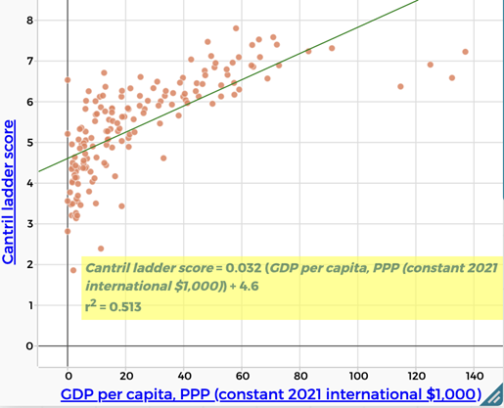 | Wealth/GDP per capita, PPP  There is a moderate positive correlation between Cantril Ladder score and wealth (GDP per capita, PPP). ($r^{2} = 0.513$)  People who are more wealthy are more likely to report being happy.
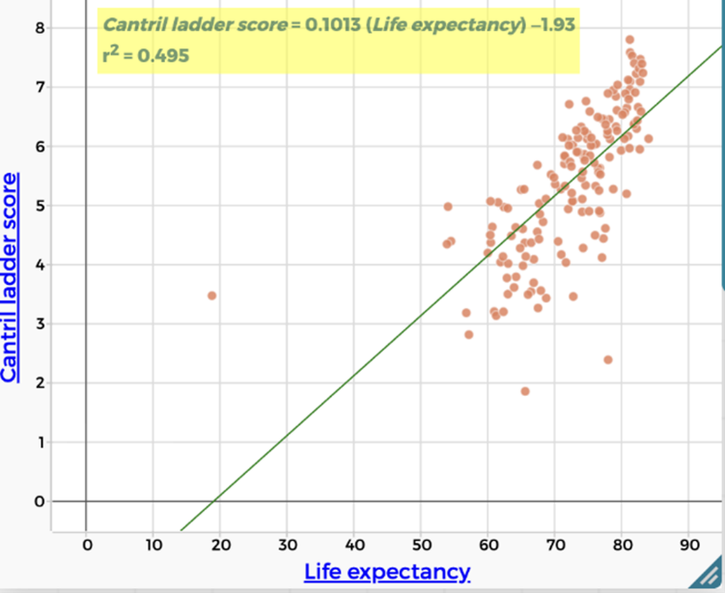 | Health/Life expectancy  There is a weak positive correlation between Cantril Ladder score and life expectancy. ($r^{2} = 0.495$)  People who are expected to live longer are more likely to report being happy.
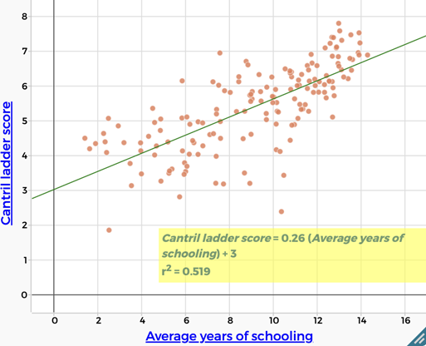 | Education  There is a moderate positive correlation between Cantril Ladder score and education levels (years of schooling). $(r^{2} =0.519$)  More highly educated people are more likely to report being happy.
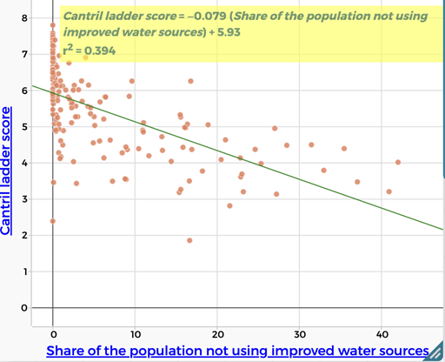 | Lack of access to clean water  There is a weak negative correlation between Cantril Ladder score and a lack of access to clean water. $(r^{2} =0.394$)  People lacking access to clean water are less likely to report being happy.
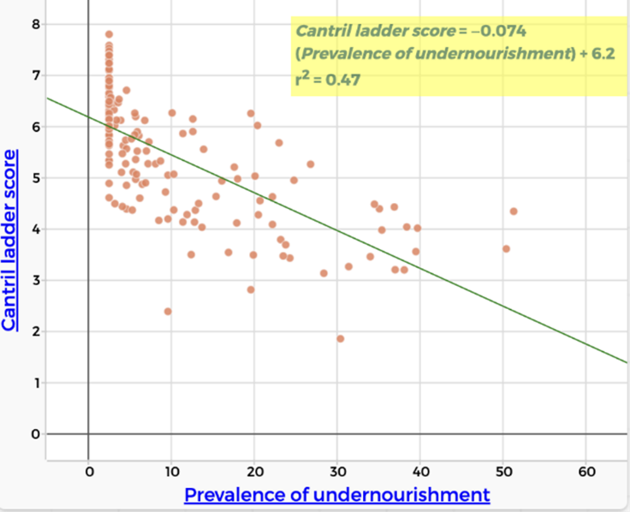 | Hunger  There is a weak negative correlation between Cantril Ladder score and hunger. $(r^{2} =0.47$)  People who experience hunger are less likely to report being happy.
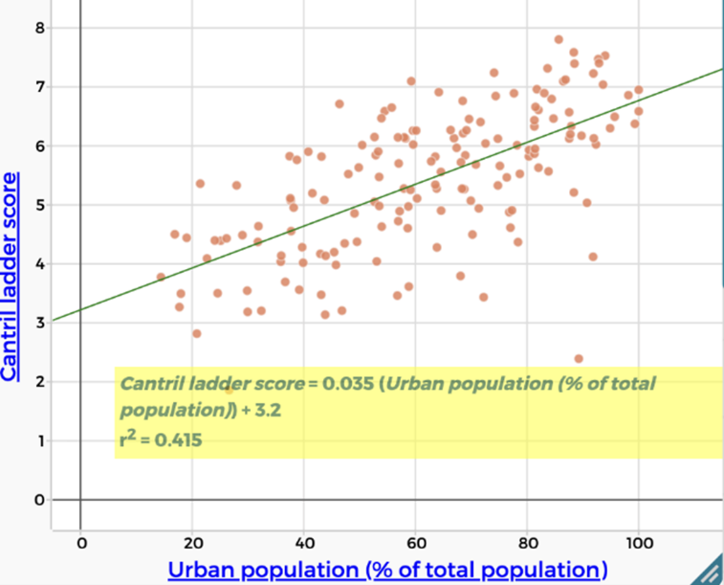 | Urbanisation  There is a weak positive correlation between Cantril Ladder score and urbanisation. $(r^{2} =0.415$)  People living in urban areas are more likely to report being happy.

Ask students to identify which factors from their original brainstorm are not represented in the data and to consider why these factors may be difficult to measure consistently at a global scale.

Problem in context | Correlation and causation
Remind students that throughout the sequence they have used scatterplots, lines of best fit, and $r^{2}$ values to identify and compare relationships between variables. Explain that while these tools are powerful for identifying correlation, they do not automatically tell us why a relationship exists.
Display slide 23 of What makes us happy? PowerPoint to illustrate how two variables can be strongly correlated without one causing the other. In this example, the global number of pirates and global average temperature show a strong correlation over time, but there is no causal link between them. The decrease in piracy is better explained by factors such as changes in naval patrols, international law, and technology, rather than by rising temperatures.
Explain that students will now examine a set of relationships drawn from the data to consider:
- which relationships may involve one factor directly influencing another (direct effect).
- which relationships appear related because they are both influenced by something else.
- how other variables that are not shown can affect how we interpret the data.
Organise students into small groups. Provide each group with a set of eight graph cards from the Causation vs correlation Student sheet, each showing a scatterplot with a line of bets fit and $r^{2}$ value. Ask groups to sort the cards into three categories:
- It is reasonable to argue that one variable causes the other.
- The variables are related, but the graph alone does not justify a causal claim.
- There is not enough information to decide.
For every card, groups must give at least one reason for their decision.
Before students begin, explain that a good reason for accepting or rejecting a causal claim should focus on whether the relationship makes sense in the real world, not just on what the graph looks like. Some prompting questions include:
- Does it make sense that changing one of these things would actually cause the other to change?
  - Having more money might improve living conditions, but it doesn’t guarantee that people will feel happier.
- Could there be other factors affecting both variables at the same time?
  - GDP per capita (PPP) and happiness might be related because wealth affects things like healthcare and education, which also affect happiness.
- Is it clear which variable could come first (dependent vs independent)?
  - It’s hard to tell if education causes happiness, or if happier, more stable countries invest more in education.
- Does the strength of the relationship support a causal claim?
  - A scatterplot might have a high $r^{2}$ value, indicating the two variables are strongly related. However, a strong correlation on its own does not prove that one variable causes the other.
Emphasise that students are not being asked to prove causation. Their task is to decide whether the data and the real-world context make a causal explanation reasonable, or whether the relationship is better understood as correlation only.

Problem in context | Factors with direct impact on happiness
Ask students to reconsider the factor that produced the highest $r^{2}$ value across the class.
Ask:
- Is this factor a useful predictor of happiness? Is it a direct cause of happiness?
- What would we need to know or measure to be more confident about this causal claim?
Emphasise that:
- a variable can be a strong predictor without being a cause.
- prediction and explanation are different goals.
- mathematics helps us test claims, but interpretation requires judgement.

