Task 5 • Sorting using place value
(Y2)

Choose numbers to go in the circles so that 25 belongs in both groups.
Label the two groups.
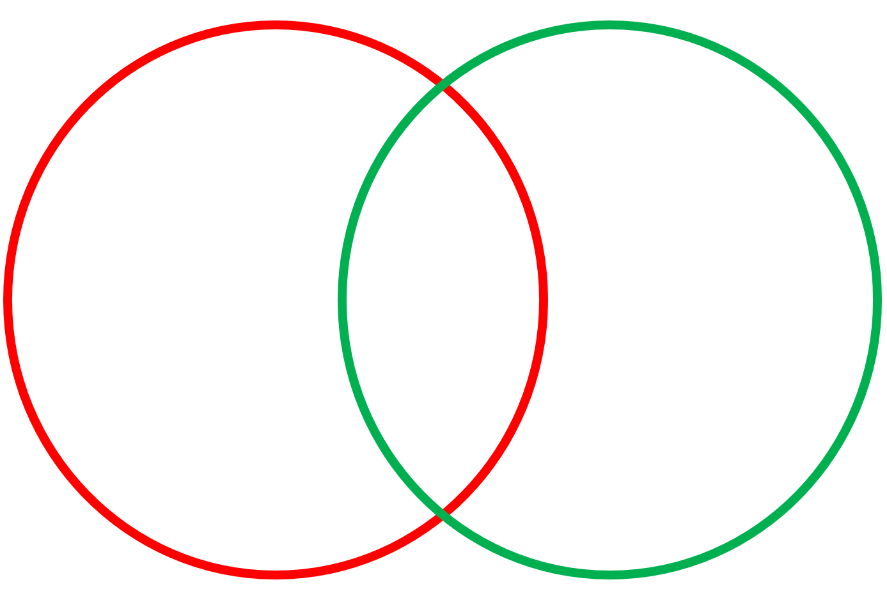
25

Choose numbers to go in the circles so that 275 belongs in both groups.
Label the two groups.
275

Choose numbers to go in the circles so that 36 belongs in both groups. What numbers could go in the other circles?
Label the three groups.

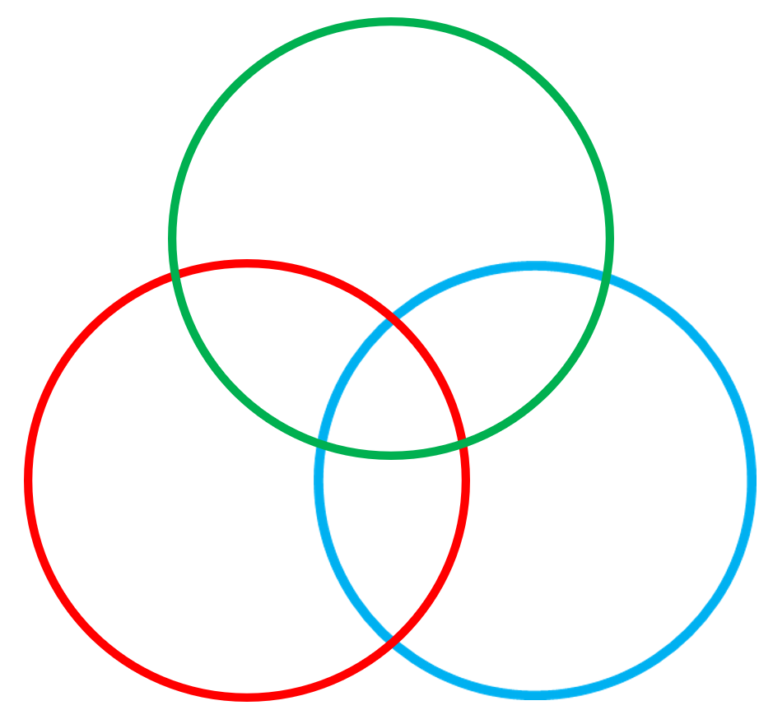
36

