
TASK 1

(Y2)

Task 1 • How will you sort it?
To read the most recent version of this task, download associated resources, and view embedded professional learning including classroom videos and work samples, visit: https://resolve.edu.au/teaching-sequences/year-2/place-value-whats-number/task-1-how-will-you-sort-it

Task overview
Students classify and sort numbers in different ways.

Learning goals
Numbers can be sorted and classified in different ways.
Numbers are made up of digits.

Resources
Whole class
- What’s in a number? PowerPoint
Each group
- Number cards to sort Student sheet
- One of the following:
  - Scissors (to cut out number cards)
  - Sticky notes & pencil (to copy each number onto a sticky note)
- A4 sheet of paper
- Glue

Task phase | Estimated time | Lesson type
Launch | All sorts! | 10 minutes | Whole class
Explore | Sorting numbers | 20 minutes | Small group
Connect | Our number sorting | 15 minutes | Whole class
Summarise | Number properties | 5 minutes | Whole class

Teach this task

Launch | All sorts!
Set the scene by asking: What do you notice about the students in this class? Focus students’ attention on similarities that they share with others to establish the idea of noticing and comparing. Suggestions might include:
- hair colour
- long hair/short hair
- wearing shorts/not wearing shorts
- eye colour
- shoes (laces vs buckles, colour)
- canteen lunch/packed lunch
- walk to school/car/bus/bike
Ask: We are going to sort our class into groups. How could we decide to sort students who are similar in some way?
Invite students to physically form groups based on a feature they share with their peers. Once students are grouped ask students to form new groups based on a different feature. Change the focus feature several times to support students to recognise that ‘things’ can be classified in different ways.
Discuss:
- What do you notice that makes you the same?
- Why do the groups change when we use a different feature to sort each other?
  - Classifying and sorting involves noticing specific features/attributes that make things similar and putting the things into groups based on these attributes. When a different attribute becomes the focus, the groups might change.
Explain that classifying and sorting are important skills used by mathematicians to organise things which are similar into groups. They sort numbers, shapes, objects, and even data by looking for similarities and differences.
Show slide 3 of What’s in a number? PowerPoint.
Pose the task: We are mathematicians and we are going to sort some numbers. I wonder how you could sort these numbers.

Explore | Sorting numbers
Divide students into pairs to work together. Provide each pair with Number cards to sort Student sheet and either scissors (for cutting out the number cards) or pencils and sticky notes (for copying out the numbers).
Allow students time to prepare (cut out/copy) the numbers to make a set of number cards and to find a way to sort their numbers into groups.
After sorting their numbers one way, challenge students to find a different way to sort the same numbers.
Invite students who are finding it hard to get started or who need some ideas to go on a spy walk, to give them chance to quietly observe their peers’ work and to get back on track.

Noticing student thinking
- Do students sort their cards into groups based on:
  - numbers that contain the same digit, e.g. 4 in 24, 34, 40, 47...?
  - numbers that have a zero and numbers that don’t have a zero?
  - one-, two- and three-digit numbers, e.g. grouping 2 and 7, 34 and 27, 140 and 142?
  - odd and even numbers?
  - place value, e.g. numbers that have a 4 in the tens place, a 7 in the ones place...?

Questioning to prompt student thinking
- How are the numbers within a group similar and how are they different?
  - The numbers in the group will be sorted based on one obvious similarity. There will be other similarities within each group as well. Prompt students to consider the numbers within the group more deeply. They may look at making smaller groups within the larger group.
- Are there any numbers that could fit in more than one group in your sort?
  - Some numbers may fit into more than one group.
- These numbers (indicate specific numbers) all contain the same digit, but they are not the same number. Why?
  - We want students to notice and articulate that although numbers might contain the same digit, the position the digit holds in the number changes the number’s value.
Provide each pair of students with A4 paper and a glue stick to make a labelled diagram showing one way that they sorted their numbers. Students should label each group with a title or an explanation of the category.
Select a few labelled diagrams for students to share during the Connect phase.

Connect | Our number sorting
The purpose of this Connect phase is to for students to understand that:
- the position of a digit in a number gives it value.
- 2-digit numbers are made up of tens and ones.
- 3-digit numbers are made up of more than 10 tens (hundreds) and ones.
Invite selected pairs of students to share how they sorted their numbers. Focus on the number properties used to sort. These may include:
- numbers that contain the same digit e.g. 4 in 24, 34, 40, 47....
- numbers that have the same digit at the start/end.
- numbers that do/don’t have a zero.
- numbers that contain the same number of digits.
- place value properties.
Focus students’ attention on place value properties by using the language of place value to describe the numbers sorted, e.g. tens place, value, worth 2 tens, etc.
Discuss:
- How are the numbers within your groups similar?
  - The numbers will be sorted into groups based on one obvious similarity. Prompt students to consider the numbers within the group more deeply. For example, do they have 1, 2 or 3 digits, do they have the same digit, are the numbers made up of tens and ones, only ones, more than 10 tens etc.
- How are they different?
  - The digits in the numbers may be the same but have different positions in the number so their value changes.
- Are there any numbers that could fit into more than one group in your sort? Why do they belong to more than one group?
Draw out and revoice some of the correct terminology when connecting the learning from this task. Encourage students to consider numbers that the position of a digit in a number gives it value, so the same digit has a different value in a number. For example, in 72 the digit 7 has a value of 7 tens, or 70, while in 17 it is worth 7 ones, or just 7. Mathematical language is important—support students to use technical mathematical language.
Show slide 4 of What’s in a number? PowerPoint and discuss the groupings.

Summarise | Number properties
Explain: We can sort numbers into the same group when they are alike in some way. We must know why they belong in that group, so we know which numbers to put into the group and which ones to leave out.
You might choose to use concrete materials (such as pop sticks, ten frames, or Unifix cubes) to model some of the numbers on the sort cards. This helps students see how a digit’s position affects its value.

TASK 2

(Y2)

Task 2 • Number sort
To read the most recent version of this task, download associated resources, and view embedded professional learning including classroom videos and work samples, visit: https://resolve.edu.au/teaching-sequences/year-2/place-value-whats-number/task-2-number-sort

Task overview
Students sort various one-, two- and three-digit numbers to build their understanding of place value.

Learning goals
Numbers can be sorted and classified using their properties.
The position of a digit in a number gives it value.

Resources
Whole class
- What’s in a number? PowerPoint
- 3 hoops (different colours if possible)
- 3 A4 sheets of paper
- Texta
Each group
- Task 2 Number cards to sort Student sheet
- One of the following:
  - Scissors and glue (to cut out and stick number cards)
  - Sticky notes & pencil (to copy each number onto a sticky note)
- A3 sheet of paper
- Glue

Task phase | Estimated time | Lesson type
Launch | How we can sort | 10 minutes | Whole class
Explore | More number sorting | 20 minutes | Small groups
Connect | Tool for sorting | 15 minutes | Whole class
Summarise | Place value properties | 5 minutes | Whole class

Teach this task

Launch | How can we sort
Revise: In the last task we sorted numbers into groups by noticing how they were similar and different.
Show slide 6 of What’s in a number? PowerPoint which displays the numbers 12 and 21.
Discuss:
- What do you notice about these numbers?
- How are the numbers the same?
- How are they different?
- What happens when the digits 1 and 2 swap places in the number?
Ask students to discuss examples of numbers where the same digits in different positions make different numbers, and to share their reasoning and understanding of this.
Show slide 7 and discuss how we can represent and model 12 and 21.
Show slide 8 and explain that students will be sorting these numbers.
Pose the task: Sort these numbers into groups. Then sort them into groups in a different way.

Explore | More number sorting
Divide students into pairs to work together and provide each pair with Task 2 Number cards to sort Student sheet, A3 paper and either scissors (for cutting out the number cards) or pencils and sticky notes (for copying out the numbers).
Allow students time to prepare (cut out/copy) the numbers to make a set of number cards and to sort their numbers into groups in different ways. Ask them to record how they sorted these numbers by drawing a picture of each different sort and labelling the categories/groups.

Noticing student thinking
- Do students use place value or face value (the value of each individual digit) to sort?
- Do they sort into more than two groups?
- Do they label categories to include every number card in their sort?
Spotlight: Highlight student work that demonstrates sorting numbers, including examples of:
- using place value.
- labelling each category.
- using all/most numbers.
- sorting into more than two groups.
- sorting that includes a misconception.
Ask:
- What do you already know that helped you begin?
  - What prior knowledge do students access?
- How did you decide to sort all/most numbers into these groups?
  - Do students recognise that digit position is important to a number’s value?
- Can you explain this part a bit more? (point to a section needing clarification)
- What is another way to sort these numbers?
Allow students time to refine and make changes to how they have sorted the numbers, if they choose.
Ask students to choose their favourite way of sorting the numbers and record this by sticking the groups of sorted numbers onto paper. They may draw around the different groups to make them clear and label the criteria that they used to sort the numbers.
Select student work demonstrating number sorts which show clear place value properties to share and discuss during the Connect phase.

Connect | Tool for sorting
The purpose of this Connect phase is for students to understand that:
- the same digit has a different value in a number depending on its position.
- the same number can belong in different groups depending on how you sort it.
Bring the class together to sit in a circle on the floor. Invite selected students to describe and explain how they sorted the numbers and to justify their choice of categories/labels.
Discuss:
- Why did you sort the numbers in this way?
- Why are numbers with the same digit in different groups?
  - Discuss what students notice about the same digit in different numbers and its value because of its position in the number. For example, 4 has a value of 40 or 4 tens in 40, 140, and 42, but has a value of 4 in 34.
- Were there any numbers which did not belong in any groups? Why did they not belong in a group?
- Did any numbers belong in more than one group? Why do they belong in more than one group?
Arrange 3 hoops where they are visible to the whole class and sort the Number cards into the corresponding hoops as in the below image.
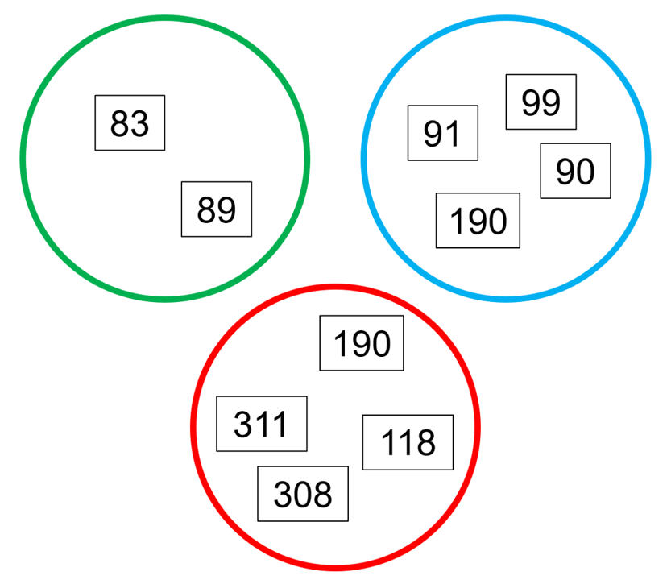
Explain that the hoops represent a Venn diagram, a useful model that mathematicians draw to sort and categorise things.
Ponder: I wonder how these numbers have been sorted.
Invite students to turn and talk to the student next to them and discuss how they think the numbers have been sorted. Prompt student thinking as they engage in turn and talk:
- What do you notice that is similar about the numbers in a circle?
- What do you notice that is different about the numbers in other circles?
Invite students to explain how the numbers have been sorted. They should notice the numbers have been sorted based on the number of tens:
- Green circle: 8 tens or eighty
- Blue circle: 9 tens or ninety
- Red circle: Over one hundred (or more than 10 tens)
  - Students may struggle to explain the idea that there are more than 10 tens in the red group.
Label each circle with these criteria and discuss:
- How can we explain this in another way?
- How many tens altogether in this number?
- Can you think of another way to sort them?
- Do you notice any numbers that fit in more than one circle?
Students may notice that 190 belongs in two groups—ask them to explain why they think it belongs in both.
Ponder: I wonder how we could show that 190 belongs in both groups.
Invite student suggestions and orchestrate the overlapping of the hoops to put 190 in the intersection of the red and blue hoops:
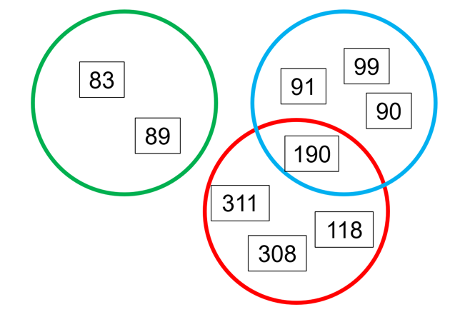
Invite students to describe how 190 fits in this overlap. This is again an opportunity to revoice student responses, using correct terminology, distinguishing between digit and value.

Summarise | Place value properties
Discuss how digits have different values because of their position in a number and that a digit, such as ‘1’ can be worth 1 one, 1 ten or 1 hundred depending on where it is in a number.
Explain: The place of a digit in a number gives its value and when a digit moves places, its value changes.
You may choose to use concrete materials (such as pop sticks, ten frames, or unifix cubes) to model some of the numbers on the cards in the same way as slides 6 and 7 on the PowerPoint—using materials to represent the concrete quantity alongside the number. This helps students see that although the digits change places, the materials cannot simply be swapped because they represent different unit values. For example, 24 and 42 use the same digits but represent different units.

TASK 3

(Y2)

Task 3 • Similarities and differences
To read the most recent version of this task, download associated resources, and view embedded professional learning including classroom videos and work samples, visit: https://resolve.edu.au/teaching-sequences/year-2/place-value-whats-number/task-3-similarities-and-differences

Task overview
Students extend their thinking on properties of place value by using Venn diagrams to show similarities between numbers.

Learning goals
Numbers can be sorted and classified using place value properties.
The position of a digit in a number gives it its unit value.
A number is the sum of its unit values.

Resources
Whole class
- What’s in a number? PowerPoint
Each group
- Task 3 Number cards to sort set 1 Student sheet
- Task 3 Number cards to sort set 2 Student sheet
- A3 sheet of paper
- One of the following:
  - Glue & scissors (to cut up & stick number cards)
  - Sticky notes & pencil (to write out each number on a sticky note)
- Optional: 3 hoops/circle frames or similar, to allow students to engage with sorting using a Venn diagram in a concrete way.
Task phase | Estimated time | Lesson type
Launch | Venn sort | 5 minutes | Whole class
Explore | Sorting strategies | 20 minutes | Small group
Connect | Why does it belong? | 20 minutes | Whole class
Summarise | Using place value properties | 5 minutes | Whole class

Teach this task

Launch | Venn sort
Revise: We sorted numbers into groups in different ways. An important idea is that the place of a digit in a number gives it value. The same digit has different values in different places in a number.
Show slide 10 of What’s in a number? PowerPoint to revisit using hoops to create a Venn diagram to sort numbers.
Discuss:
- how the hoops were useful for sorting numbers into groups.
- how the hoops were helpful to show numbers which belonged in more than one group.
- the sorting criteria used, focusing on place value properties: place/position, digit value, and place value units (hundreds, tens and ones).
Show slide 11 and recap why the number 190 belongs in more than one group.
Remind students to use what they know about how the position of a digit in a number gives it its value, to help them to sort number cards into groups.
Pose the task: How might you sort your numbers and what rules might you use to label each group? Look out for numbers which might fit in more than one group.

Explore | Sorting strategies
Divide students into pairs to work together. Provide each pair with either Task 3 Number cards to sort set 1 Student sheet or Task 3 Number cards to sort set 2 Student sheet, A3 sheet of paper and either glue or sticky notes.

Differences between set 1 and set 2
- Number cards to sort set 1 has examples of two-digit numbers where the digits have been swapped to build on Task 2. Number cards to sort set 2 has more three-digit examples of numbers with similar digits which are in different positions, which may be more challenging.
Allow students time to prepare (cut out/copy) the numbers to make a set of number cards and to sort their numbers into groups using place value properties to label their groups.
Students can use hoops/circles to create their Venn diagrams or draw circles around their groupings to show which numbers overlap.

Questioning to prompt student thinking
- What do you notice about the number cards you have? What similarities are there between some numbers?
- How might you sort these numbers? What rules could you use to label each group?
- What do you know about the position of each digit in the number that may help?
- How can you label your groups to show that some numbers can belong to two groups?
Prompt students to consider if any of their numbers might even belong in three groups.
Ask them to think about ways to show how the numbers belong to more than one group.

Noticing student thinking
- Have students organised their numbers using place value, focusing on the place of each digit (hundreds, tens and ones) in a number?
- Does each group have a clear label?
- Does their labelling allow for numbers to belong in more than one group?
- Have they created groups where numbers belong in more than one group?
- Are there numbers that do not fit in any group?
- Have they found numbers that belong in an intersection?
- Have some students found numbers belonging in multiple intersections?
Checkpoint: Highlight any examples of sorting where students have sorted numbers using place value properties. Draw student attention to different ways to categorise and label numbers using place value. Where a number fits in more than one group, encourage students to reason about why it belongs in the intersection.
Discuss:
- What similarities have been used to sort these numbers?
  - The numbers might have the same digits in different places. For example, 13 and 31.
  - Numbers in a group may have a particular number of hundreds, tens or ones. For example:
    - has 1 hundred (or more than 10 tens)—109, 118, 108, 189.
    - has 80 (or 8 tens)—83, 89, 189.
- Could you sort these numbers in a different way? How?
  - Focus on the different ways that place value can be used to sort numbers. For example:
    - each number has 9 ones—9, 89, 99, 109, 189.
    - each number has more than 10 tens—118, 190, 308, 311.
    - each number has 8 tens—83, 89.
- Can you explain why this number belongs in more than one group?
  - A number belonging to more than one group has the properties of all of the groups it belongs to. For example, 109 or 189 both have 1 hundred and 9 ones.
Allow students time to refine and make changes to how they have sorted and labelled their groups using place value, if they choose.
Students record their sorting on their A3 sheet and may glue/write the numbers and label each group.
Select two or three examples of student work that clearly show sorting based on place value properties, as well as numbers belonging to more than one group.

Connect | Why does it belong?
The purpose of this Connect phase is to for students to understand that:
- the same digits make different numbers because place gives a digit its unit value.
- digits unit values are added together to make a number.
- numbers can belong in more than one group if they possess the properties of each group.
Bring the class together to sit in a circle on the floor. Invite selected students to describe and explain how they sorted the numbers and how they chose their categories/labels. These students model their sorting using the hoops on the floor while other students observe.
Using talk moves, prompt students to think aloud so that other students have an insight into their thinking and sorting strategies, and revoice their discourse when needed to ensure that the class hears the mathematical language used correctly and accurately.
Discuss:
- How have these numbers been sorted?
- If I rearranged the digits into a new number would it belong in the same group? Why/why not?
- How do I know what the whole number is worth?
- What do you notice about the numbers where the two circles overlap?
- Why does this number belong in both groups?
Discuss with the class:
- the similar/different sorting categories/labels students used.
- any numbers that belong in more than one group and why they belong in those groups.
Invite other students to share any different place value categories/labels from their sorting and explain their choices.

Summarise | Using place value properties
Discuss how numbers with the same digits can belong in different groups because the place/position of a digit in a number holds value.
Explain: When we sort numbers using place value, we pay attention to where each digit is in the number. The place of a digit tells us how much it is worth; if it is worth a one, or a ten or a hundred.
You may choose to use concrete materials (such as pop sticks, ten frames, or Unifix cubes) to model some of the numbers on the cards to represent the concrete quantity alongside the number. This helps students see that although the digits change places, the materials cannot simply be swapped because they represent different unit values.

TASK 4

(Y2)

Task 4 • Place value sort
To read the most recent version of this task, download associated resources, and view embedded professional learning including classroom videos and work samples, visit: https://resolve.edu.au/teaching-sequences/year-2/place-value-whats-number/task-4-place-value-sort

Task overview
Students use a Venn diagram model to sort numbers using place value and explore why a number may belong to more than one group.

Learning goals
The position of a digit in a number gives it its unit value.
A digit represents the number of units in a place value position.
A number is the sum of its unit values.

Resources
Whole class
- What’s in a number? PowerPoint
Each group
- Venn diagram place value sort cards, cut into cards
- Place value sort Game Board printed on A3 paper and laminated for future use

Task phase | Estimated time | Lesson type
Build | What’s the connection? | 25 minutes | Whole class
Build | Place value sort | 25 minutes | Small group

Teach this task

Build | What’s the connection?
Revise: In the previous task we found that some numbers can belong to more than one group when we sort using place value.
Show slide 13 of What’s in a number? PowerPoint.
Ponder: I wonder what Hugo did to sort these numbers?
Allow students time to discuss the ways that the numbers have been sorted and why there are numbers in the overlap/intersection.
Invite students to share their thinking and discuss:
- How have the numbers in each group been sorted? Explain your thinking.
- What is the rule for each group?
- What’s the connection between the numbers in the overlap/intersection?
- What other numbers would fit in each circle? Explain your thinking.
Show slide 14.
Ponder: I wonder what Kayla was thinking when she sorted these numbers? Discuss.
Show slide 15.
Ponder: How did Max use place value to sort these numbers?
Allow students time to discuss the ways that Max's numbers have been sorted and the connections between the numbers in the overlaps/intersections.
Show slide 16-19 of What’s in a number? PowerPoint to deconstruct the Venn diagram into each circle for students to see each separate sort.
Invite students to share their thinking and discuss:
- What place value ideas have been used to sort numbers into groups? Explain your thinking.
- What’s the connection between the numbers in the overlaps/intersections and each individual circle? Explain your thinking.
- What other numbers would fit in each circle? Explain your thinking.

Build | Place value sort
Revise: We know we can sort numbers using place value and thinking about the number of hundreds, the number of tens and the number of ones. We can sort in ways so that some numbers belong in more than one group.
Slides 21-23 of What’s in a number? PowerPoint show the place value sort cards, the place value game board and rules for how to play, if you choose to use these with students.
Model how to play Place value sort for the whole class, prior to students playing in pairs:
- Shuffle the Venn diagram place value sort cards and place them face down in a pile next to the Place value sort Game Board.
- One player draws a card from the pile and places it in the centre intersection of the Venn diagram on the game board.
- Each player thinks of a place value rule for one of the Venn diagram circles, making sure their rule applies to the number in the intersection. They record their rule next to the circle.
- Players take turns drawing a card and put it in the appropriate place on the game board. If the card does not fit in either circle, they can place the card next to the board.
- The game ends when all cards have been placed.
When the game ends, players can shuffle the cards and play again with a different number card in the intersection.
Optional: Players may make their own number cards to add to the game to increase the challenge.

TASK 5

(Y2)

Task 5 • Place value understanding
To read the most recent version of this task, download associated resources, and view embedded professional learning including classroom videos and work samples, visit: https://resolve.edu.au/teaching-sequences/year-2/place-value-whats-number/task-5-place-value-understanding

Task overview
Students identify place value properties of numbers in the intersection of Venn diagrams and complete the diagrams with numbers that reflect these properties.

Learning goals
The position of a digit in a number gives it its unit value.
A digit represents the number of units in a place value position.
A number is the sum of its unit values.

Resources
Whole class
- What’s in a number? PowerPoint
Each student
- Sorting using place value Student sheet printed on A3 paper

Task phase | Estimated time | Lesson type
Launch | Using what we know | 10 minutes | Whole class
Explore | Applying place value properties | 25 minutes | Individuals
Connect | Place value properties | 10 minutes | Whole class
Summarise | Sorted! | 5 minutes | Whole class

Teach this task

Launch | Using what we know
Revise: We can sort numbers into different groups using place value. The place of a digit in a number gives it value. The same digit has different values in different positions in a number. We add the place value parts to find the whole number.
Show slide 25 of What’s in a number? PowerPoint. Ask students to work out what numbers might go in the two circles, based on the number in the intersection.
Draw students’ attention to the difference between this task and the Place value sort game played in the previous task—not only must students think of place value rules that apply to the number in the intersection, they will need to think of a place value rule for each of the Venn diagram circles and generate the numbers that belong in each circle.
Students should:
- label each circle with a property.
- be able to explain why the number in the intersection belongs there.
Discuss the clues that are in the number that will help them to decide what place value properties they might use to label each circle.
Pose the task: You are going to work on your own to decide which numbers belong in the circles. Remember to use place value thinking to label each circle.

Explore | Applying place value properties
Students work independently on this task, which may be used as an assessment.
Provide each student with Sorting using place value Student sheet.
The Student sheet includes three different Venn diagram sorting activities. Students should select and fill out at least one Venn diagram sort. They may complete a second and third if they have time.

Questioning to prompt student thinking
- What can you tell me about the number in the middle of the circles?
- What do you know about the digits in the number that could help you to label each circle?
- Talk to me about the numbers you have placed in the circles. How can you describe what is the same about these numbers? How are they different?
- What other numbers might fit here?
- How could you explain your sorting to someone who did not do this learning today?
Strategically select work samples from students which demonstrate a range of thinking, including samples that show ‘nearly there’ levels of understanding to prompt critical thinking.

Connect | Place value properties
Discuss and share student work samples, focusing the discussion on:
- What place value clues does the number in the overlap give about the numbers chosen to go in each circle?
- What other numbers could you think of that would fit in the overlap?
- What other numbers could belong in the circles and why?
The goal of these questions is to encourage students to justify their understanding of the generalisations they have made.
You may choose to show any of slides 25-28 to generate further discussion about the number in the intersection and what properties numbers would need to have in order to fit in the groups.

Summarise | Sorted!
Bring the learning together by highlighting the idea that mathematics has a special language to talk about numbers.
Explain: The place of a digit in a number gives its value as one, or ten, or a hundred. The digit tells us how many hundreds, tens or ones there are in the whole number. When a digit is moved to a different place in a number this changes the value of the whole number.
Ask students for examples of numbers with the same digits in a different place in the number. Invite them to explain and justify their thinking.
You may want to highlight the idea that 1 ten is the same as 10 ones, and that 10 tens is the same as 1 hundred. This makes it more efficient for us to count collections.
You may also want to encourage students to represent their ideas using models (tens frames, bundled pop sticks, unifix etc.) of the concrete quantity next to a number.

