The steepest slopes on Baldwin St
(Y9)

Baldwin Street
Below are several photos taken on Baldwin Street. Your task is to investigate how steep the street is.
There is no single correct method. You must decide:
- what information you need.
- which image (or images) would be most useful.
- how you will measure or estimate steepness.
- how you will represent your answer.

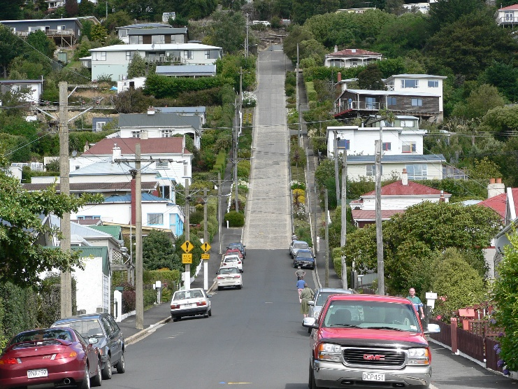 | 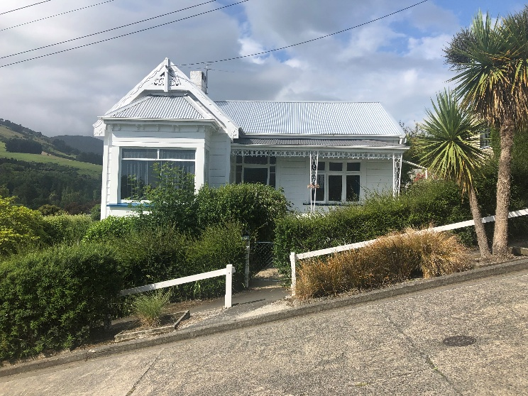
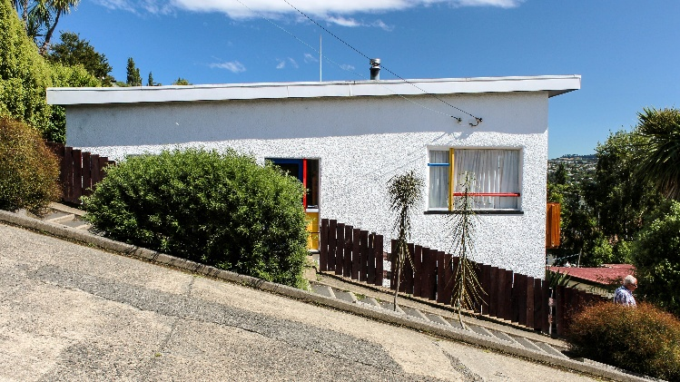 | 