The steepest slopes on Baldwin St
(Y9)

How steep is Baldwin Street?

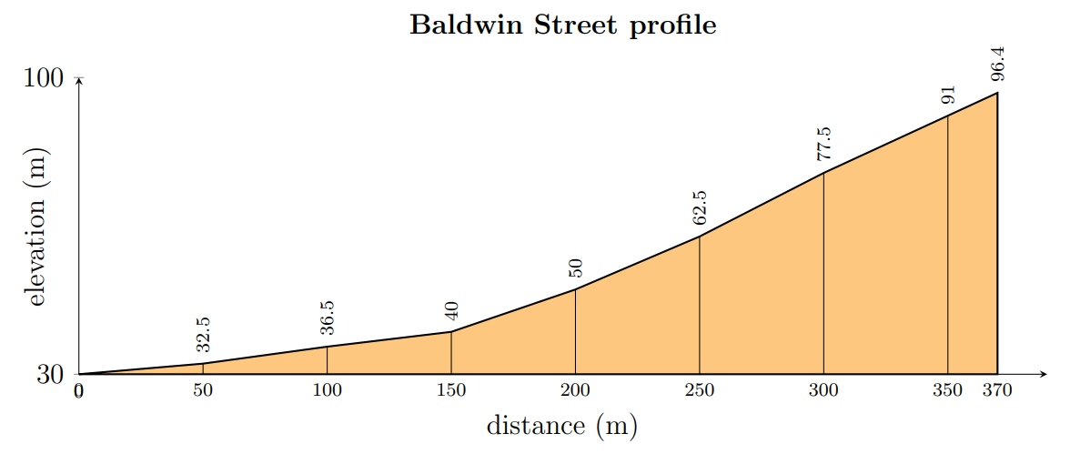

The diagram shows Baldwin Street from the side.
- The horizontal axis shows distance along the road (metres).
- The vertical axis shows height (metres above sea level).
This view helps us see how the height changes and compare how steep different sections are.
The street has been drawn using straight-line sections to make measuring easier.

Measuring steepness
On the diagram:
- Draw a right-angled triangle over a section that looks steep.
- Draw a right-angled triangle over a section that looks gentler.
- Draw a large right-angled triangle from the bottom of the street to the top.
Each triangle must have:
- a vertical side (rise).
- a horizontal side (run).
- a hypotenuse that follows the street.
For each triangle:
- Calculate the gradient as $\frac{\text{rise}}{\text{run}}$.
- Convert the gradient to a percentage.
- Calculate the angle using $θ=\tan^{-1}{(\frac{\text{rise}}{\text{run}})}$.
Complete the table.
Section | Rise | Run | Gradient (%) | Angle ($°$)
Steep
Gentle
Whole street

Is the whole street as steep as the steepest part?

If a road sign could display only one number, what should it show? Should it represent the steepest section or the whole street?

