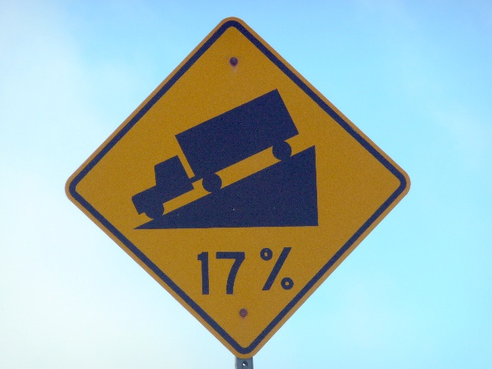
The steepest slopes on Baldwin St
(Y9)

True or false?
For each statement:
- Circle one option only:
  - Always True
  - Always False
  - It Depends
- Write a clear explanation to justify your decision. Use calculations, examples, or values from your earlier work where possible.

- A road labelled “15% gradient” has the same steepness as a road labelled “15°”.

Circle one: Always True Always False It Depends

Write a mathematical explanation to justify your decision.
- A gradient cannot be greater than 100% because percentages only go up to 100.

Circle one: Always True Always False It Depends

Write a mathematical explanation to justify your decision.
- The triangular slope symbol on a road sign is drawn to match the exact gradient shown.

Circle one: Always True Always False It Depends

Write a mathematical explanation to justify your decision.
- If a road sign shows the average gradient of the entire road, it gives the safest information.

Circle one: Always True Always False It Depends

Write a mathematical explanation to justify your decision.
- Rounding 34.7% to 35% and rounding it to 30% have the same effect on interpretation.

Circle one: Always True Always False It Depends

Write a mathematical explanation to justify your decision.
- A 100% gradient means the road is vertical.

Circle one: Always True Always False It Depends

Write a mathematical explanation to justify your decision.

