The steepest slopes on Baldwin St
(Y9)

Writing steepness as a ratio (1 : n)
A slope written as 1 : n means that for every 1 unit up (rise), the road goes n units across (run).

1. Expressing steepness as a ratio
For each triangle:
- Write the gradient as a fraction ($\frac{\text{rise}}{\text{run}}$).
- Write the gradient as a percentage.
Diagram | Gradient as ratio | Gradient ($\frac{\text{rise}}{\text{run}}$) | Gradient (%)
3  1 | 1 : 3
5  1 | 1 : 5
2  1 | 1 : 2

2. Rescaling to 1 : n
For each triangle:
- Write the gradient as a fraction ($\frac{\text{rise}}{\text{run}}$).
- What scale factor makes the rise equal to 1?
- Apply the same scale factor to the run.
- Write the gradient in the form 1 : n.
Diagram | Gradient ($\frac{\text{rise}}{\text{run}}$) | Gradient (%) | Scale factor | Scaled triangle | Ratio form  (1 : n)
8  4 |  |  |  | 1  2
5  2 |  |  |  | ?  1
3  5 |  |  |  | ?  1

3. Comparing ratios
Using your earlier table from Section 1:
- order the three slopes from flattest to steepest.
- record the steepness as a ratio below.

Flattest: ____________
Middle: ___________
Steepest: ___________

4. Thinking about road signs

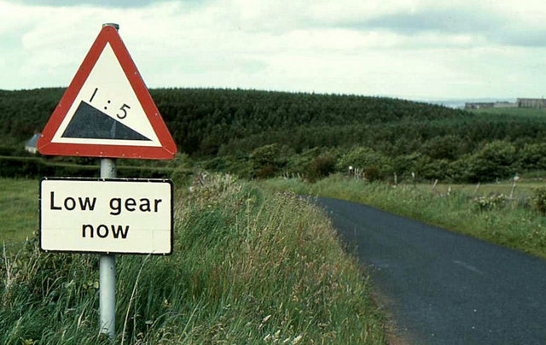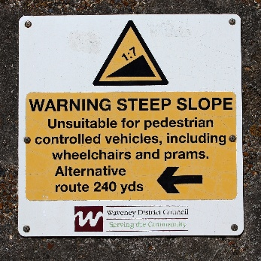

Two road signs are shown with slopes written as 1 : 5 and 1 : 7.

Without calculating, which sign uses the larger numbers?

Express both gradients as decimals. Which road is steeper?

What incorrect conclusions might someone draw from these signs, and why could that be a problem?

